TEAM “Data Pirates”

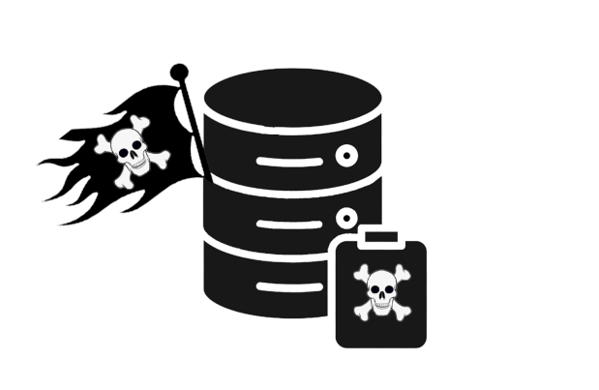

Contents

Website and interactive timeline 1

Team Information 1.2

Introduction 1.3

Ways of Realization 1.4

Block Scheme 1.5

Work Plan 2

Tasks for completion 2.1

WEBSITE AND INTERACTIVE TIMELINE

**Team Information**

|  |  |
| --- | --- |
| **№** | **Roles in the team** |
| **1** | Nikolay Dimitrov – Scrum Trainer |
| **2** | Daniil Chebotarev – Front-End Game Developer |
| **3** | Mihail Petrov – Back-End Developer |
| **4** | Gabriel Dimitrov – Back-End Web Developer |
| **5** | Georgi Ivanov – Front-End Web Developer |
| **6** | Bozhidar Dimov – Front-End Web Developer |
| **7** | Egor Semenov – Quality Assurance |

**Introduction**

|  |  |
| --- | --- |
| **№** | **Introduction** |
| **1** | What is the product?  The product of our project was to make a game that can entertain you using C++. |
| **2** | How can you access it?  You can read about our collaborative work on GitHub and access the files in our project’s repository. |
| **3** | What about communication?  We communicated through Discord due to its helpful functions like screen sharing and text channels. The team was well connected and the work was efficient. |
| **4** | What programs were used?  Programs we used consisted of GitHub for file management and collaborative work, Visual Studio Code and Visual Studio for code editing, Discord for communication, MS PowerPoint for our Presentation, MS Word for the documentation. |
| **5** | The story of the game  Ray is on a ship going to an unknown destination. Suddenly a storm occurs and the ship is destroyed. Ray is unconscious, but the waves somehow manage to get him to an island. He wakes up and doesn't have anything. He barely remembers anything, and he doesn't actually remember how he got there. The island is rich in materials, and his task is to collect them and build a ship to get back home. |

**Ways of Realization**

|  |  |
| --- | --- |
| **№** | **How did we do it?** |
| **1** | Task Distribution  Our team consists of seven people. Each and every one of us has a specific role in the realization of the project. |
| **2** | Task Completion  In five meetings in around 20 p.m. we held a meeting to track the development of the project and help each other progress further. It also helped us resolve issues and share ideas. |
| **3** | Deadlines  In these meeting we also discussed time management, how specific parts were coming along, what everyone had done in their specified time and what things should be completed in the near future. |

**Block Scheme**

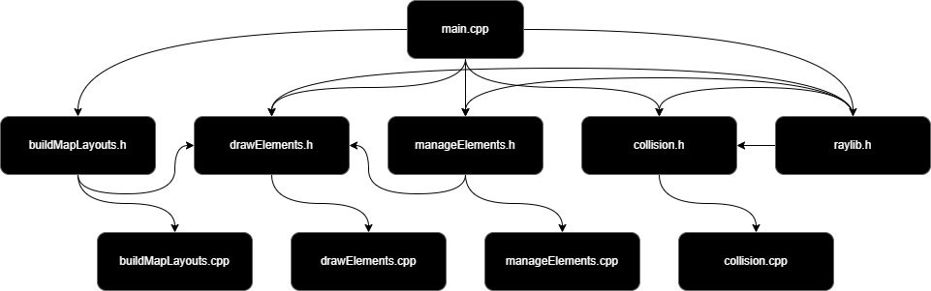

WORK PLAN

**Tasks for Completion for the game**

|  |  |
| --- | --- |
| **№** | **Task Breakdown** |
| **1** | Add movement |
| **2** | Fix camera 2D |
| **3** | Add draw map function |
| **4** | Add map layouts |
| **5** | Add Collision |
| **6** | Add object spawn function |

**Tasks for Completion for the website**

|  |  |
| --- | --- |
| **№** | **Task Breakdown** |
| **1** | Fix header |
| **2** | Create download mechanism |
| **3** | Fix form |
| **4** | Add pictures |