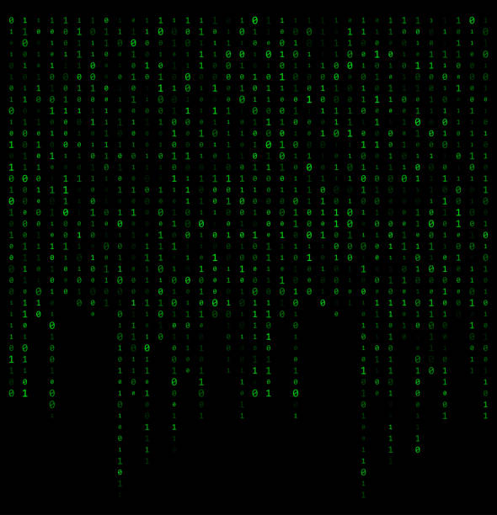

Binary Space

Documentation

Table of content

Team 3

Introduction 3

Game 3

Methods and manners of implementation 4

Task alignment 4

Productive work 4

# Team

|  |  |  |
| --- | --- | --- |
| **#** | **Name** | **Role** |
| 1 | Teodora Lozeva | Scrum Trainer |
| 2 | Boyan Kyovtorov | Back-End developer |
| 3 | Stanislav Dzheneviz | Front-End developer |
| 4 | Dimitar Dimov | Quality assurance engineer |

# Introduction

## Game

The product is a C++ application about a spaceship that shoots lasers to destroy incoming enemy ships. The lasers are 1’s and 0’s and the enemy ships have a binary number displayed on them. The player must solve a bitwise question, solve it and shoot laser with binary number to destroy the enemy ship.

Used technologies

The technologies that we used are Visual Studio 2022 as an integrated development environment. C++ as a programming language. Microsoft Word for the documentation, Microsoft PowerPoint for the presentation, GitHub for collaborative work.

# Methods and manners of implementation

## Task alignment

Each person is assigned a task in which he does well to complete the task to the best of his ability

## Productive work

The tasks are defined in a way that everyone is aware of the tasks performed so far.