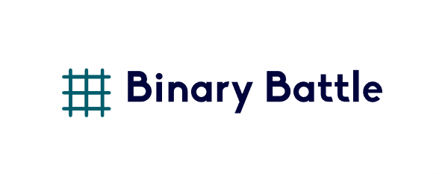

Code Cutters

Table Of Contents
Project Description 2
Our Idea 2
Team Information 2
Project Information 2
Technologies used 4
Ways of Realization 5
Work Plan 6
Block scheme 7

Project Description 2
Our Idea 2
Team Information 2
Project Information 3
Technologies used 4
Ways of Realization 5
Work Plan 6
Block scheme 7

Project Description
- The project was build using “raylib” and C++.

Our Idea
- The goal of our game is to fight different opponents by solving household operations to escape from the dark forest

Team Information
№ | Name | Role
1 | Yavor Penkov | Scrum Trainer
2 | Ivan Dimov | Back-end Developer
3 | Kevin Rusev | Front-end Developer
4 | Sergei Tuptunov | QA engineer

Project Information
№ | Information
1 | Task description  *We had to make a ….. Game using C++” for example
2 | Installation  To install the project, you can open our GitHub and download the project from there.  https://github.com/codingburgas/2223-9th-grade-sprint-math-games-code-cutters.git
3 | Communication  For communicate we used MS Teams. Which made it easy to share file and text messages.

Technologies used
№ | Technologies | Usage
1 | Visual Studio 2022 | As our main IDE
2 | GitHub | For collaboration
3 | C++ | As programming language
4 | Raylib | For our GUI (graphical library)
5 | MS Word | For the documentation
6 | MS PowerPoint | For the presentation
7 | MS Excel | For the QA documentation
8 | MS Teams | For communication
10 | *YourDesignApp* | For designing the UI (for the creation of the logo)
11

Ways of Realization
№ | Issue | Solution
1 | Task Distribution | Allocation of roles
2 | Task Completion | All members of the team gathered and united our ideas for the project into a common idea
3 | Deadlines | Everyone complied with their tasks according to the time allotted to them.

Work Plan
№ | Task Description
1 | *Things you’ve made*
2
4 | Create QA documentation  The QA documentation was created by our QA engineer.
5 | Create Documentation  The documentation was created by our Scrum trainer. To show the process of work in our team.
6 | Create Presentation  The Presentation was created by our Scrum Trainer.

