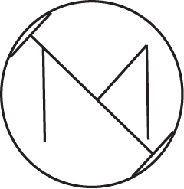

Documentation

ICEMATH

Contents

1. Project idea 1

2. Preformed tasks 1

3. Team members 1

4. Used technologies 1

5. Block scheme 2

6. Summary 2

# Project idea

The aim of the project is to help with learning bitwise operations. There are 12 random questions in the application itself. When you answer correctly you get 1 point.

# Preformed tasks

Our application currently meets all requirements. The application is based on probit operations, there are 12 questions that seed 1 point each.

# Team members

|  |  |  |
| --- | --- | --- |
| Name | Role | Class |
| Nikoleta Ruseva | Scrum trainer | 9A |
| Mariela Dimova | Front-End developer | 9G |
| Kaloyan Georgiev | Back-End developer | 9V |
| Biliyana Badalova | QA engineer | 9B |

# Used technologies

* Visual Studio 2022
* GitHub
* MS Teams
* MS Word
* MS PowerPoint
* MS Excel
* Adobe Illustrator

# Block scheme

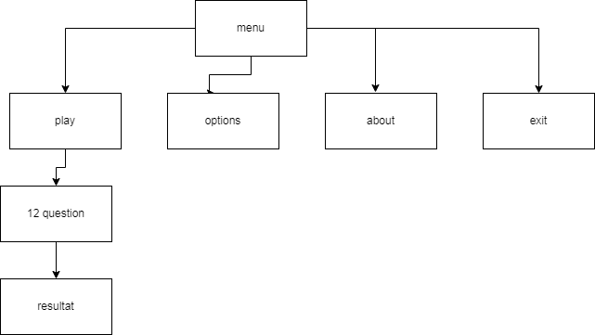

# Summary

|  |  |
| --- | --- |
| Goals | The aim of our application is to help with learning bitwise operations. |
| WHAT IS OUR PRODUCT? | The essence of this project was to create a C++ game based on probit operations. The game has 12 threads. There are 12 random questions in the application itself. When you answer correctly you get 1 point. |
| REALIZATION | We used:  Visual Studio 2022 and C++ - for the application  Teams – for communication  Word и PowerPoint – for documentation  Adobe Illustrator – for design |