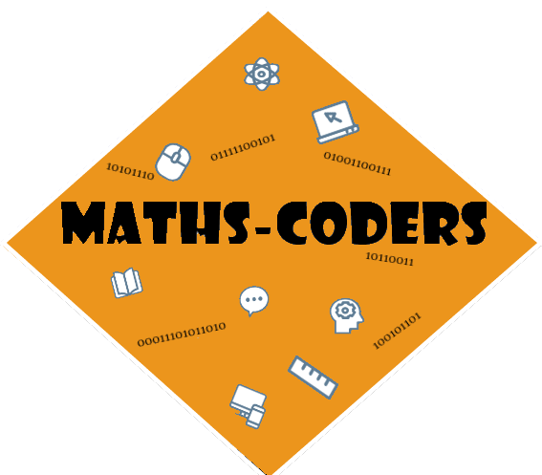**Documentation**

Table of Contents:

1.Team……………………………………………………………………………3

2.Work on the project…....………………………………………3

3.Difficulties encountered…………………………..........3

4.Means used………………………………..……………………………4

5.Conclusion……………………………………………………………….4

6.Block diagram ……………………………………………………….4

1. Team:

|  |  |
| --- | --- |
| № | Roles in the team |
| 1. | Radomir Aleksandrov – Scrum Trainer – RAAleksandrov21@codingburgas.bg |
| 2. | Stanimir Popov – QA Engineer - SSPopov21@codingburgas.bg |
| 3. | Enis Mustafa - Back-end Developer - EEMustafa21@codingburgas.bg |
| 4. | Stilian Georgiev - Front-end Developer - SZGeorgiev21@codingburgas.bg |

1. Work on the project:



Getting a basic idea of the project:

We got together in a meeting and discussed ideas and in the end we all settled on one opinion.



Early and late stages of the project:

We made a schedule, we worked together, everyone helped with everything. The last few days have been hard at work. We have been trying to keep the time for work. It has been difficult to organize and arrange.



Presentation of the project:

We added the last edits to our project in the last days because time was pressing us and we only had to submit it.

1. Difficulties encountered

|  |  |
| --- | --- |
| Making of the team | 9/10 |
| Making the code | 9/10 |
| Communication | 8/10 |
| Distributing the roles | 10/10 |

1. Means used

|  |  |
| --- | --- |
| Word | Tool for making the documentation |
| PowerPoint | Tool for making the presentation |
| Teams | Communication tool |
| Paint | Making the team logo and the game logo |
| Excel | Tool for making the QA table |
| Visual Studio | Tool for writing the code |
| GitHub |  |

1. Conclusion

We learned a lot of new things. We improved our teamwork. We had fun and worked hard on this project activity even later than planned.

1. Block diagram

