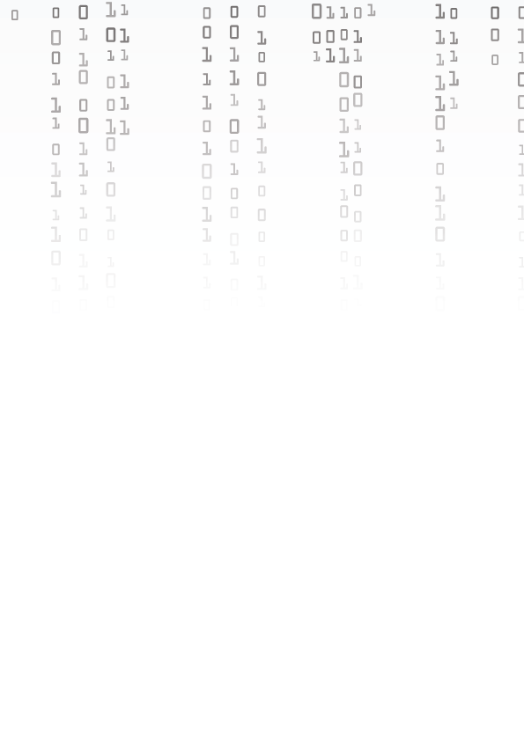

**Documentation**

**Table of Content**

Team information 2

Introduction 2

Completion Tasks 3

# **Table Description automatically generatedProject information and plan**

• We created our bitwise game using C++, in a span of 30 days.

# **Team information**

|  |  |
| --- | --- |
| № | Roles in the team |
| 1 | Stilian Mishev – Scrum Trainer |
| 2 | Ivan Tsvyatkov – QA Developer |
| 3 | Dimitar Byandov – Backend Developer and Frontend Developer |

**Introduction**

|  |  |
| --- | --- |
| № | Introduction |
| 1 | **What is the final product?**  The finished product is a bitwise game, by using C++ with library (raylib) |
| 2 | **How can you access the game?**  You can access the game through our GitHub. |
| 3 | **How did we communicate?**  For our communication we used Microsoft Teams so we can chat, make meetings together and discuss everything related to the project. |
| 4 | **What programs were used?**  We used Visual Studio Code for coding, MS Teams for communication, MS PowerPoint for our presentation, MS Word for the documentation, Adobe Creative for the design, Github as our main collaborative work. |

# **Completion Tasks**

|  |  |
| --- | --- |
| № | Task Breakdown |
| 1 | **Tasks and deadlines**  Our Scrum Trainer has assigned our team tasks to complete the project on time. |
| 2 | **Creating the basics of the code**  The basics of the code are created by our Backend Developer. |
| 3 | **Coming up with the idea**  Everyone on the team gets involved in coming up with idea. |
| 4 | **Looking for information on the tools needed to make the code**  Our Backend and Frontend did that. |
| 5 | **Quality Insurance**  Our QA created unit-test files in Visual Studio and ran them with parts of our code. |
| 6 | **Clear the errors**  All of the team gets involved in that. |
| 7 | **Documentation**  The documentation was written by our Scrum Trainer and Designer to summarize everything related to the site. |
| 8 | **Presentation**  The presentation was created by our Backend, Frontend and Scrim Trainer. |