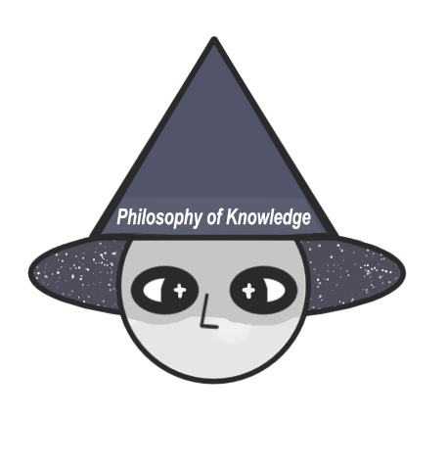

*Philosophy of Knowledge*

**Project Topic: Bitwise Operations**

The theme of the project was to create a C++ game related to bitwise operations.

Our project idea is calculator

**Team Members:**

|  |  |  |  |
| --- | --- | --- | --- |
| [**Emma Georgieva 9B**](https://github.com/EGGeorgieva21) | **Stiliyan Tanev 9V** | [**Kristian Kostadinov 9G**](https://github.com/KNKostadinov21) | **Dariq Kavaldzieva** [**9**](https://github.com/KNKostadinov21)**A** |
| **Scrum Trainer** | **QA Engineer** | **Backend Developer** | **Frontend Developer** |

**Technologies used**

* **C++ (language used to make the game)**
* GitHub (version control)
* Word (documentation)
* Teams (used to get the team together)
* PowerPoint (presentation)
* Visual Studio (used to make the game)
* Excel (QA table)

  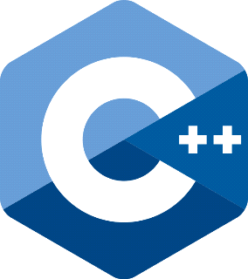

  

**Summary:**

* Our aims
* Our aims are to make sure that the code runs properly and that its functions have the expected output.
* Main Stages of the project
* Creation of repository
* Creation of the game
* Documentation
* Release the first version on GitHub