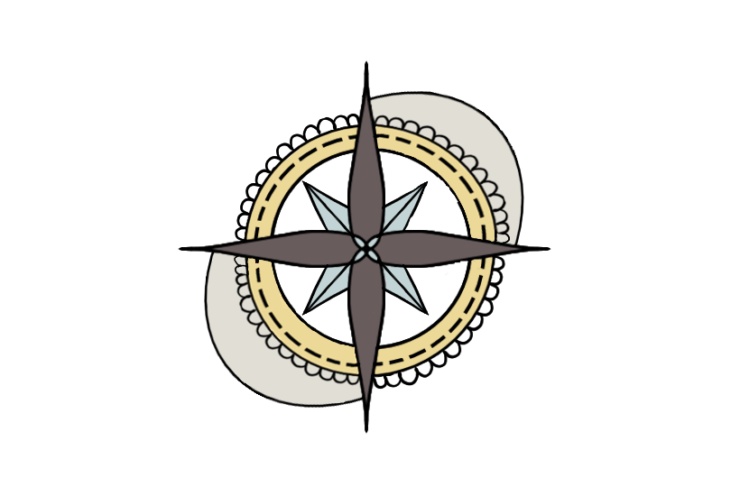

**TEAM HYDRA**

**DOCUMENTATION**

**Content**

1.OUR IDEA 3

2.TEAM 3

• **Scrum Trainer** 3

• **Backend Developer** 3

• **QA Engineer** 3

3.STAGES OF DEVELOPMENT 4

• **Start of the project** 4

• **Making of the project** 4

• **End result** 4

4.USED PROGRAMS AND TECHNOLOGIES 4

• **Microsoft Teams** 4

• **Word** 4

• **Excel** 5

• **C++** 5

• **PowerPoint** 5

• **GitHub** 5

• **Raylib** 5

• **Krita** 5

5.Conclusion 5

6.Block scheme 6

# **1.OUR IDEA**

**This is a game about traveling around Europe. It's a board game and the players can choose to sabotage the enemy with different cards or travel around Europe. There are 5 different types of cards, one of which can give you money and the others are used to sabotage your enemy. You can take away a part of their balance or points, stop them from playing or even ban a country, however the banned country affects for both players.**

# **2.TEAM**

* **Scrum Trainer–Pavel Yordanov**

**The scrum trainer is the leader of the team. His job isto first register the team and then to discuss the schedule for the meetings with the other members of the team. He has to organize and help the team. When the project is ready, he has to create a presentation and a documentation for it.**

* **Backend Developer–Galya Ivanova and Nikola Stoyanov**

**Backend Developer is the member of the team that is responsible for the biggest part of the code. He needs to understand what he writes andhe also has to make sure that the code is understandable and well written.**

* **QA Engineer –Petya Stoyanova**

**QA Engineer is the member of the team that has to make sure everything with the code is alright. He has to make different type of tests on the code and then to create a QA documentation in which he has to write in detail about every test he made.**

# **3.STAGES OF DEVELOPMENT**

## **Start of the project**

**After we formed our team, we decided the name of it and what everyone’s role is and after that the scrum trainer registered the team. Then we decided when we are going to have meetings and how to communicate.**

## **Making of the project**

**When the team was registered, we made a schedule for the meetings. Most of the time everyone in the team was able to be in the meeting and to work. We had no problems communicating with each other and the teamwork was good.**

## **End result**

**When the game was finished, we checked if everything was alright with it. Then we made our presentation, documentation and the QA documentation.**

# **4.USED PROGRAMS AND TECHNOLOGIES**

## **Microsoft Teams**

**Microsoft Teams is the program that we used to communicate. We decided to use it because it was easy to use and gave us the best sound quality and connection.**

## Microsoft Apps**Word**

**MS Word is the program that we used to create our documentation for the project. In it we’ve described the process of making the project, every program that was used for the project and every role in the team.**

## **Excel**

**Microsoft Excel is the program that we used to create our QA documentation. In the QA documentation our QA Engineer made a description about any test that he has made on the game. After that he wrote down if the has test passed.**

## **C++ – УикипедияC++**

**C++ is the programming language in which our code for our game is written.**

## **PowerPoint**

**We used MS PowerPoint to make our presentation. In the presentation we introduce ourselves and everyone’s role and the programs and technologies that we used for the project.**

## **GitHub**

**GitHub is the place where we share and store our code. It was easy to use for every member of the team.**



## **Raylib**

**Raylib is the library that we used for the creation of our game.**

## 

## **Krita**

**We used Krita to create the design of the game and our logo.**

# **5.Conclusion**

**Our work was really enjoyable and we all had fun during the project. We learned a lot of new things which is always useful. For example, we learned how to work better in a team and how to plan our time.We made new friends and learned a lot of new things that can be very useful for future projects.**

# **6.Block scheme**

