**ASTROGRESS**

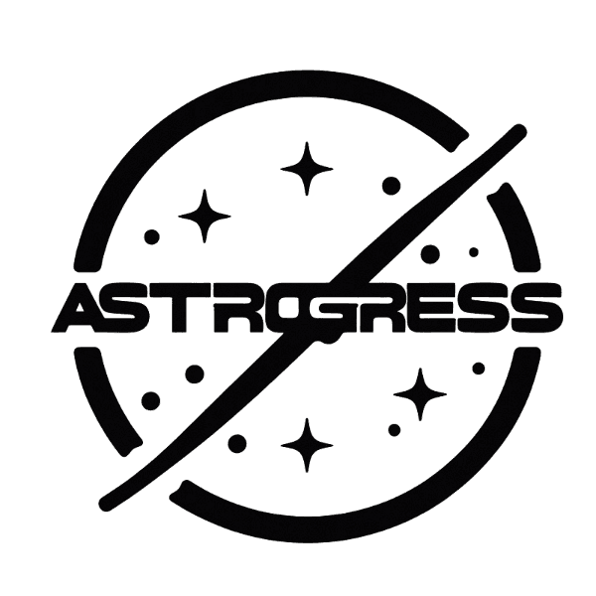

**CONTENTS**

1. Team MEMBERS 3

1.1 NAMES AND ROLES 3

2. ABOUT ASTROGRESS 3

3. PERFORMED TASKS 4

4. Tools and languages 5

5. Scrum trainer’s opinion 5

5.1 How was the project going in my opinion: 5

5.2 What would I change in the work style: 6

6. Sources 7

6.1 Our sources: 7

# Team MEMBERS

## NAMES AND ROLES

|  |  |
| --- | --- |
| Name | Role |
| Alexander Harakchiyski | *Scrum trainer* |
| Miroslav Markov | *Back-end developer* |
| Milan Nedelchev | *Back-end developer* |
| Iliyan Stanchev | *Back-end developer* |

# ABOUT ASTROGRESS

# AstroGress is a company specializing in creating engaging knowledge games about the universe. Our innovative games combine entertainment with education, offering players an interactive and accurate exploration of astronomy, astrophysics, and space exploration. AstroGress aims to make learning about the universe enjoyable and accessible to a wide audience..

# This repository contains the codebase for the game, featuring a user-friendly interface and a database of captivating questions about celestial bodies, astrophysics, and cosmic phenomena. Developed with a focus on both entertainment and education, our game encourages players to explore and deepen their knowledge of the universe through a gamified experience. The repository is regularly updated with new content and improvements to enhance the overall gaming and learning experience.

# PERFORMED TASKS

|  |  |
| --- | --- |
| № | Completed tasks |
| 1 | *We decided what our game is going to be about* |
| 2 | *Miroslav made the logo* |
| 3 | *Alexander and Milan made the game* |
| 4 | *There were some small mistakes that we fixed* |
| 5 | *Miroslav made the documentation* |
| 6 | *Alexander made the presentation* |

# tools and languages

|  |  |
| --- | --- |
|  | We used Discord to share our progress of the project |
|  | We used Visual Studio as our code editor |
|  | We used C++ to code our game |
|  | We used Word to make our documentation |
|  | We used PowerPoint to make our presentation |
|  | We used Teams to share our progress of the project |
|  | We used GitHub for source control and task management |
|  | We used Git for collaborating with each other on the project |

# 

# Scrum trainer’s opinion

## 5.1 How was the project going in my opinion:

In my opinion the project was going really well, very smoothly and it was very cool to have teammates like these, but we started a little late. I think we could have done better if we started earlier but I think our project is great.

## 5.2 What would I change in the work style:

I would probably change the way I talk to my teammates. I should have been more strict and bossier. If I had done that maybe our project could have been better. However, even with the short period we had, we did a great job.

# Sources

The information we used came from different places. We carefully chose our sources and read all of the information. That’s why we think it’s suitable for our readers. Anybody, who wants to have fun and enjoy gaming can play our game!

## 6.1 our sources:

<https://www.wikipedia.org/>

<https://www.pinterest.com/>

<https://www.w3schools.com/>

[https://chat.openai.com/](https://chat.openai.com/(for) (for shortening our text)

<https://github.com/>

<https://fonts.google.com/>