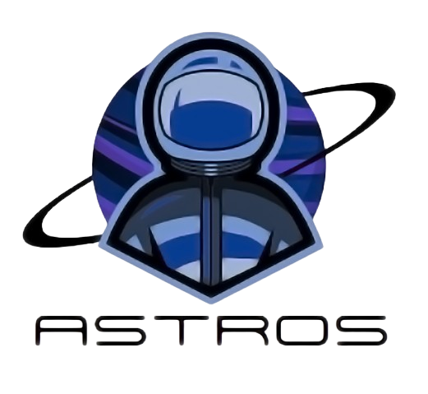

*Documentation*

Table of Contents

1. Team 2

2. Introduction 2

4. Summary 3

5. Block scheme 4

# Team

|  |  |
| --- | --- |
| # | Roles in the team |
| 1 | Hristo Rusev – Scrum Trainer |
| 2 | Ivan-Mihail Ivanov – Back-End developer |
| 3 | Teodora Skulieva – Back-End developer |
| 4 | Zlatin Lazarov – Back-End developer |

# Introduction

|  |  |
| --- | --- |
| # | Introduction |
| 1 | *What is the product?*  Offering a variety of mini-games and interactive planetary lore, take this new command blocking system developed by highly skilled engineers on a whirlwind adventure through the universe in. The program offers replayability and fun learning experiences for all ages. |
| 2 | *Main stages in the realization?*  First Week – Create the idea  Second Week – Start coding  Third Week – Make final touches Fourth Week - Realization |
| 3 | *Communication?* Communication is realized through Microsoft Teams. Thanks to all the features and the provided visualization – on-screen communication and feedback are sufficiently completed. |
| 4 | *What technologies are used?* The technologies that are used are Visual Studio 2022 as IDE, C++ as a programming language. Microsoft Word for documentation. Microsoft Teams as a communication channel. Adobe Photoshop and Adobe Illustrator as a design for the logo. Microsoft PowerPoint as a presentation tool. Git and GitHub as a collaborative workplace. |

1. Method and manner of implementation

|  |  |
| --- | --- |
| # | Method and manner of implementation |
| 1 | *Productive work.* The tasks are defined in a way that everyone is aware of the tasks performed so far to present and answer quickly, clear, and accurately, and teamwork is more efficient and productive. |
| 2 | *Distribution of tasks* For each task, a person is selected who is more familiar with the field and will be able to perform the task in the most competent way possible. |
| 3 | *Terms* Observance of dates was reminded by the Scrum Trainer. A meeting of the team is held every week to discuss the amount of time needed to complete the assigned task. |

# Summary

# Astros’ game package has 4 mini-games, designed for all ages. Dive into the cosmos with ASTROS! Our program consists of 4 minigames, aiming to test your trivial knowledge and help you learn more about space in a fun and exciting way.

# Block scheme

