**Spac o**

Educational Application

Table of contents

Team 3

Summary 3

o Objectives 4

o Main stages in the development 4

o Stages of the scrum methodology 5

o Block scheme of Spacio 8

Conclusion 9

# A white logo with black background Description automatically generatedTeam

Scrum Trainer

Iva Dianova Raykova – 9g

Developers

Simeon Stiliyanov Stefanov – 9b

Natali Ivo Ribareva – 9v

Nikol Stefanova Stoyanova – 9g

# A light bulb with a speaker in the middle Description automatically generatedSummary

## Objectives

Spacio's educational application is the key to understanding complex scientific concepts like physics in a more accessible way. Users can choose between visual demonstrations and theoretical material to learn the information. This provides a flexible approach to learning that introduces them to the fun and interactive world of science.

## Main stages in the development

1. Reflection on the topic

During the first week, the team met systematically to discuss ideas and solutions that could be applied to the design.

1. Design

The artistic design was mainly done by Natali Ivo Ribareva and when designing a new window, everyone's opinion was listened to and the recommendations were transferred to the [Figma](https://www.figma.com/) program.

1. Development

The development of the project happened gradually, for each week each team, without exceptions, had given tasks and worked on them focused. When a case arose with someone, teammates and a mentor, in our case Maria Koleva, were called in to help fix it. Our teamwork was at a high level which allowed us to refine our idea several times for better results.

1. Introducing

For Spacio's presentation, the team agreed that our presentation slides should be split up so that everyone could talk about what they wrote. Mainly the presentation will be conducted by the Scrum Trainer, since part of his job and duties is to introduce the team and its concept.

## Stages of the scrum methodology

1. Analtsis over the assignment and topic

The first job as scrum trainer of the team was to download the brief and read what requirements were expected from the project and I built an idea of what direction to head.

1. First team meeting

In the first meeting it was discussed by the whole team, as well as a mentor, what was required of us and what our capabilities were. Then the team name was thought of.

1. Birth of an idea

Coming up with an idea is very much up to the scrum trainer, since it's up to the scrum trainer to get the team together, see all the ideas, and put together the best possible mix. When the idea is ready, he proposes it to his team and again they review for a better alternative or something new that can be added.

1. Allocation of tasks

At this stage, the scrum trainer has a basic knowledge of the team's capability and allocates the implementation of the project according to this and factors such as time. An equal number of windows are given to each one, including the scrum itself.

1. Communication between the team

The connection between the team happened both in a specific group and through the scrum trainer. A systematic check was made on each individual's progress, after which a new assessment of what the team could do in the given time was created. If there was any ambiguity the scrum trainer would approach the mentor who would help their team to resolve the issue in a more professional manner.

1. Presentation of the project

The presentation of the work done is one of the most important things. This is handled by the scrum trainer, who explains the concept of what has been written to a committee and an audience in order to evaluate what has been heard. During the presentation, the scrum must pass the floor to his other teammates as each of them must explain his part.

* Implemenation

Software for programming our project are [Visual Studio 2022](https://visualstudio.microsoft.com/) and [Visual Studio Code](https://code.visualstudio.com/) 2022



For the creation of our design the main programs are [Figma](https://www.figma.com/), [Canva](https://canva.com/) и [Procreate](https://procreate.com/)

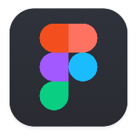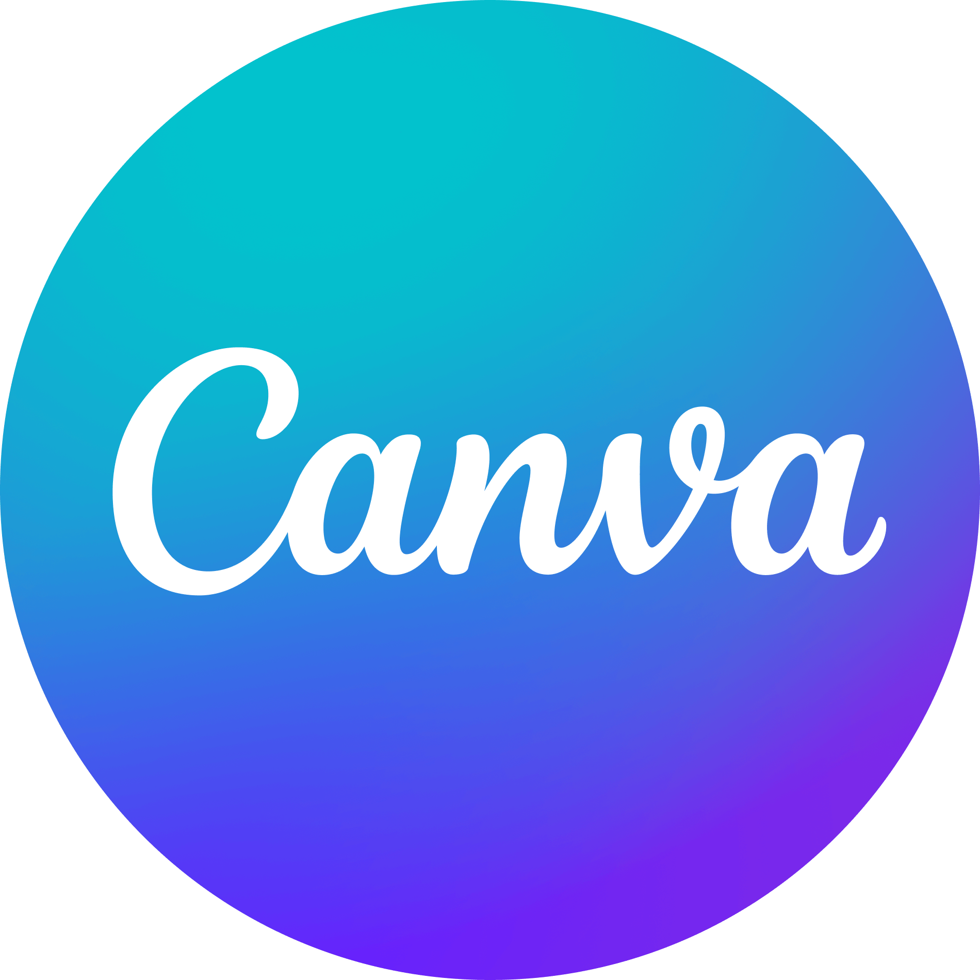

Our collaboration tools are [GitHub](https://github.com/) and [Git](https://git-scm.com/).



Programming languages we have programmed in are C++, HTML and CSS



The technologies, libraries and instruments used in our project are [Raylib](https://www.raylib.com/), [Vite](https://vitejs.dev/), [Tailwind](https://tailwindcss.com/) and [AOS](https://michalsnik.github.io/aos/)

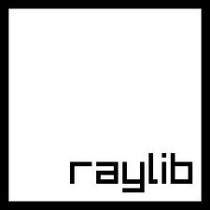

Pages from which we have taken images and icons are [freepik](https://www.freepik.com/) and [Pixabay](https://pixabay.com/)



Software used for the presentation of the project are [Microsoft Word](https://www.microsoft.com/en-us/microsoft-365/word) and [Microsoft PowerPoint](https://www.microsoft.com/en-us/microsoft-365/powerpoint)



# Block scheme of Spacio

# A white line on a black background Description automatically generated Conclusion

The Spacio app is an innovative way to understand complex scientific concepts by offering visual demonstrations and theoretical learning materials in a more accessible way. The feedback received has been positive, and the interest in technology-based educational solutions suggests the high potential for the development of the app. As new features and enhancements are added, Spacio can continue to provide valuable educational opportunities for users.