📘 GradeUP – Final Project Report

Table of Contents

**1. Introduction 2**

**2. Team Contributions 2**

**Backend : 2**

**Designers: 2**

**Scrum Master: 2**

**3. Features Implemented 2**

**4. Development Process 2**

**5. Screenshots 4**

**6. Results and Challenges 4**

**7. Conclusion 4**

# 1. Introduction

GradeUP is a Flask-based web application built to help students evaluate universities and academic programs through surveys and data collection. It serves as a feedback and analysis platform for students, administrators, and researchers to make informed decisions and improve educational offerings.

# 2. Team Contributions

Each team member contributed to different modules of the platform:  
- Frontend: UI/UX design and Jinja templating  
- Backend: Flask architecture, SQLAlchemy models, survey logic  
- Admin Panel: Management tools for users, programs, and universities  
- Survey System: Question types, response handling, progress tracking  
- Documentation and Testing: User stories, ER diagram, and bug fixes

### Backend:

[KRRusev21](https://github.com/KRRusev21) | [TPIvanov21](https://github.com/TPIvanov21)

### Designers:

[PSDineva21](https://github.com/PSDineva21) | [GYFilipov21](https://github.com/GYFilipov21)

### Scrum Master:

[SGMikov21](https://github.com/SGMikov21)

# 3. Features Implemented

• Secure user authentication with role-based access  
• University and program listings with search and filters  
• Custom survey creation and results analysis  
• Admin dashboard for managing users, content, and data  
• Data export functionality  
• Responsive, modern UI with cosmic design theme

# 4. Development Process

We followed an agile development cycle with user stories, sprints, and regular team check-ins. Progress was tracked using GitHub Projects boards. Sprint goals were defined weekly, and each iteration focused on building, testing, and refining a specific feature set.

Link to the project’s User Stories: [UserStories_GradeUp.docx](https://codingburgas-my.sharepoint.com/:w:/g/personal/psdineva21_codingburgas_bg/ETnxmdVJbtNCjy9s46VYJVUBRbZHnOejhYerQbgJAb3D8Q?e=FxY1lc)

Screenshots of the GitHub Projects board would be included here:

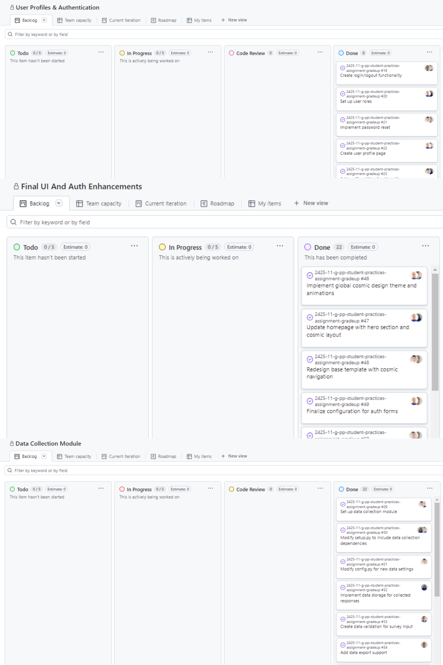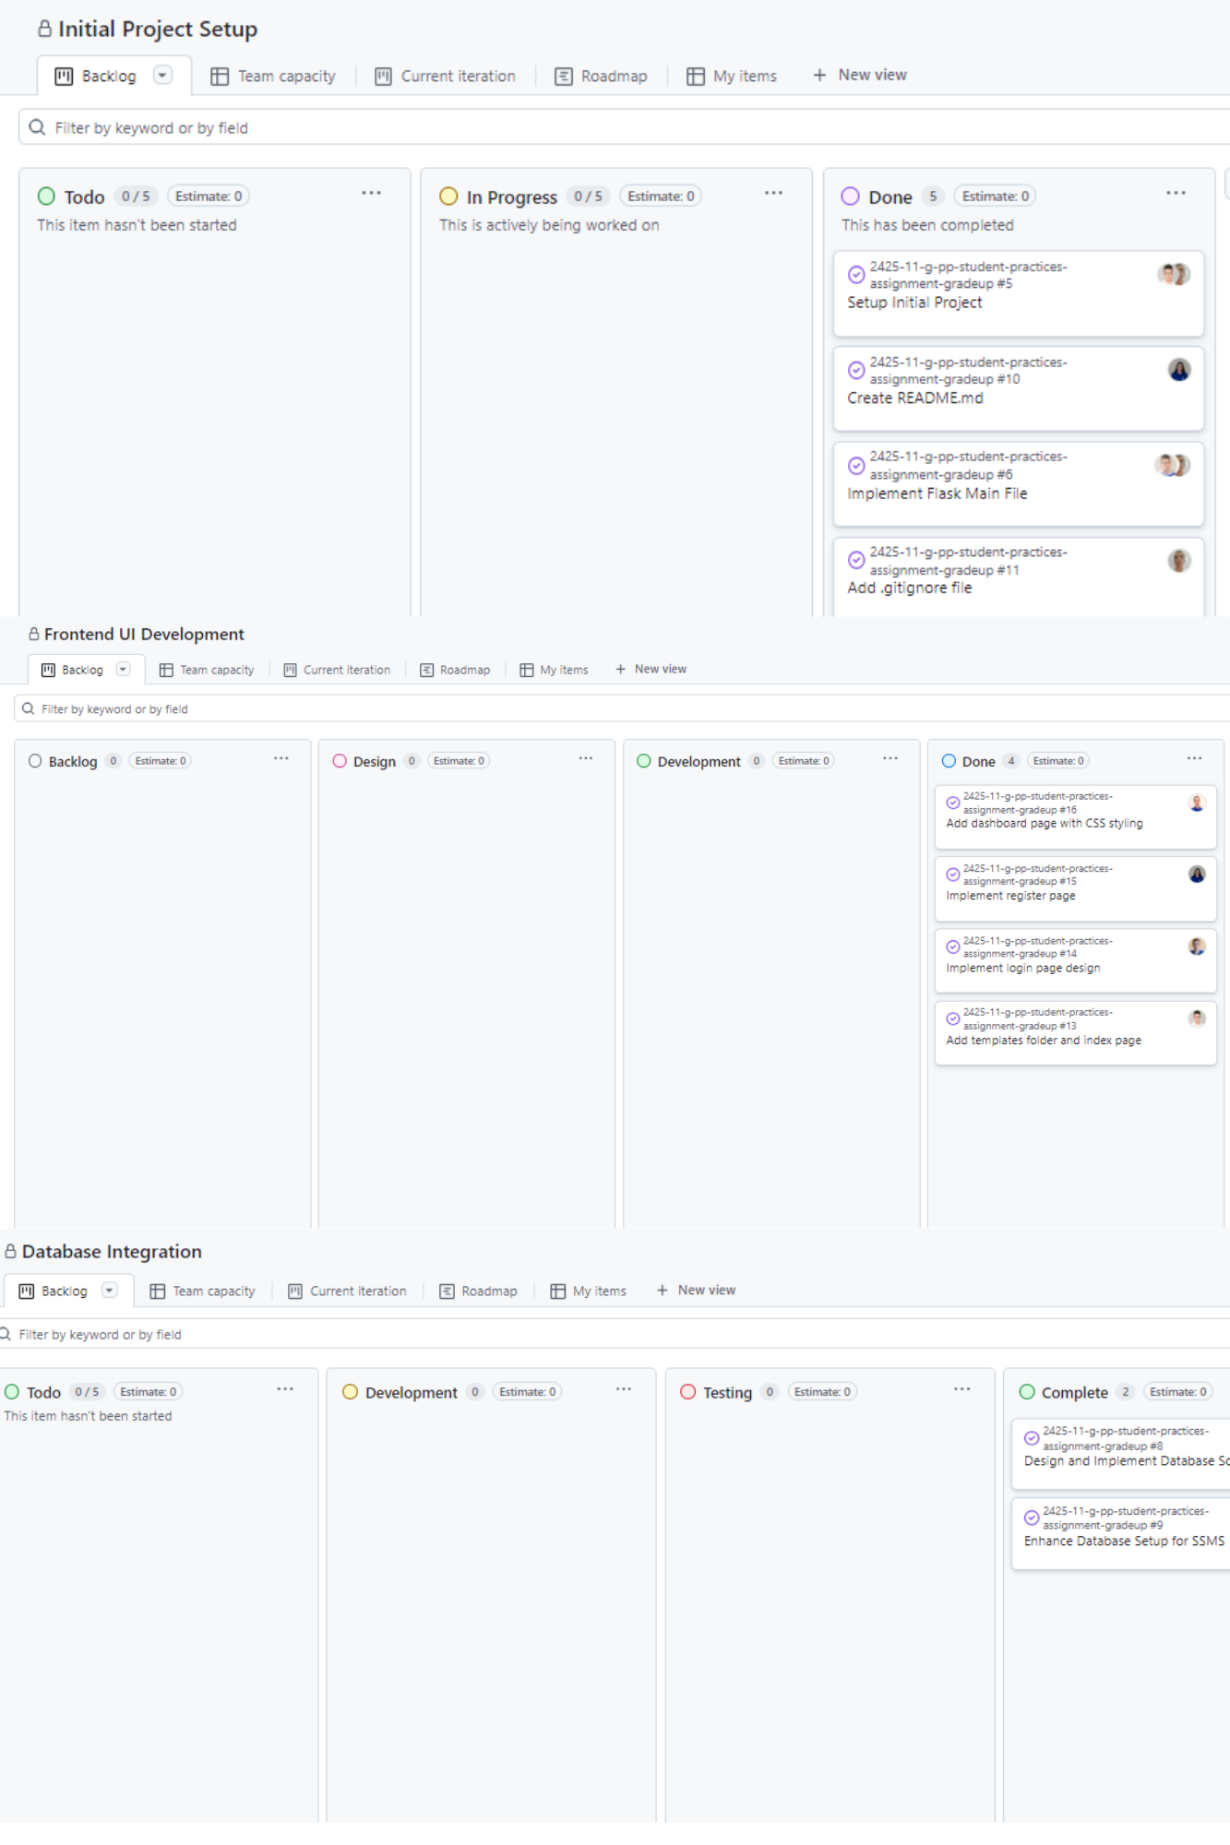

# 5. Screenshots

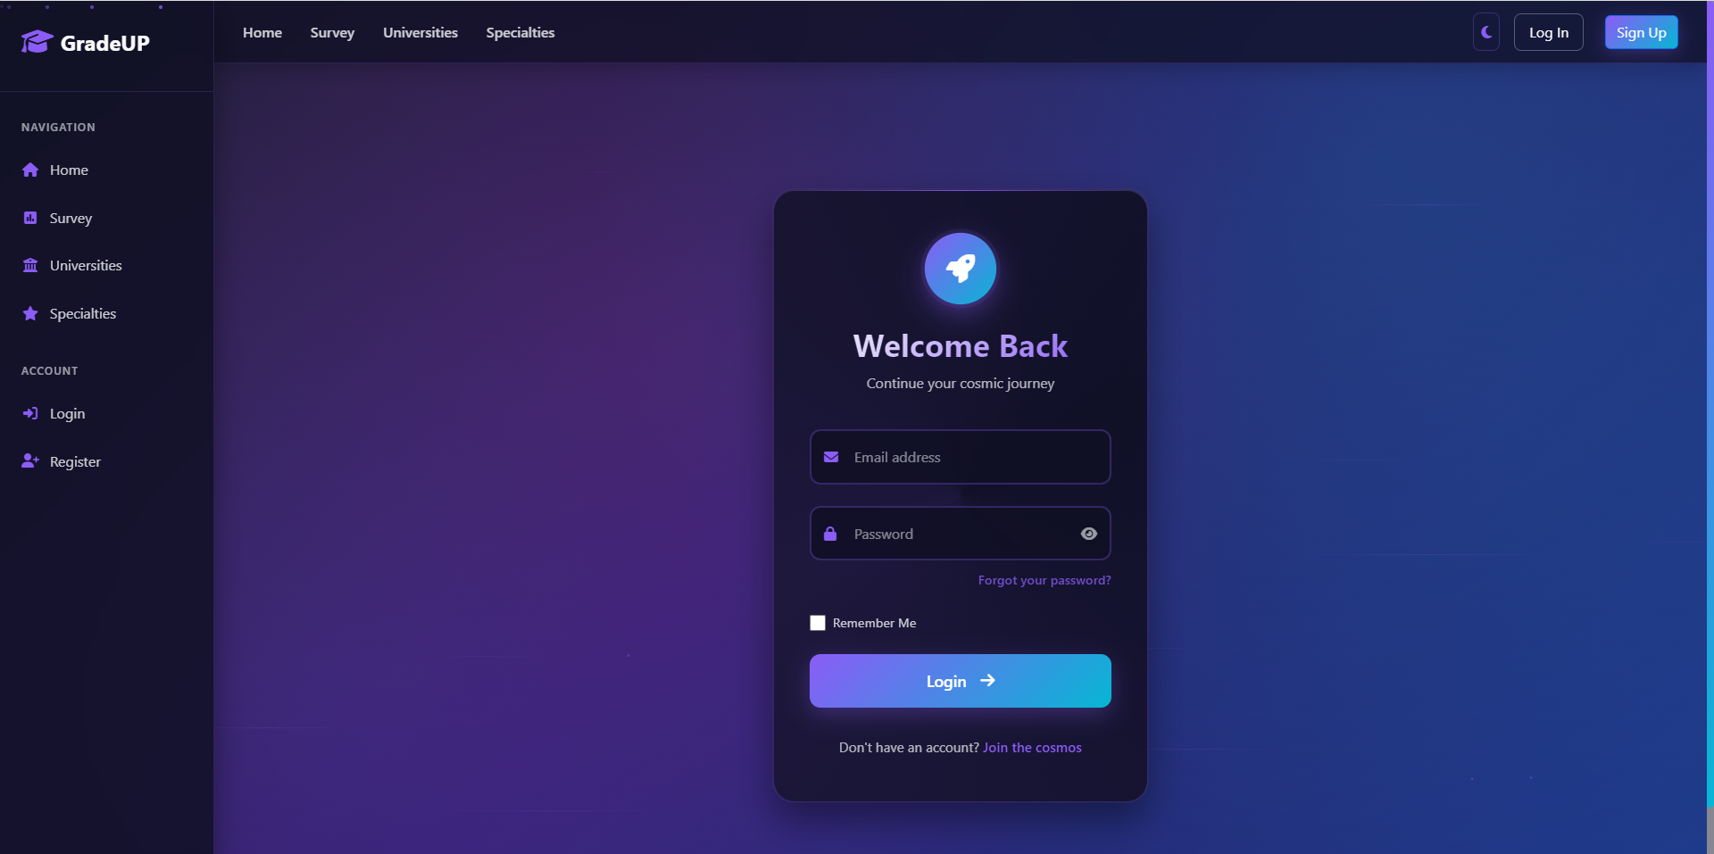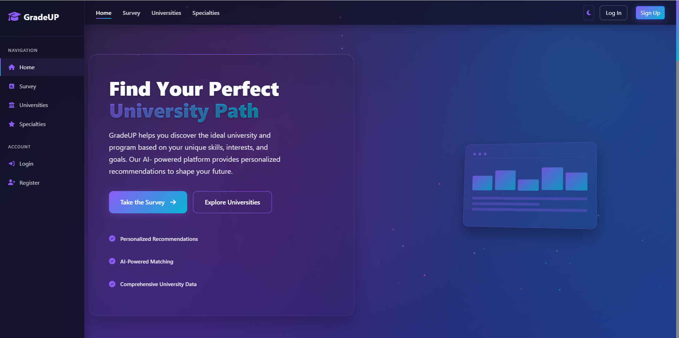Screenshots of the UI and core features would be included here:

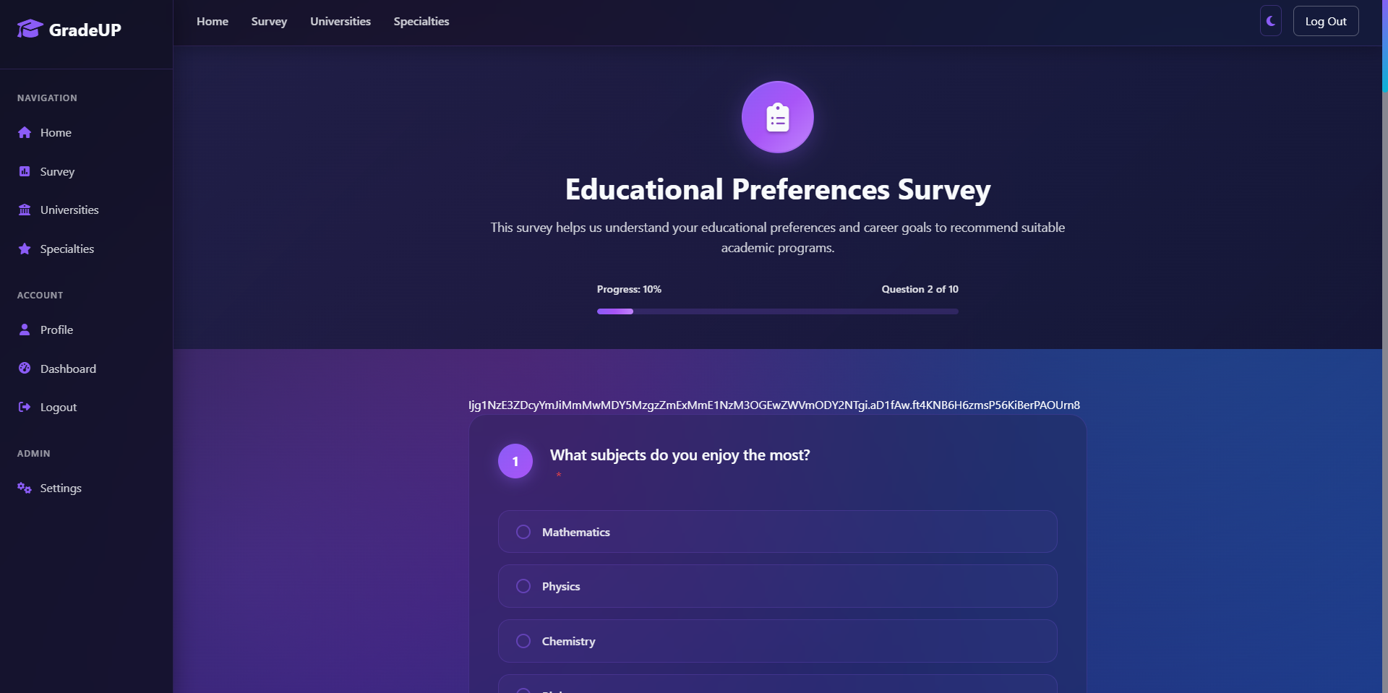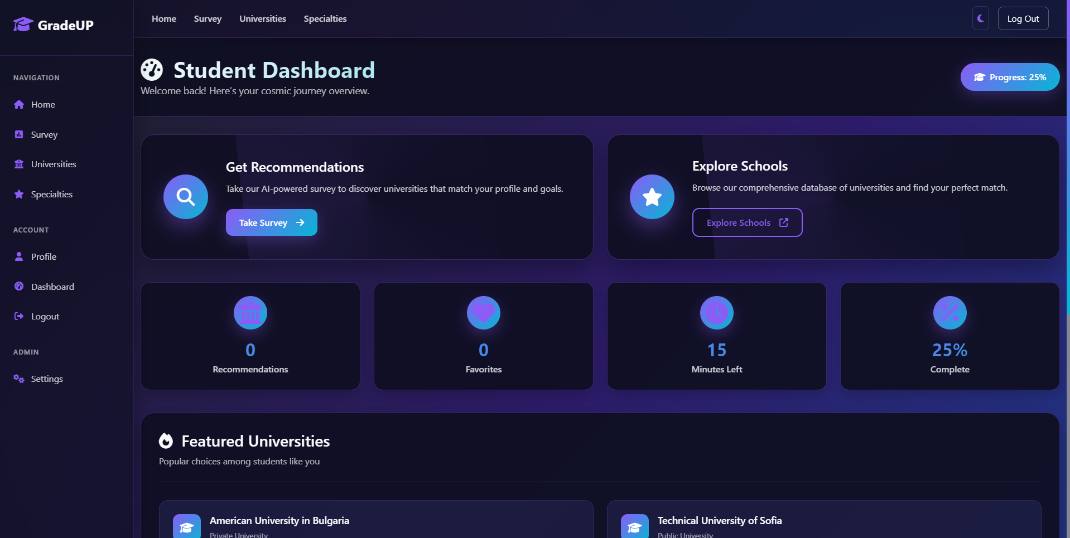

# 6. Results and Challenges

GradeUP successfully implements a complete evaluation workflow. Key challenges included managing dynamic survey structures and fixing infinite loading issues in the details modal. These were addressed through better data handling and optimized frontend rendering.

Screenshots of the UML Diagrams would be included here:

# 7. Conclusion

GradeUP is a functional and scalable tool for academic feedback and evaluation. It combines modern web technology with user-centric design to create value for students, educators, and researchers.