Certa.dev

Movie Catalogue and Recommendation System
Project Documentation
17.04.2026 - 20.05.2026

Table of Contents

Contents
Table of Contents 1
Contents 1
1. Team Members 3
2. Introduction 3
2.1 Project Overview and Goals 3
2.2 Working Period and Methodology 3
2.3 Technology Stack 4
3. Architecture 4
3.1 Three-Tier Architecture Overview 4
3.2 Layer Responsibilities 4
3.3 Architecture Diagram 5
3.4 Communication Rules Between Layers 6
3.5 File-to-Layer Mapping Table 6
4. Algorithms 7
4.1 Bubble Sort 7
4.2 Linear Search 8
4.3 Recursive Rating Sum 9
4.4 Algorithm Complexity Table 10
4.5 Flowchart: Recursive Rating Sum 10
5. Graphical User Interface 11
5.1 Qt Widgets and .ui Files 11
5.2 Screen-by-Screen Walkthrough 12
5.3 How the GUI Calls the Service Layer 12
5.4 User Guide 12
5.5 Screenshots 13
6. Build and Run Instructions 15
Prerequisites 15
Build Steps 15
7. GitHub Workflow 15
7.1 Repository Structure 15
7.2 Branching Strategy 15
7.3 Commit Convention 16
7.4 Pull Request Process 16
7.5 Kanban Board 16
8. Stages of Development 17
8.1 Team Assembling 17
8.2 Main Concept and Planning 17
8.3 Creating the Project 18
8.4 Final Polishing 19
9. Sprint Reports 20

1. Team Members
The table below lists all project contributors, their class grade, and the role each person held throughout the development cycle.
Name | Grade | Role
Denislav Dimov | 9 V | Scrum Master
Vsevolod Bolotov | 9 V | Back-end Developer
Georgi Georgiev | 9 V | Back-end Developer
Dimitar Rusev | 9 B | Front-end Developer

2. Introduction

2.1 Project Overview and Goals
Certa.dev is a desktop application that lets users build a personal movie catalogue, discover new films, and receive recommendations based on their genre preferences. The project was developed as a 9th-grade computer science assignment. Its purpose was to demonstrate practical skills in desktop GUI development, object-oriented C++ and relational database management.
The main goals of the project were: to build a working multi-screen desktop application; to separate concerns cleanly using a three-tier architecture; to implement core algorithms (sorting, searching, and recursion) without relying on standard library helpers; and to manage the full development process using Scrum and GitHub.

2.2 Working Period and Methodology
The team worked on Certa.dev from 20.04 to 18.05, completing 4 sprints of approximately 1 week each. The team followed the Scrum methodology throughout: work was broken into sprints, tasks were tracked on a GitHub Kanban board, and the team held brief retrospectives at the end of each sprint to reflect on what went well and what needed to improve.

2.3 Technology Stack
The technology choices were made early in the planning phase. C++17 was the required language. For the GUI layer, the team chose Qt 6 Widgets because it provides a mature, cross-platform widget toolkit with strong tooling support, a visual form editor (Qt Designer), and a built-in SQL module. An alternative such as Dear ImGui was considered but rejected because it targets game-style immediate-mode rendering, which does not suit a data-driven desktop application.
SQLite was chosen for local data storage because it requires no separate server process and ships as a single file, which suits a student desktop project. CMake with MinGW on Windows was used for the build system because it integrates well with Qt's code-generation steps (AUTOMOC, AUTOUIC, AUTORCC). Git and GitHub provided version control, issue tracking, and the Kanban project board.

3. Architecture

3.1 Three-Tier Architecture Overview
Certa.dev uses a three-tier architecture that divides all code into three distinct layers. Each layer has a single, well-defined responsibility and a strict rule: the layer above may call the layer directly below it, but never skip a layer. The presentation layer never executes SQL, and the data access layer never constructs UI elements.
This separation keeps the code organised, makes individual pieces easier to test, and means that changing the database engine, for example, would only require edits to the data access layer. The same user interface code works regardless of what query sits underneath it.

3.2 Layer Responsibilities
The Presentation Layer lives in the presentationLayer/ directory. It contains every Qt widget, every .ui file, and all layout code. Its only job is to display data and capture user input. When the user clicks a button or submits a form, the widget calls a method on the appropriate service. It then reads the response struct the service returns and updates the display accordingly. It has no knowledge of how data is stored.
The Service Layer lives in the serviceLayer/ directory. It holds all business logic: password validation, rating calculation, filtering rules, and the decision of whether a user action is allowed. Services receive plain request data from the presentation layer, apply whatever rules apply, call the relevant repository, and return a typed response struct. The UserSession singleton, also in this layer, keeps track of who is currently logged in.
The Data Access Layer lives in the dataAccessLayer/ directory. It contains one repository per domain area (auth, user, movie, actor). Every SQL statement in the project lives inside a repository. Queries are built with QSqlQuery::prepare() followed by addBindValue() calls so that user-supplied strings can never be interpreted as SQL commands. The Database singleton in this layer opens the application's SQLite file and provides a shared connection.
Models are plain data-transfer structs in the models/ directory. They cross all layer boundaries but contain no logic, no SQL, and no Qt signals.

3.3 Architecture Diagram
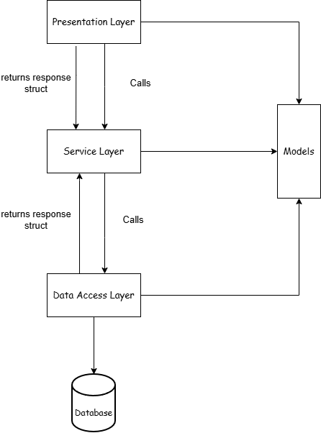

3.4 Communication Rules Between Layers
When a user submits the sign-in form, for example, the Auth widget in the presentation layer validates that the fields are not empty, then calls AuthService::signIn(email, password). AuthService looks up the stored hash via AuthRepository::findUserByEmail(), runs the PBKDF2 comparison, and returns an AuthResponse struct that contains a success flag, an error message string, and an AuthStatus enum value. The Auth widget reads these fields and either navigates to the home screen or displays an error label. The widget never sees SQL. The repository never sees a Qt layout.

3.5 File-to-Layer Mapping Table
The table below maps every significant source file to its architectural layer and summarises its responsibility.
File / Class | Layer | Responsibility
main.cpp | Entry Point | Init Database singleton, set app icon, configure QPixmapCache, show Layout
layout.h/.cpp | Presentation | Main window, sidebar navigation, QStackedWidget routing
auth.h/.cpp | Presentation | Sign-in and sign-up forms, input validation
interestsDialog.h/.cpp | Presentation | Genre interest selection dialog shown after registration
home.h/.cpp | Presentation | Home screen with actor highlights
movies.h/.cpp | Presentation | Movie list with sort controls
movie.h/.cpp | Presentation | Individual movie detail page
actors.h/.cpp | Presentation | Actor list with sort controls
actor.h/.cpp | Presentation | Individual actor detail page
search.h/.cpp | Presentation | Real-time search with 250 ms debounce timer
favorites.h/.cpp | Presentation | User favorites list
recommendations.h/.cpp | Presentation | Personalised recommendation screen
profile.h/.cpp | Presentation | User profile and settings
movieCard / actorCard / actorChip | Presentation | Reusable common widgets
authService.h/.cpp | Service | Sign-in, sign-up, password validation logic
passwordHasher.h/.cpp | Service | PBKDF2-SHA256 hashing (100k iterations, 32-byte key, 16-byte salt)
userService.h/.cpp | Service | User profile, interests, favorites business logic
movieService.h/.cpp | Service | Movie retrieval, rating calculation, bubble sort, recursive sum
actorService.h/.cpp | Service | Actor retrieval and bubble sort
userSession.h/.cpp | Service | Singleton: holds the currently logged-in user (std::optional)
database.h/.cpp | Data Access | Database singleton, opens assets/Certadev.db
authRepository.h/.cpp | Data Access | SQL for user authentication queries
userRepository.h/.cpp | Data Access | SQL for user profile and interest queries
movieRepository.h/.cpp | Data Access | SQL for movies, genres, reviews, favorites
actorRepository.h/.cpp | Data Access | SQL for actors and actor-movie relationships
models/ (user, movie, actor, auth) | Models | Plain data-transfer structs, no logic

4. Algorithms
Three algorithms are implemented in Certa.dev. The project style guide forbids all functions from the <algorithm> header, such as std::sort and std::find.

4.1 Bubble Sort
Category: Sorting. Files: serviceLayer/movieService/movieService.cpp and serviceLayer/actorService/actorService.cpp.
Bubble sort is used to order movie and actor lists before the UI renders them. The user can sort movies by rating (ascending or descending) and by release year (ascending or descending). For actors, the sort options are by last name (A-Z or Z-A) and by number of films (most or fewest). Eight separate functions implement these variants, all following the same pattern.
The algorithm uses two nested index-based for loops. The outer loop runs from index 0 to n-1. The inner loop compares adjacent elements at positions j and j+1. If they are in the wrong order, a temp variable holds one value while the swap is performed. After each full pass of the inner loop, the largest (or smallest) unsorted element has moved to its correct position at the end of the array.

Pseudo-code: sortByRatingDesc (movieService.cpp)
void MovieService::sortByRatingDesc(QVector<MovieDto> &movies) {
int n = movies.size();
for (int i = 0; i < n - 1; i++) {
for (int j = 0; j < n - 1 - i; j++) {
if (movies[j].rating < movies[j + 1].rating) {
MovieDto temp = movies[j];
movies[j] = movies[j + 1];
movies[j + 1] = temp;
}
}
}
}

Time complexity: O(n²) in the worst and average case. Space complexity: O(1), because only a single temp variable is used; no extra array is allocated.

4.2 Linear Search
Category: Searching. File: presentationLayer/widgets/search/search.cpp.
The search screen lets the user type a query and see matching movies and actors in real time. A 250 ms debounce timer ensures the search does not fire on every keystroke; it only runs after the user pauses. Two functions implement the search: findMatchingMovieIndexes() and findMatchingActorIndexes(). Both walk a pre-loaded QVector from index 0 to the end, checking each element for a match.
For movies, the function checks whether the title or description contains the query string. For actors, it checks the full name, the biography text, and the filmography text. Matching is case-insensitive, done via QString::contains(query, Qt::CaseInsensitive). A helper function textMatches() encapsulates this single call to keep the loop body clean. Matching indexes are collected into a result QVector<int>, which the widget then uses to display only the matched cards.

Pseudo-code: findMatchingMovieIndexes (search.cpp)
QVector<int> Search::findMatchingMovieIndexes(const QString &query) {
QVector<int> matches;
for (int i = 0; i < movies.size(); i++) {
if (textMatches(movies[i].title, query) ||
textMatches(movies[i].description, query)) {
matches.append(i);
}
}
return matches;
}

bool Search::textMatches(const QString &text, const QString &query) {
return text.contains(query, Qt::CaseInsensitive);
}

Time complexity: O(n) per search, where n is the number of movies or actors loaded. Space complexity: O(k), where k is the number of matches found.

4.3 Recursive Rating Sum
Category: Recursion. File: serviceLayer/movieService/movieService.cpp.
The average rating shown on every movie card and movie detail page is computed using a recursive function called sumRatings(). The function takes a QVector<double> of all user review scores for a movie and an integer index i. It adds the element at position i to the result of calling itself with i + 1, walking forward through the vector one step at a time until it reaches the end.
The base case returns 0.0 when i is equal to or greater than the size of the vector, stopping the recursion. The recursive case returns ratings[i] plus the result of the next call. The calling function, fillRating(), passes an initial index of 0 and then divides the returned total by the count of reviews to get the average.

Pseudo-code: sumRatings and fillRating (movieService.cpp)
double MovieService::sumRatings(const QVector<double> &ratings,
const int i) {
if (i >= ratings.size()) return 0.0; // base case

return ratings[i] + sumRatings(ratings, i + 1); // recursive case
}

void MovieService::fillRating(MovieDto &movie) {
QVector<double> ratings = movieRepository.getRatings(movie.id);

if (ratings.isEmpty()) {
movie.rating = 0.0;
return;
}

double total = sumRatings(ratings, 0);
movie.rating = total / ratings.size();
}
Time complexity: O(n), where n is the number of ratings for the movie. Space complexity: O(n) in stack space, because the call stack grows to depth n before any call returns.

4.4 Algorithm Complexity Table

4.5 Flowchart: Recursive Rating Sum
The flowchart below traces one complete execution of sumRatings() for a movie with three ratings.
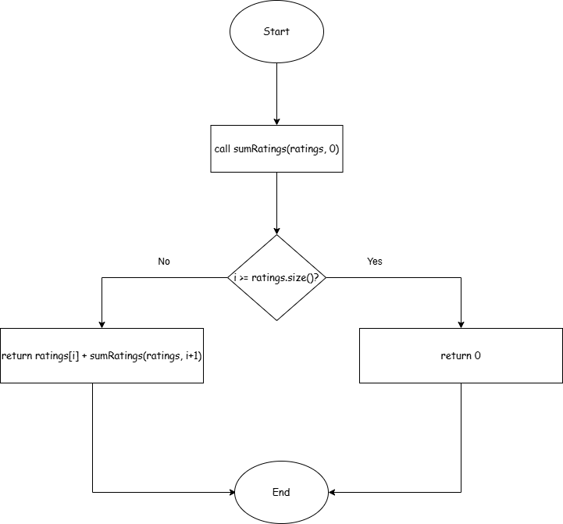

5. Graphical User Interface

5.1 Qt Widgets and .ui Files
The entire user interface is built with Qt Widgets. Every screen is a class that inherits from QWidget. Each screen has a matching .ui file created in Qt Designer, which is a visual drag-and-drop editor for placing and configuring widgets. At build time, CMake's AUTOUIC step reads each .ui file and generates a C++ header (ui_ClassName.h) that contains the layout code. The screen class then calls ui->setupUi(this) in its constructor to apply the layout. Developers do not write layout code by hand; they edit the .ui file in Qt Designer instead.
The visual theme uses a dark color scheme defined presentationLayer/theme/color_theme.json. The background color is #0F0F11, the primary accent is #AE1A19 (the same red used in this document), and the body text color is #FFFFFF. All Qt stylesheets reference only the color tokens defined in that file.

5.2 Screen-by-Screen Walkthrough
Auth screen (auth.h/.cpp): The first screen the user sees if no session is active. It contains a sign-in form and a sign-up form. The sign-up form asks for a username, email, and password. After successful registration, the InterestsDialog opens so the user can select their preferred genres.
Home screen (home.h/.cpp): Shown after login. Displays a welcome section and highlights several actors. Clicking an actor card navigates to that actor's detail page.
Movies screen (movies.h/.cpp): A scrollable grid of movie cards. The user can sort the list by rating or by release year in either direction. Clicking a card navigates to the movie detail page.
Movie detail screen (movie.h/.cpp): Shows the movie poster, title, release year, genre tags, average rating, and full description. A list of cast actors appears below. The user can add the movie to favorites and write or read reviews.
Actors screen (actors.h/.cpp) and Actor detail screen (actor.h/.cpp): Mirror the movies pattern. The list can be sorted by last name or by number of films. The detail page shows a biography and a list of films the actor appeared in.
Search screen (search.h/.cpp): A text input triggers the linear search algorithm after a 250 ms debounce. Results show matching movie cards and actor cards side by side.
Favorites screen (favorites.h/.cpp): Lists all movies the logged-in user has marked as a favourite. Recommendations screen (recommendations.h/.cpp): Shows films the system suggests based on the user's selected genre interests.
Profile and Settings screens (profile.h/.cpp, settings.h/.cpp): Allow the user to view and update account details and adjust application preferences.

5.3 How the GUI Calls the Service Layer
Each screen holds a reference to the service objects it needs. The widget validates user input before making any service call. If validation passes, it calls the relevant service method. The service returns a response struct. The widget reads the success field: if true, it updates the display; if false, it shows the errorMessage string in an error label. No widget ever calls a repository method directly, and no widget ever accesses the Database singleton.

5.4 User Guide
Launch the application. The Auth screen appears. Click Sign Up, enter a username, email, and password, then click Register. The genre interest dialog opens; select at least one genre and click Confirm.
The Home screen loads. Click Movies in the sidebar to see the full catalogue. Use the sort buttons at the top to reorder by rating or year. Click any movie card to open the detail page. On the detail page, click the heart icon to add the film to favorites.
Click Search in the sidebar and type any word. Matching movies and actors appear after a short pause. Click the Recommendations link in the sidebar to see films the application suggests based on the genres selected at registration.

5.5 Screenshots
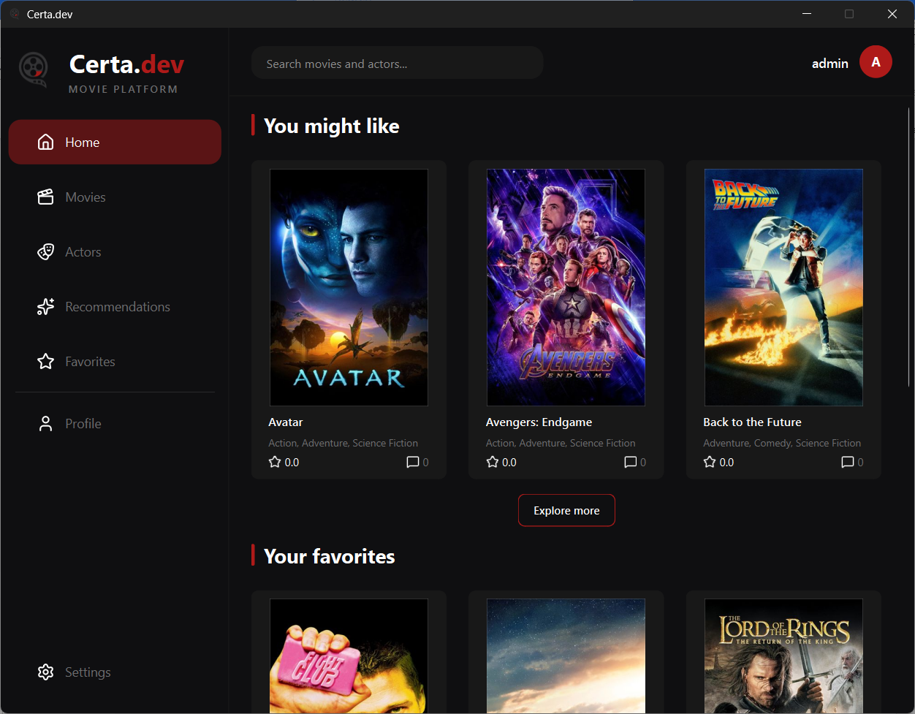
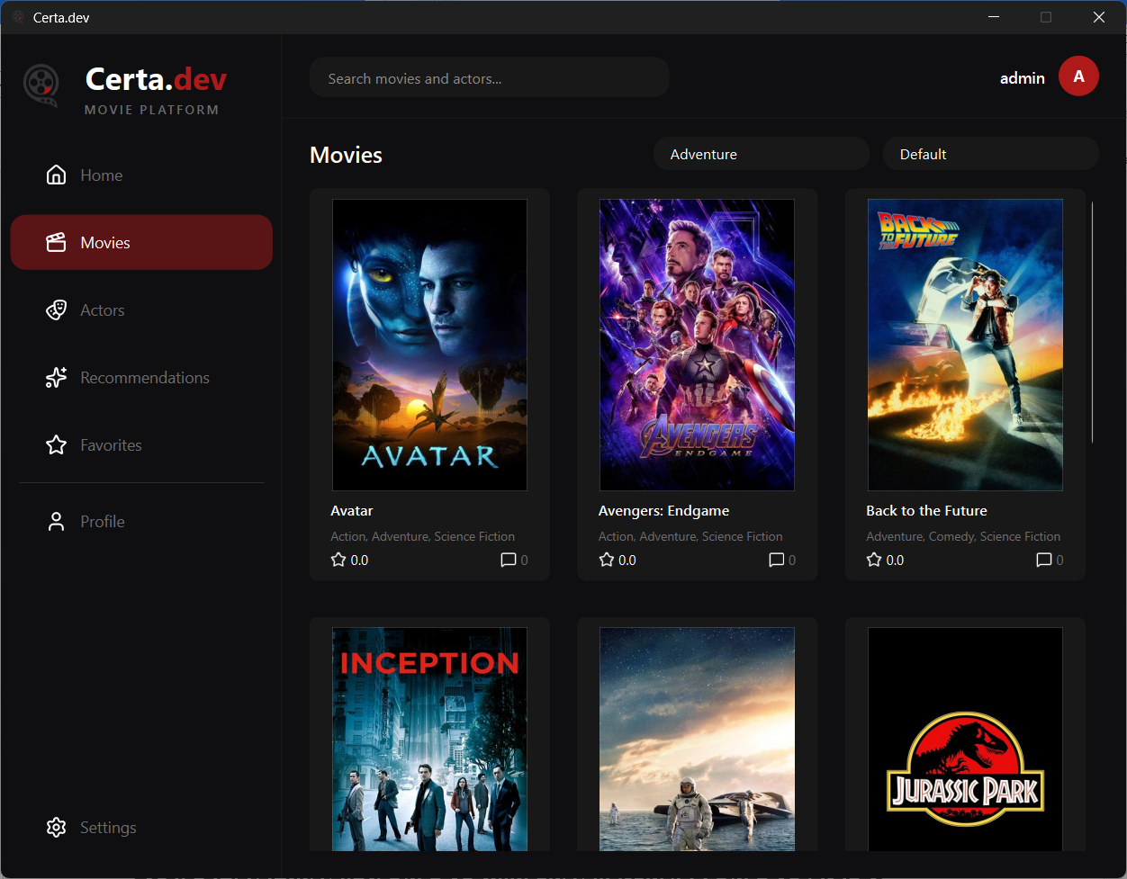
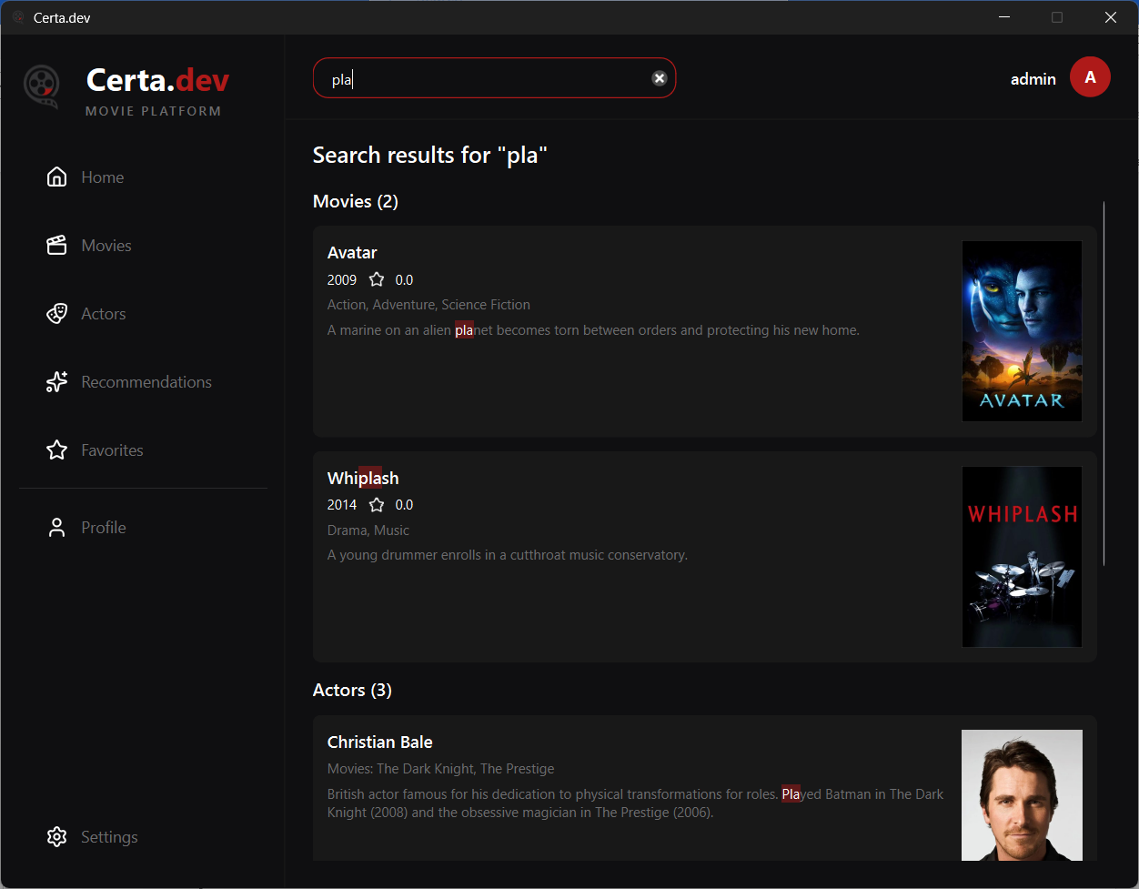

6. Build and Run Instructions
The steps below produce a working binary on a clean Windows machine. The build process requires no package manager. Qt's code-generation steps (AUTOMOC, AUTOUIC, AUTORCC) run automatically as part of the CMake build.

Prerequisites
- Qt 6.5 or later (install via the Qt Online Installer; include Qt Core, Qt Widgets, Qt SQL, and Qt Network modules, plus the MinGW kit)
- CMake 3.20 or later (add to PATH during installation)
- MinGW 12 or any C++17-capable compiler compatible with Qt 6 on Windows (bundled with the Qt MinGW kit)
- Git (download from git-scm.com)

Build Steps
Step 1 Clone: git clone https://github.com/codingburgas/Certa.dev.git
Step 2 Enter: cd Certa.dev
Step 3 Config: cmake -B cmake-build-debug-qt-mingw -S .
Step 4 Build: cmake --build cmake-build-debug-qt-mingw
Step 5 Run: execute the binary from the cmake-build-debug-qt-mingw directory. The binary reads assets/Certadev.db relative to its working directory, so do not move the binary without also moving the assets folder.

7. GitHub Workflow

7.1 Repository Structure
The project lives in a single GitHub repository at https://github.com/codingburgas/Certa.dev. The source tree follows the three-tier directory layout described in Chapter 5: presentationLayer/, serviceLayer/, dataAccessLayer/, and models/ sit alongside main.cpp and CMakeLists.txt in the root. The assets/ folder holds the SQLite database file.

7.2 Branching Strategy
The main branch is always kept in a stable, runnable state. Every new feature or bug fix is developed on a short-lived feature branch. Branch names follow the pattern feature/featureName, for example feature/movie or feature/auth. When the work on a branch is complete, a pull request is opened against main. At least one other team member reviews and approves the PR before it is merged. Branches are deleted after merge to keep the branch list clean.

7.3 Commit Convention
All commits follow the Conventional Commits format: type(scope): description. The type describes what kind of change was made. Common types used in this project are:
- feat - a new feature
- fix - a bug fix
- docs - documentation changes only
- style - formatting, no logic change
- refactor - code restructuring without changing behavior
- perf - a performance improvement
- build - build system or dependency changes
- chore - maintenance tasks
- revert - reverting a previous commit
When a commit closes a GitHub issue, the issue number is appended at the end, for example:
feat(movie): calculate average rating with recursion, closes #29
fix(auth): handle empty password on sign-in.

7.4 Pull Request Process
When a feature branch is ready, the developer opens a pull request against main on GitHub. The PR description summarises what was changed and lists the issues it closes. At least one other team member reads through the diff and leaves comments or approval. If changes are requested, the author pushes additional commits to the same branch. The PR is merged only when at least one approval has been given and the branch has no conflicts with main.

7.5 Kanban Board
The team used a GitHub Projects board to track all tasks. The board has four columns: To Do, In Progress, Review, and Done. Each issue is a card on the board. When a developer starts working on an issue, they move it to In Progress. When they open a PR, the issue moves to Review. When the PR is merged and the issue is closed, the card moves automatically to Done.
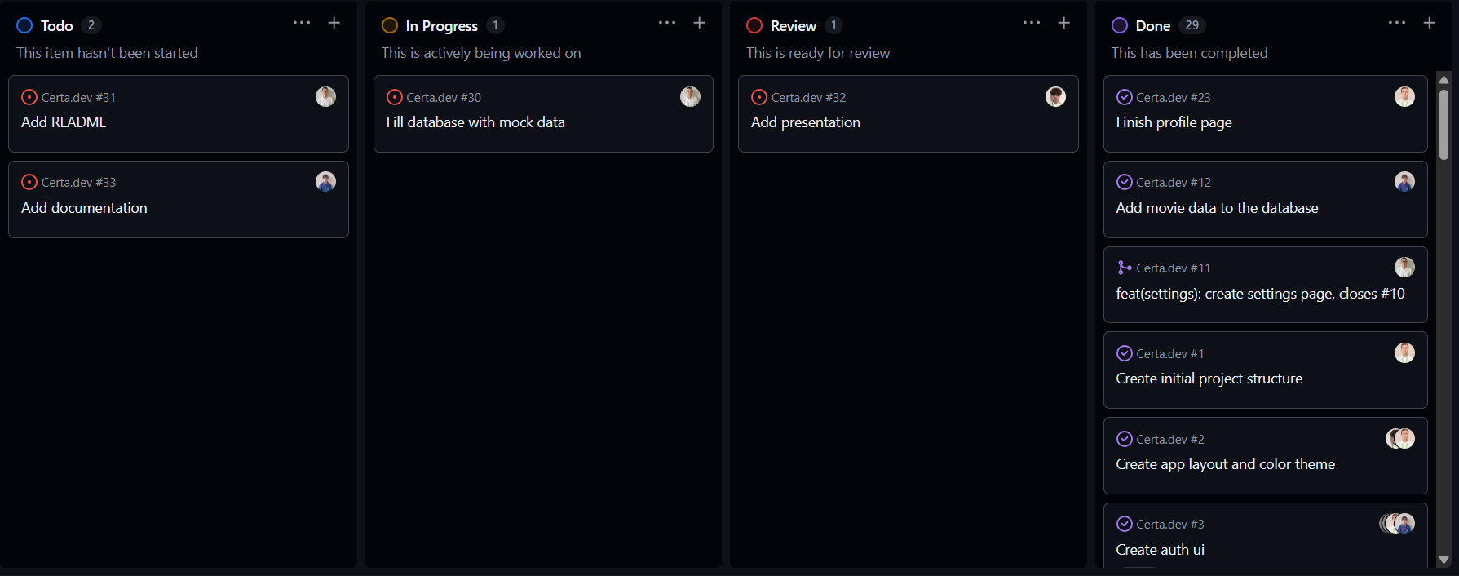

8. Stages of Development

8.1 Team Assembling
The team consisted of four members who chose to work together based on shared interest in the project and complementary technical skills. Denislav Dimov took the role of Scrum Master and overall project lead, coordinating the workflow and managing team communication. Vsevolod Bolotov and Georgi Georgiev were responsible for the back-end development, focusing on the service layer and data access layer of the application. Dimitar Rusev led the front-end development, working on the presentation layer and user interface design. Roles were assigned according to each member’s strengths and preferred area of development to ensure efficient collaboration throughout the project.

8.2 Main Concept and Planning
The team discussed several project ideas before choosing to create a movie catalogue application. Some of the first ideas were a student grade tracker, a recipe manager, and a small library system. In the end, the team decided that a movie catalogue would be more interesting and would allow the use of more advanced features such as movie recommendations and user preferences.

The final decision was made after a group discussion where every member shared their opinion. Since most of the team members were interested in movies and streaming platforms, the idea felt both useful and enjoyable to work on. After choosing the project, the team divided the tasks according to each member’s skills and interests. The Scrum Master organized the tasks and managed the workflow, the two back-end developers worked on the database and application logic, and the front-end developer focused on the user interface and design.

The first backlog was created by listing the main features needed for the application. These included movie search, filtering by genre, user accounts, watchlists, and a recommendation system. The team also added tasks for database design, UI planning, and repository setup. All tasks were added to the GitHub Kanban board so the team could follow the progress and work together more efficiently.

8.3 Creating the Project
Implementation was completed in several development sprints. During the first sprint, the team created the basic structure of the project. This included the CMakeLists.txt configuration, the folder structure for the three application layers, the Database singleton class, and the main application window with working sidebar navigation. This sprint focused mainly on preparing a stable foundation for future development.

The second sprint focused on user authentication and account management. The team implemented registration, login, and password validation. Authentication was developed first because many other features depended on identifying the current user. During this sprint, the team also connected the application to the SQLite database and tested the first database operations.

In the following sprints, the team added the main application features one by one according to the backlog. Movie and actor management were implemented first, followed by movie search, filtering, favorites, and recommendation features. Each feature was developed in a separate Git branch and later merged into the main branch after testing and code review. One important milestone was the completion of the recommendation system, because it connected several parts of the application together.

The most significant technical challenge was implementing PBKDF2-SHA256 password hashing using Qt's built-in QCryptographicHash and QMessageAuthenticationCode classes. The team also faced difficulties when connecting the user interface to the back-end logic, especially when updating data dynamically after database changes. Another challenge was organizing communication between the different application layers without creating tightly connected code. Merge conflicts also appeared several times because multiple team members were working on the same files at the same time, but these problems were solved through code reviews and better task separation.

8.4 Final Polishing
In the final sprint, the team focused on polishing the application and fixing remaining problems before the final presentation. Several smaller bugs were corrected, including issues with search results not updating correctly, problems with navigation between pages, and incorrect handling of empty database fields. The team also improved error messages shown to users during login and registration.

The user interface was refined during this stage to make the application look more consistent and easier to use. Colors, spacing, and button styles were updated to create a cleaner design. Some screens were reorganized to improve navigation, and additional icons and labels were added to make the interface more understandable. The team also tested the application with the SQLite database file to make sure all features worked correctly with real stored data.

At the same time, the project documentation was completed, including explanations of the architecture, technologies, and development process. To prepare for the jury presentation, the team created a live demonstration plan that showed the main features of the application step by step. The demo included user registration, login, browsing movies, searching by title or genre, adding favorites, and viewing movie recommendations. Team members also practiced their presentation parts in advance so the demonstration could run smoothly and within the required time.

9. Sprint Reports
The table below summarises all sprints, their date ranges, goals, and completion status.
Sprint | Dates | Goal | Status
1 | 20.04 to 27.04 | Authentication system and three-tier architecture setup | Completed
2 | 27.04 to 04.05 | Movies feature, genre interests dialog, and favorites | Completed
3 | 04.05 to 11.05 | Actors feature, global search, and filtering on each page | Completed
4 | 11.05 to 18.05 | Project Documentation | Completed

