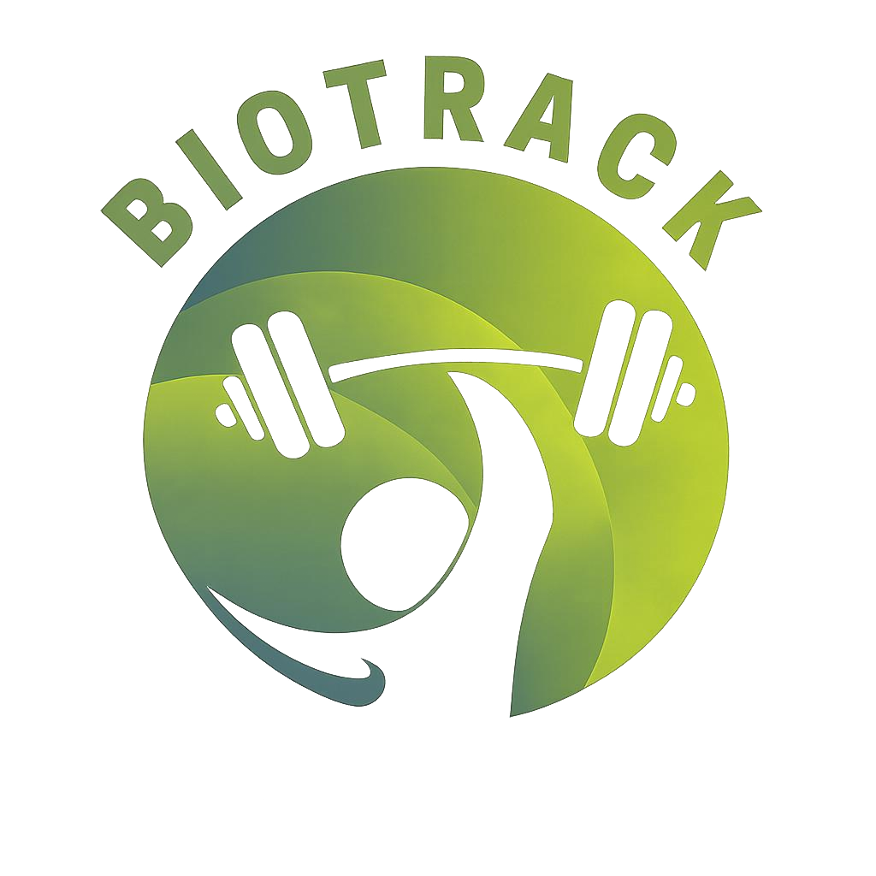
INTRODUCING BIOTRACK, THE №1 FITNESS WEBSITE

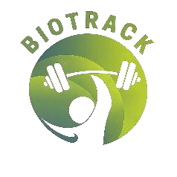
Contents
- About our team
- About out project
- Used technologies


ABOUT OUR TEAM
Our team consists of 3 passionate individuals:
  - Vsevolod Bolotov
  - Juliana Stoykova
  - Sofiya Chapkina
The goal for this project was to create a fitness website, and we came together to do exactly that.

ABOUT OUR PROJECT
Our project is centered around the idea of creating
a smart and engaging fitness dashboard that helps users easily track their personal progress, workouts, and goals in one place. It aims to present fitness data in a clear, visually appealing, and interactive way, encouraging users to stay motivated and consistent in their training. By combining progress
tracking and training resources, the dashboard
simulates a real-life fitness assistant that supports users inbuilding and maintaining a healthy lifestyle.


USED TECHNOLOGIES
 VS code
As the primary app we used for coding
  HTML 5 and CSS
Used to make the core of the website  JavaScript
The primary coding language used to make the
website more interactive  MS Teams
Used for communication



MS Word and MS PowerPoint
Used for documenting our project

 GitHub and Git
Used as primary cooperation tools

