

**Documentation**

Table of content

1. Project Overview 2

1.1 Introduction 3

1.2 Key Features 3

2. Technical Specifications 3

2.1 Technology Stack 3

3. Implementation Details 3

3.1 File Structure 4

4. Development Process 4

4.1 Workflow 5

4.2 Milestones 5

5. Team Structure 5

5.1 Roles & Responsibilities 6

5.2 Collaboration Tools 6

6. Future Development 7

6.1 Roadmap 7

6.2 Enhancement Opportunities 7

7. References 7

### **1. Project Overview**

### **1.1 Introduction**

AutoRent Pro is a responsive web platform designed to modernize the car rental experience. The system provides customers with an intuitive interface for browsing available vehicles, comparing rental options, and completing bookings across various devices.

### **1.2 Key Features**

* Responsive design (mobile, tablet, desktop)
* Interactive vehicle catalog with filtering
* Location-based office finder
* Customer feedback system
* Transparent pricing structure

## **2. Technical Specifications**

### **2.1 Technology Stack**

|  |  |
| --- | --- |
| **Category** | **Technologies/Tools** |
| Markup languages | HTML5, CSS3 |
| Design | Photoshop, Canva, Coolors |
| Communication | MS Teams |
| Code editors | VS Code, GitHub |

## **3. Implementation Details**

### **3.1 File Structure**

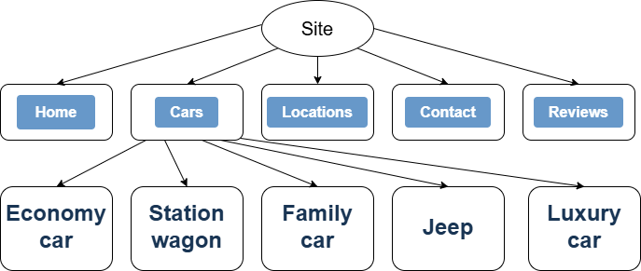

**3.2 Key Components**

**3.2.1 Navigation System**

* Consistent header across all pages
* Mobile-friendly menu

**3.2.2 Vehicle Display**

* Grid-based layout

## **4. Development Process**

### **4.1 Workflow**

1. **Planning Phase** (Sprint planning, wireframing)
2. **Implementation Phase** (HTML → CSS → Testing)
3. **Review Phase** (Code review, testing)
4. **Documentation Phase**

### **4.2 Milestones**

|  |  |
| --- | --- |
| **Phase** | **Deliverables** |
| 1 | HTML Structure |
| 2 | CSS Styling |
| 3 | Responsive Design |
| 4 | Documentation |

## **5. Team Structure**

### **5.1 Roles & Responsibilities**

|  |  |  |
| --- | --- | --- |
| **Member** | **Role** | **Key Tasks** |
| Teodor Spasov Todorov | Scrum Trainer | Agile management, task coordination |
| Selin Aydanova Vatansever | Designer | design, asset creation |
| Gabriela Mitkova Miteva | HTML Developer | Semantic markup, accessibility |
| Alexander Ivaylov Petrov | CSS Developer | Styling, responsive layouts |

### **5.2 Collaboration Tools**

* **GitHub**: Version control and issue tracking
* **Microsoft Teams**: Daily standups and communication
* **Figma**: Design collaboration (shared workspace)

## **6. Future Development**

### **6.1 Roadmap**

* JavaScript integration for dynamic features
* User account system
* Implementing online payment

### **6.2 Enhancement Opportunities**

1. Integration with mapping APIs for real-time availability
2. Vehicle comparison tool
3. Loyalty program system

### **7. References**

* W3C Web Standards
* MDN Web Docs
* Google Mobile-Friendly Test