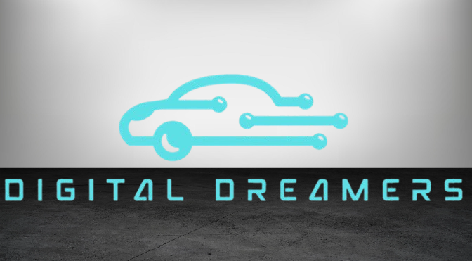

Table of Contents

1. Members 3

2. Purposes of our project 3

3. Realization steps 3

4. Used technologies 3

5. Block scheme 4

6. Conclusion 4

## Members

|  |  |  |
| --- | --- | --- |
| ***Team member*** | ***Grade*** | ***Role in the team*** |
| Borislav Andrikov | 8A | Scrum trainer |
| Tatiana Kovacheva | 8B | Front-end developer |
| Rostislav Ivanchev | 8G | Back-end developer |
| Maxim Iliev | 8V | Designer |

# Purposes of our project

# The goal of our car rental project is to provide an easy and affordable way for students and staff to access transportation. It helps with getting to school events, internships, or other important places. We also aim to teach responsibility through car booking and return, while learning how a real rental system works by combining technical and business skills.Realization steps

|  |  |
| --- | --- |
| 1. Idea | We came up with an idea and started working on it from the first week. |
| 2. Design | We created the design using Figma and Canva, then we started working on the project following the design that we made at the start |
| 3.The process | We communicated everyday and everytime someone had a problem the mentor helped. We used Microsoft Teams for communication and GitHub to commit changes of the code. We worked through the whole time. |
| 4. Presentation, Documentation | We created the documentation using Microsoft Word. For the presentation we used MS PowerPoint & Canva. |

## Used technologies

|  |  |
| --- | --- |
| 1. Languages | We used HTML and CSS |
| 2. Tools | We used MS PowerPoint, Canva, Microsoft Word and Visual Studio Code. |
| 3.Design Tools | For design we used Canva and Design.com |

## Block scheme

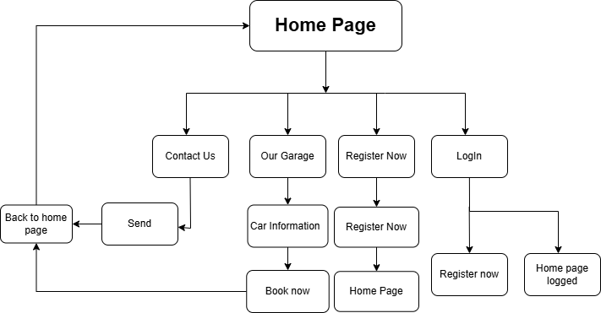

# 

# 5. Conclusion

We are happy with the progress we made during the one-month period we had. However, we know that our project has significant potential for further development. Moving forward, we aim to integrate databases to store results and track user progress efficiently. Additionally, we plan to expand the platform by incorporating more assignments and lessons. We also intend to implement a feature that allows users to select their grade level and access relevant lessons and assignments accordingly. These enhancements will improve the overall functionality and user experience of our project.