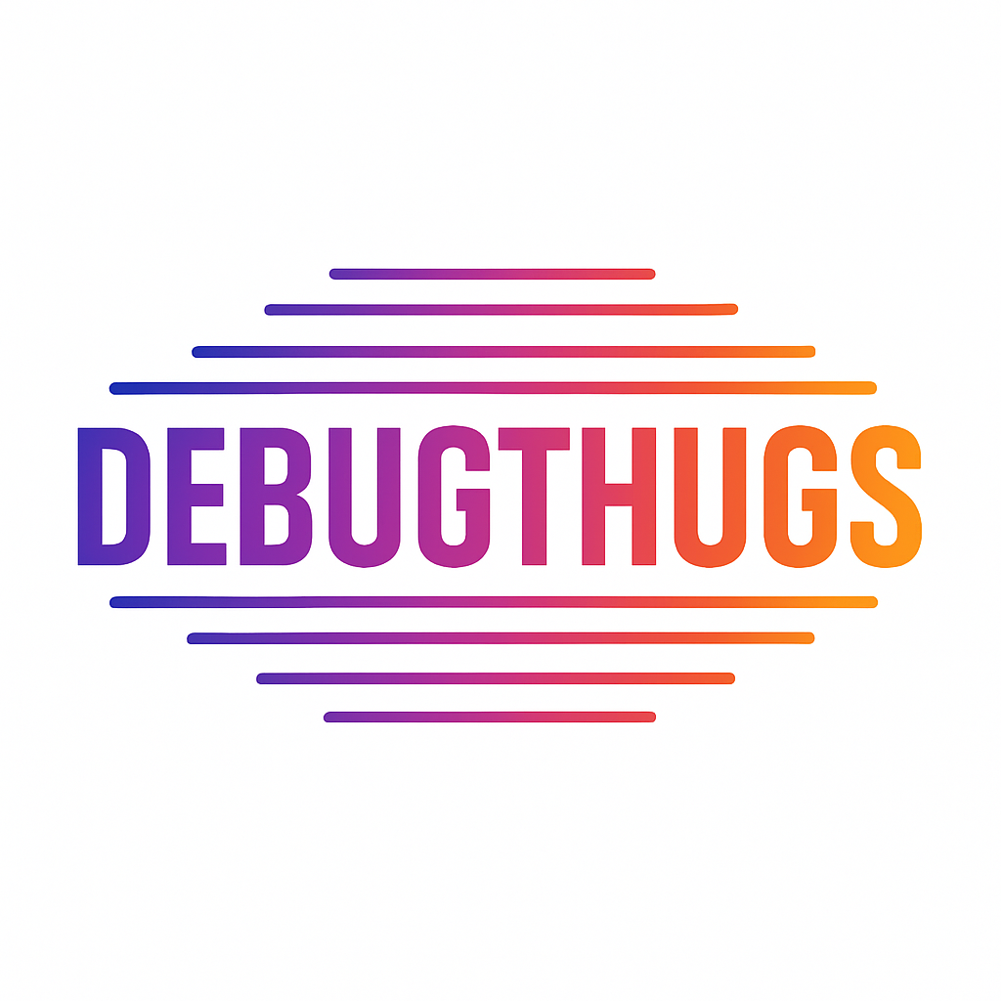

Debuhthugs

Contents

1. Members…………………………………………………………………………………………………………
2. Idea of the project…………………………………………………………………………………………….
3. Realization steps……………………………………………………………………………………………..
4. Used technologies……………………………………………………………………………………………
5. Project block-scheme……………………………………………………………………………………….

1. Members

|  |  |
| --- | --- |
| **Name** | **Role** |
| **Kaloyan Koev** | Front-end Developer |
| Teodor Despotov | Back-end Developer |
| **Lubomir Imelov** | Designer |

2. Idea of the project

The main target of our project is to make an easier way of notifying the authorities about accidents and fires around the area.

3.Stages of realization

1. Idea
2. GitHub Setup
3. Organization
4. Desing
5. Coding
6. Execution of presentation & documentation

4.Used tachnologies

1. Main language – HTML, CSS, JavaScript
2. IDE – Visual Studio Code
3. Documentation – Word, Power Point
4. Communication – Teams
5. Repo – GitHub, Git