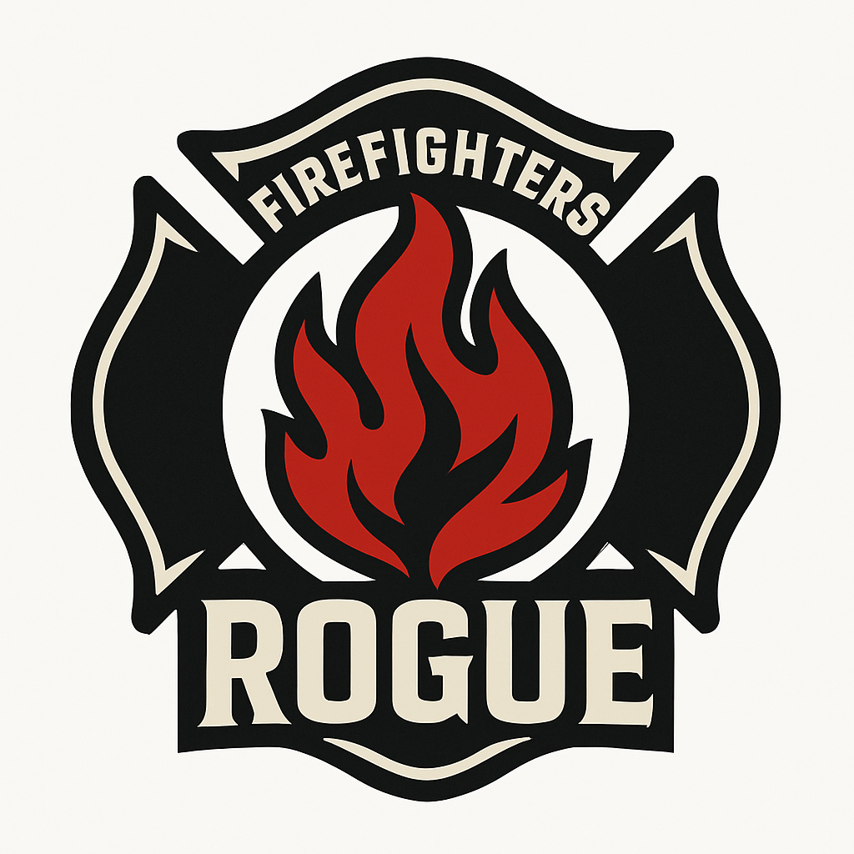Project Documentation

Table of contents

Contents

1. Our team 1

2. Resume 2

Goal: 2

Stages of Realization: 2

Workflow: 2

Used programs and languages: 3

3. Conclusion 3

# Our team

Dimitur Harizanov – Scrum Trainer

[DMHarisanov23@codingburgas.bg](mailto:DMHarisanov23@codingburgas.bg)

Alexandur Georgiev – FrontEnd Developer

[AVGerorgiev23@codingburgas.bg](mailto:AVGerorgiev23@codingburgas.bg)

Nikolai Yanuzov – BackEnd Developer

[NSYanuzov23@codingburgas.bg](mailto:NSYanuzov23@codingburgas.bg)

Anastas Apostolov – Designer

[AVApostolov23@codingburgas.bg](mailto:AVApostolov23@codingburgas.bg)

# Resume

## Goal:

Our team decided to make firefighter-based site that helps with finding available crews and contacting them for an easier time in any situation.

## Stages of Realization:

At first, we had to distribute the roles and then we started brainstorming ides. We decided to make a firefighter-based site that helps with finding and calling crews to you location. After that we started coding.

## Workflow:

We had to make the site. We decided to use some techniques in HTML, CSS and JS which we have used. Which helped us start developing the project. We split to three teams: one person organizes the team, two people develop the game and one person that made the design for the site. Everything ran smoothly.

## Used programs and languages:

HTML - We used it for developing the site

CSS – We used for the design

JS – We used for creating the map and other interactive features

Visual Studio 2022 – We used it for writing the code for the site

GitHub – We used it for storing, tracking, and collaborating on software projects.

# Conclusion

In the end, after lots of work, we finished the site. The work journey was enjoyable. We learned a lot about HTML, CSS, JS and teamwork.