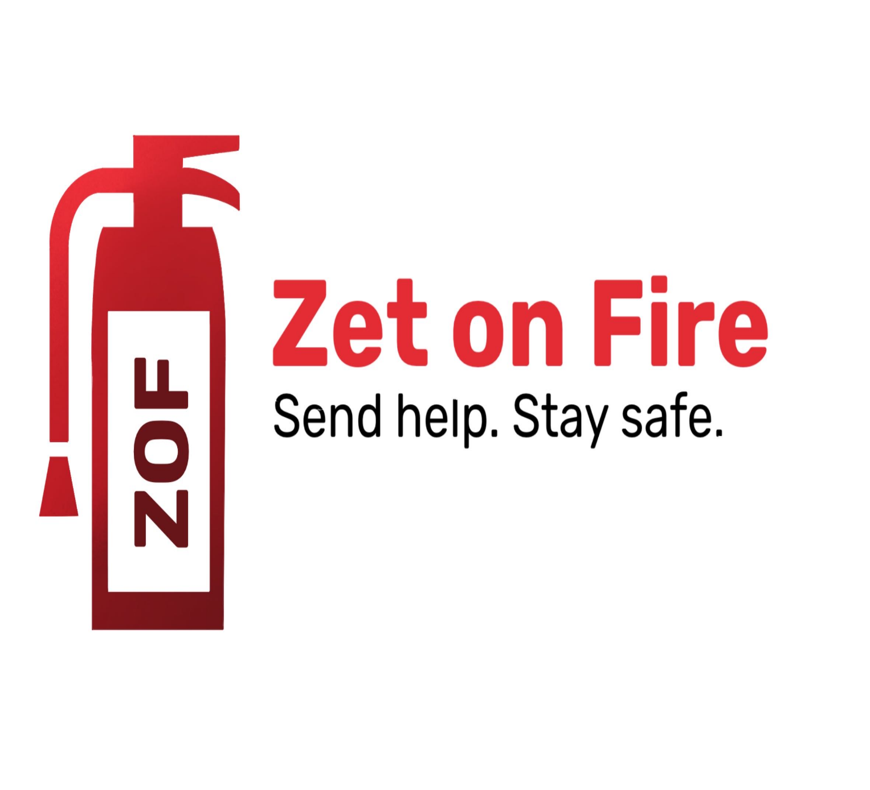

Table of Contents

1. Members 3

2. Purposes of our project 3

3. Realization steps 3

4. Used technologies 3

5. Block scheme 4

6. Conclusion 4

## Members

|  |  |  |
| --- | --- | --- |
| ***Team member*** | ***Grade*** | ***Role in the team*** |
| David Papazqn | 9A | Scrum trainer |
| Ivelin Metodiev | 9V | Front-end developer |
| Ivayla Keserdzhieva | 9G | Back-end developer |
| Ekaterina Zalinskaya | 9B | Designer |

# Purposes of our project

# We are Team Z(et on Fire), and our mission is to create a website where you can report fire incidents happening in your area. Our platform is designed to make filling out the form easy for everyone. Additionally, we provide access to our team information and charts.

## Realization steps

|  |  |
| --- | --- |
| 1. Idea | We came up with an idea and started working on it from the first week. |
| 2. Design | We created the design using Figma and ProCreate, then we started working on the project following the design that we made at the start |
| 3.The process | We communicated everyday and everytime someone had a problem the mentor helped. We used Microsoft Teams for communication and GitHub to commit changes of the code. We worked through the whole time. |
| 4. Presentation, Documentation & QA | We created the documentation using Microsoft Word. For the presentation we used MS PowerPoint and for the QA documentation we used MS Excel. |

## Used technologies

|  |  |
| --- | --- |
| 1. Languages | We used HTML, Javascript, CSS. |
| 2. Documents tools | We used MS PowerPoint, Microsoft Word and MS Excel. |
| 3.Design Tools | We used Figma for the design and ProCreate for our logo. |

## Block scheme

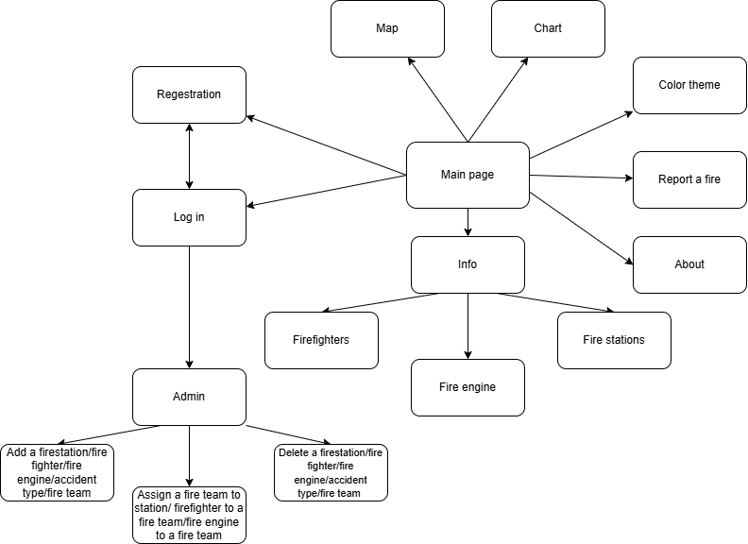

# Conclusion

We are happy with the progress we made during the one-month period we had. However, we know that our project has significant potential for further development. Moving forward, we plan to expand the platform by incorporating more functionalities. We also intend to implement a feature that allows users, apart from admins, to be able to report fires. These enhancements will improve the overall functionality and user experience of our project.