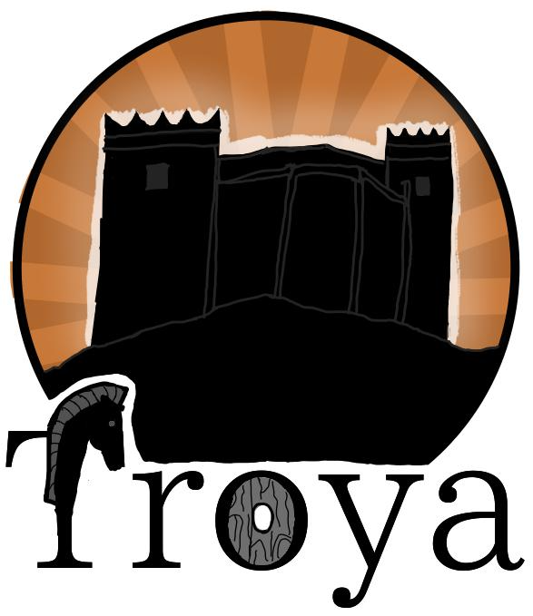TroyaOnFire

Created by:

Table of contents

Team 2

★ Objectives 3

★ Main stages in the development 3

★ TroyaOnFire block scheme 5

Functions 6

Conclusion 7

# Team

Scrum Trainer

Ulvie Mustafa Mustafa (9G)

The Scrum Trainer began contributing in the first week of the project by organizing the team and setting up a collaborative working environment. She also created and managed the project issues on GitHub and provided valuable guidance on design choices and time management strategies.

In the second week, her focus shifted to the frontend development of the site. She contributed directly by building key components, including the navigation bar, profile page, and home page.

During the final week, she worked on backend development, integrating a MongoDB database to store and manage essential data. This data was then utilized across various parts of the site, including the news, events, and profile pages.

She reflected on the experience, noting that although the work was challenging, it was ultimately a rewarding and worthwhile endeavor.

Backend Developer

Sheniz Idris Ali (9B)

The Backend Developer began contributing from the first week of the project by setting up a local server environment. She installed necessary Node.js modules and developed JavaScript functionality for key components such as the navbar, profile page, login, and registration pages.

In the second week, she focused on implementing backend functionality, enabling data storage and retrieval through a MongoDB database. This functionality was successfully executed and tested on the local server.

As someone new to working with databases, she shared that learning to use MongoDB and Mongoose was both fun and intellectually rewarding.

Frontend Developer

Martin Nikolaev Dimarov (9V)

The Frontend Developer was responsible for building the site's user interface using HTML, CSS, and JavaScript. In the first week, he focused on developing the home page and implemented a dark and light mode feature, which was integrated across nearly all pages of the site.

In the second week, he dedicated his efforts to building the Organization page, the Fire Reports page, and refining the home page. His work on these components resulted in a visually appealing and functional interface.

Throughout the project, he demonstrated strong dedication, hard work, and patience, contributing significantly to the overall quality and usability of the site.

Designer

Georgi Licanovski (9A)

During the first week, the Designer dedicated significant effort to crafting the visual design of the site using Figma, bringing his creative vision to life and providing a clear design direction for the team.

In the second week, he contributed to the frontend development by working on the Organization and FAQ pages, delivering a well-executed and visually cohesive interface.

In the final week, he shifted his focus to preparing the project presentation and documentation — including the very report you’re reading now — ensuring the team’s work was clearly communicated and professionally presented.

Summary

## **Objectives**

* Create an engaging educational game with four levels that combine math and language challenges.
* Enhance players’ problem-solving and critical thinking skills.
* Provide a fun and interactive learning experience through diverse gameplay mechanics.

## **Main stages in the development**

1. **Exploration**

In the initial phase, our team gathered regularly to brainstorm and explore various ideas and solutions applicable to the project’s design and purpose.

1. **Design**

The design was created by our designer, Georgi Licanovski, who demonstrated exceptional creativity and dedication throughout the process. He completed the full design in the first week, which gave the team valuable time to implement the visuals into functional HTML, CSS, and JavaScript components during the following weeks.

1. **Development**

Step by step, week by week, and task by task, our site gradually came to life. The development process was a result of a collaborative, focused effort from every team member. Despite facing various challenges along the way, we consistently found effective solutions, ensuring continuous progress. Everyone on the team contributed fully, bringing dedication, creativity, and hard work to every part of the project.

* **Implementation**

**Software for programming our project is** [**Visual Stu**](https://visualstudio.microsoft.com/)**dio Code**

**Our collaboration tools are** [**GitHub**](https://github.com/) **and** [**Git**](https://git-scm.com/)**.**



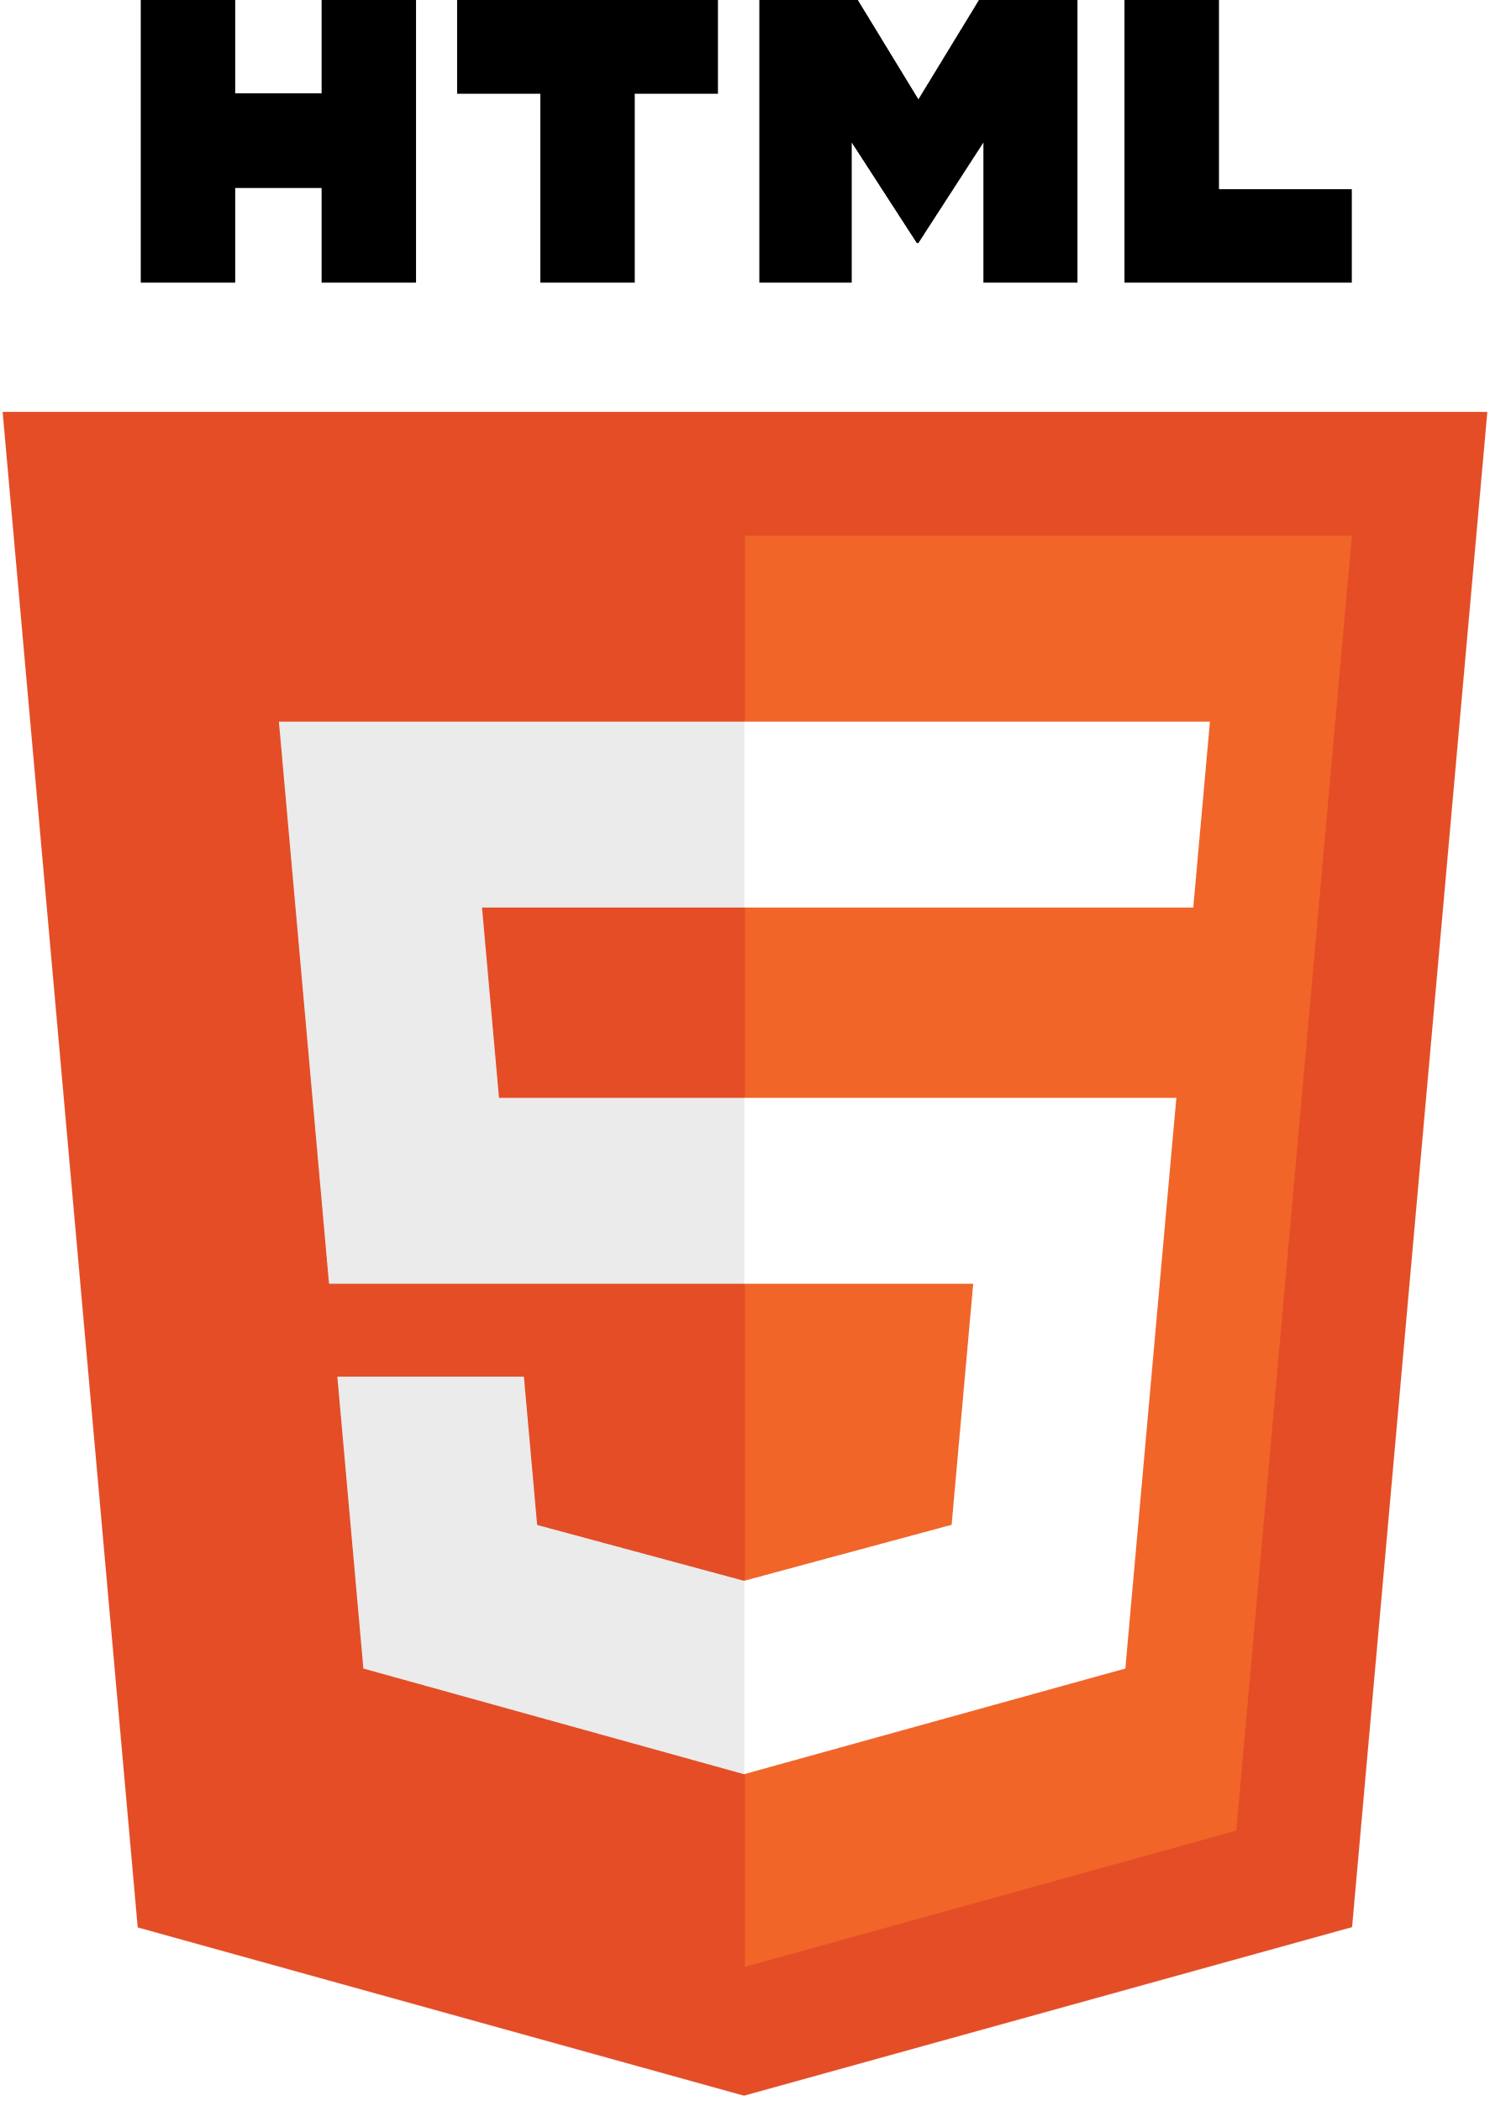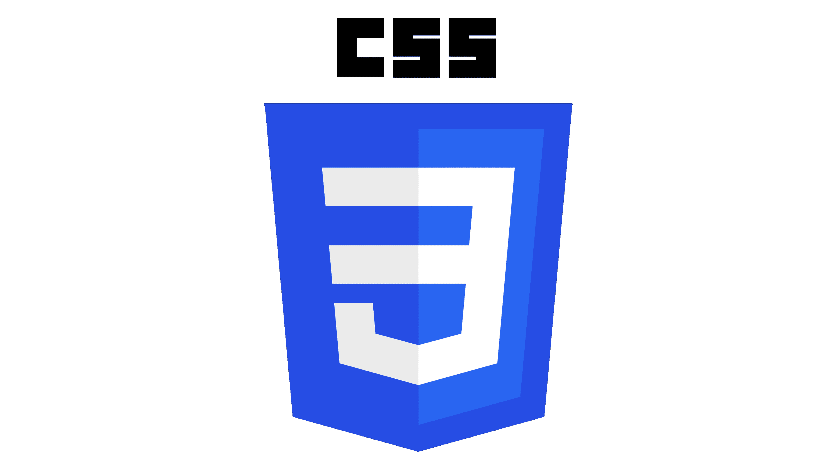**The programming languages we have programmed in is JavaScript, HTML, and CSS**

**Software used for the presentation of the project is** [**Microsoft Word**](https://www.microsoft.com/en-us/microsoft-365/word) **and** [**Microsoft PowerPoint**](https://www.microsoft.com/en-us/microsoft-365/powerpoint)



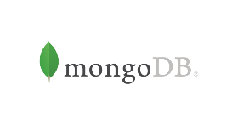**For storing the data, we used** **MongoDB**

**For visualization and design, we used** [**Figma**](https://www.figma.com/)



# **TroyaOnFire block scheme**

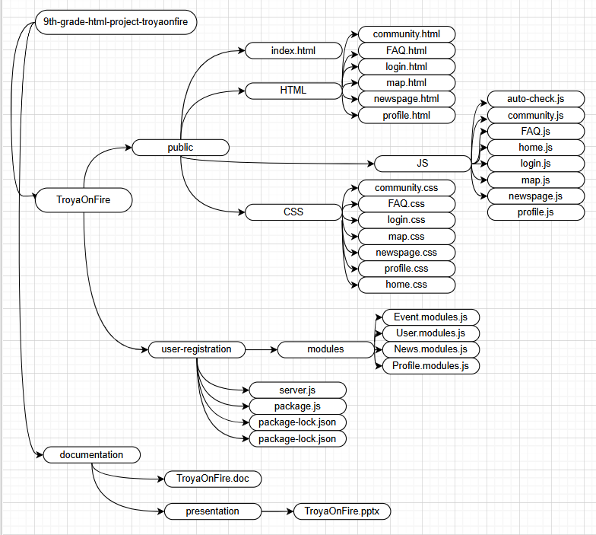

|  |  |
| --- | --- |
| Functions | |
| Types | Name |
| function | checkAuthStatus() |
| function | getCurrentUser() |
| function | logout() |
| function | filterCards() |
| function | updateStats() |
| function | checkExistingLogin() |
| function | clearLoginData() |
| function | setLoginWithExpiry() |
| function | openModal() |
| function | closeModal() |
| const | fireIcons() |
| const | initializeMap() |
| const | setupMap() |
| const | initializeClearLocationButton() |
| const | initializeMapSearch() |
| const | searchLocation() |
| const | saveFireReport() |
| const | deleteFireReport() |
| const | removeFireMarker() |
| const | removeFromIncidentsList() |
| const | clearAllReports() |
| const | exportReportToJSON() |
| const | addExportButton() |
| function | loadPosts() |
| const | initializeThemeToggle() |
| const | initializeSidebarToggle() |
| const | initializeSearch() |

# 

A possible solution could be implementing better career orientation programs in middle school, where students can explore different fields through internships, job shadowing, and hands-on projects. Schools could also offer more flexible curriculums that allow students to switch their focus if they realize their initial choice wasn't the right fit.

Here comes our app which is going to be applied as an extra classes after 12th grade. The person is going to choose which major they want to study and they will have the lessons, homeworks and their scores saved in achievement, they just need to create their own profile and they're ready to go!