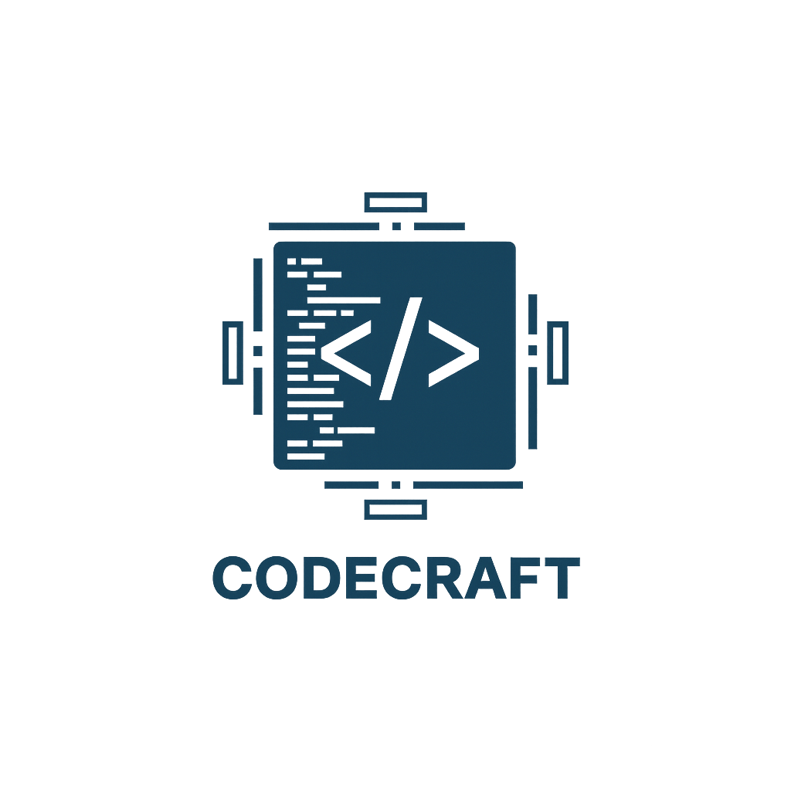
CodeCraft

Contents
1.About us 2
2.Idea of the project 2
3.Stages of working 2
4.Used technologies 2
5. Block diagram 3
6. Functions 4

1.About us
Name | Role | Grade
Ivaylo Georgiev | Scrum trainer | 9B
Toma Ivanov | Front-End Developer | 9A
Dimitar Bornusuzov | Back-End Developer | 9G
Ioan-Aleksandur Georgiev | Back-End Developer | 9A

2.Idea of the project
“Spendora” is a modern expense tracking application designed to help users manage their finances in a simple and efficient way. The application uses Dear ImGui for its user interface, providing a clean, fast, and responsive experience.
The app includes a budget system where users can set monthly spending limits, track expenses through a progress bar, and receive warnings when they are close to exceeding their budget. It also features advanced filtering options by category and amount range, making expense management easier and more organized.
Additionally, Spendora provides useful statistics such as average, highest, and lowest expenses, helping users better understand their spending habits.

3.Stages of working
№ | Stages
First Week | We created the idea and the working environment.
Second Week | We created the Main Menu, Login/Register and also the menus of the app.
Third Week | In the third week we made the presentation and documentation and now the project is ready to be presented.

4.Used technologies
- C++ - for creating the app.
- Github – for the synchronization.
- Dear ImGui – for the User Interface.
- MS PowerPoint – for creating presentation.
- MS Word – for creating documentation.
- MS Teams – for communication in the team.
- 5. Visual Studio 2022 – for writing the code.

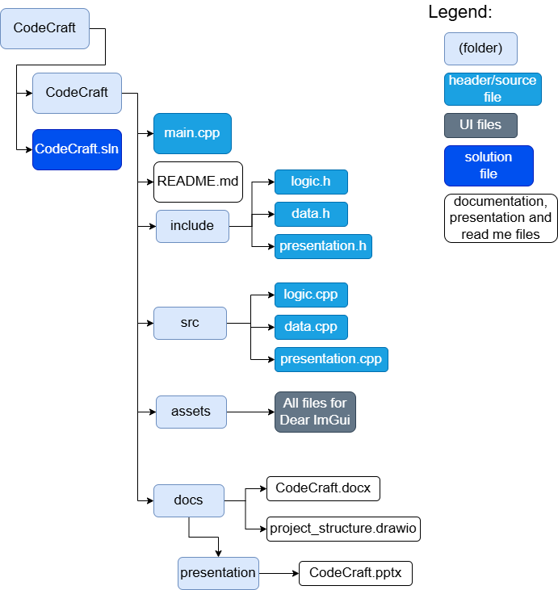
5. Block diagram

6. Functions
Type | Name
void | mainMenu()
void | renderApp()
void | renderLoginScreen()
void | renderRegisterScreen()
void | renderDashboard()
void | renderHeader()
void | renderExpenseTable()
void | renderFormPanel()
void | renderSearchPanel()
void | renderStatsPanel()
void | renderBudgetPanel()
void | renderSettingsWindow()
void | renderNotifCenter()
void | renderStatusBar()
void | renderDeleteModal()
void | addNotification()
void | checkBudgetNotifications()
void | refreshExpenses()
bool | registerUser()
bool | loginUser()
bool | usernameExists()
bool | changePassword()
void | bubbleSortByAmount()
void | quickSortByDate()
void | bubbleSortByCategory()
int | binarySearch()
double | recursiveTotal()
double | recursiveMonthlyTotal()
int | recursiveCountByCategory()
bool | addExpense()
bool | editExpense()
bool | removeExpense()
bool | toggleCompleted()
double | totalExpenses()
double | avgExpense()
double | maxExpense()
double | minExpense()
void | categoryTotals()
bool | setBudget()
double | getBudget()
double | getBudgetUsed()
bool | isValidDate()
bool | isValidAmount()
bool | isValidUsername()
bool | isValidPassword()
bool | isValidEmail()
int | loadExpenses()
bool | saveExpenses()
bool | appendExpense()
bool | updateExpense()
bool | deleteExpense()
int | nextExpenseId()
int | loadUsers()
bool | saveUsers()
int | loadBudgets()
bool | saveBudgets()

