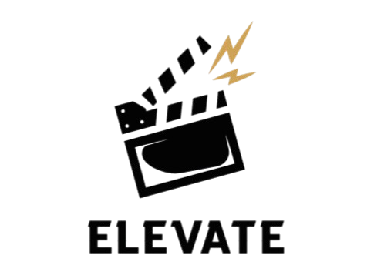
Elevate

Contents
1.About us 2
2.Idea of the project 2
3.Stages of working 2
4.Used technologies 2
5. Block diagram 3

1.About us
Name | Role | Grade
Dimana Foteva | Scrum trainer | 9g
Mariela Apostolova | Back-End Developer | 9b
Todor Neshev | Designer | 9b
Vilian Ivanov | Front-End Developer | 9g

2.Idea of the project
Evalua is a lightweight utility that takes your chaotic movie list and sorts it exactly how you want it. Whether you're looking for the highest-rated sci-fi films of the 90s or just trying to organize your local media files, this tool handles the heavy lifting so you can spend less time scrolling and more time watching.

3.Stages of working
№ | Stages
First Week | We created the working environment.
Second Week | We created the Main Menu, Login/Register and also the menus of the app.
Third Week | In the third week we made the presentation and documentation and now the project is ready to be presented.

4.Used technologies
- C++ - for creating the app.
- Github – for the synchronization.
- QT – for the User Interface.
- MS PowerPoint – for creating presentation.
- MS Word – for creating documentation.
- MS Teams – for communication in the team.
- Visual Studio 2022 – for writing the code.

5. Block diagram
