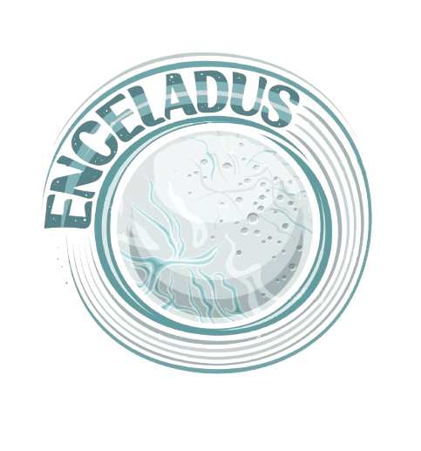

Enceladus

**DOCUMENTATION**

Contents

1. Project idea 2

2. Preformed Tasks 2

3. Team Members 2

4. Used Technologies 2

5. Block Scheme 3

6. Summary 3

# Project idea

We created an eSchool that provides useful information about Math, English, Biology and Science. You have six lessons for each of the subjects and test for them. You can learn better and test yourself after that.

# Preformed Tasks

Our application currently meets all requirements.

# Team Members

|  |  |  |
| --- | --- | --- |
| Name | Role | Class |
| Daniil Moldovanov | Scrum Trainer | 9V |
| Hristiyan Grozdev | Frontend Developer | 9B |
| Grigori Nedyalkov | Backend Developer | 9V |
| Dimitar Dimitrov | Designer | 9B |

# Used Technologies

* Visual Studio 2022
* GitHub
* MS Word
* MS Teams
* MS PowerPoint
* Git
* Raylib

# Block Scheme

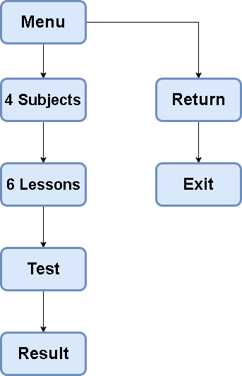

# Summary

|  |  |
| --- | --- |
| Goals | The aim of our project is to create application about interesting learning of school subjects. |
| What is our Application | The essence of this project was to create a C++ application in witch you can study school subjects in funny and interesting way. |
| Realization | We used:  Visual Studio 2022 and C++ - for the application.  Teams – for the communication.  Word and PowerPoint – for documentation. |