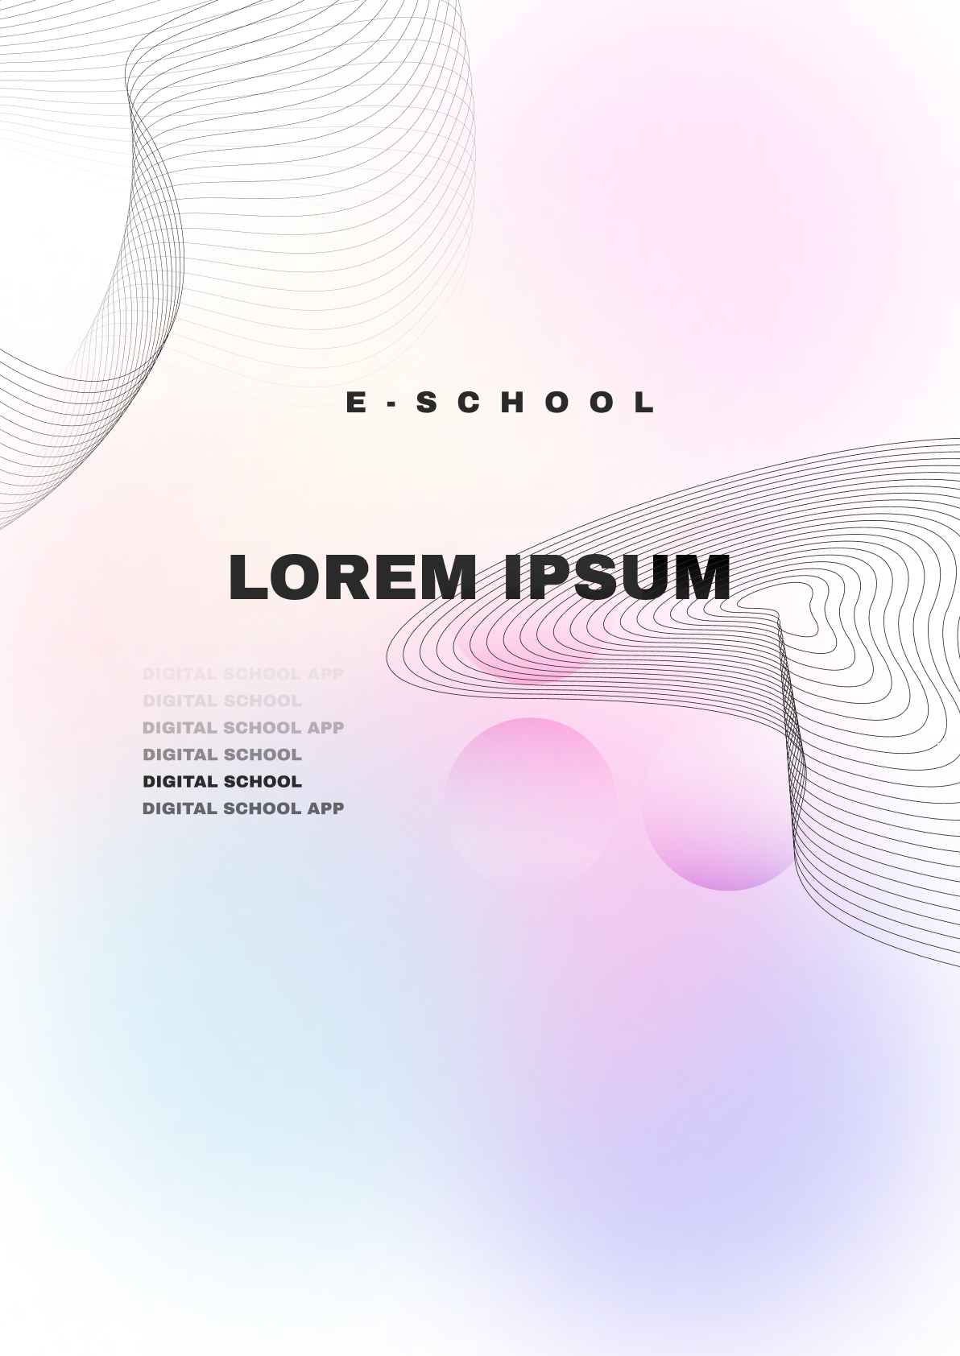

Table of Contents

Team 2

Summary 3

Objectives 3

Main stages in the development 3

Stages of the scrum methodology 4

Implementation 5

Block scheme of Lorem Ipsum 6

Conclusion 7

# Team

# **Scrum Trainer**

Iva Dianova Raykova – 9g

**Developers**

Ivan Yankov Stoychev – 10b

Maria Veselinova Koleva – 10v

Ivan Svetoslavov Delchilov – 10b

Dimitar Petrov Dimitrakov – 9a

**QA**

Natali Ivo Ribareva – 9v

# Summary

## **Objectives**

The objective of Lorem-Ipsum is to provide an E-Learning platform where users can establish organizations and teachers can publish lessons online for their students. Students can complete assignments after each lesson, and their performance is evaluated by our software, which also grades tests. Each course has a minimum passing percentage set by the teacher. Students have the flexibility to enroll in multiple courses and track their progress through their dashboard

## **Main stages in the development**

1. Reflection on the topic

In the first week, the team consistently gathered to exchange ideas and potential design solutions.

1. Design

Maria Koleva was responsible for the artistic design, and when creating a new window, everyone's ideas were considered, and the suggestions were added to the Figma program.

1. Development

The project progressed steadily, with each team member receiving tasks weekly, and all members working on them regularly. Whenever an issue occurred, teammates were consulted for assistance. Our teamwork was strong, enabling us to refine our idea multiple times for improved outcomes.

1. Introducing

For Lorem ipsum’s presentation, the team decided to divide our slides so that each member could discuss their part. The Scrum Trainer will mainly lead the presentation as it's part of his role to introduce the team and its concept.

## **Stages of the scrum methodology**

1. Analysis over the assignment and topic

As the team's Scrum Trainer, the first step was to download the project instructions and carefully read through the requirements. This helped to understand the task better and plan out our approach accordingly.

1. First team meeting

At our very first meeting, the whole team, gathered to talk about what we needed to do for the project and figure out what each of us is good at. We also brainstormed ideas for our team name to capture our shared vision.

1. Emergence of an idea

Coming up with ideas is mostly the Scrum Trainer's job. They listen to what everyone thinks, pick the best ideas, and show them to everyone for feedback. Then, we all work together to make the ideas even better, ensuring they match our goals.

1. Task assignment

The Scrum Trainer carefully assigns tasks to everyone based on their strengths and the time we have. Everyone, including the Scrum Trainer, gets a fair share of work, fostering a sense of teamwork and collaboration.

1. Communication between the team

We communicate as a team, led by the Scrum Trainer. We regularly check in on each other's progress to make sure we're all moving forward together. If anyone has questions or faces challenges, we support each other to find solutions.

1. Presentation of the project

The presentation of our work is essential. The Scrum Trainer takes the lead, explaining our concept to a group and audience for assessment. Each team member contributes by presenting their respective parts during the presentation.

## **Implementation**

Software for programming our project are:

[Visual Studio 2022](https://visualstudio.microsoft.com/), [Visual Studio Code](https://code.visualstudio.com/) 2022 and Rider



For the creation of our design the main programs is :

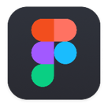[Figma](https://www.figma.com/)

Our collaboration and communication tools are :

[GitHub](https://github.com/), [Git](https://git-scm.com/) and Teams.

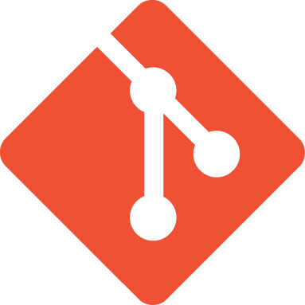

Programming languages we have programmed in are :

C++ and Python

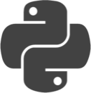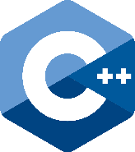

The technologies, libraries and instruments used in our project are:

[Raylib](https://www.raylib.com/), Microsoft Azure, Pistache, Entt, Postman, JSON Web Token, Docker, React, pgAdmin, Argon2, Tailwind CSS

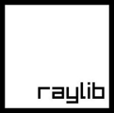

Software used for the documentation of the project are :



[Microsoft Word](https://www.microsoft.com/en-us/microsoft-365/word), [Microsoft PowerPoint](https://www.microsoft.com/en-us/microsoft-365/powerpoint) and Microsoft Excel

## **Block scheme of Lorem Ipsum**

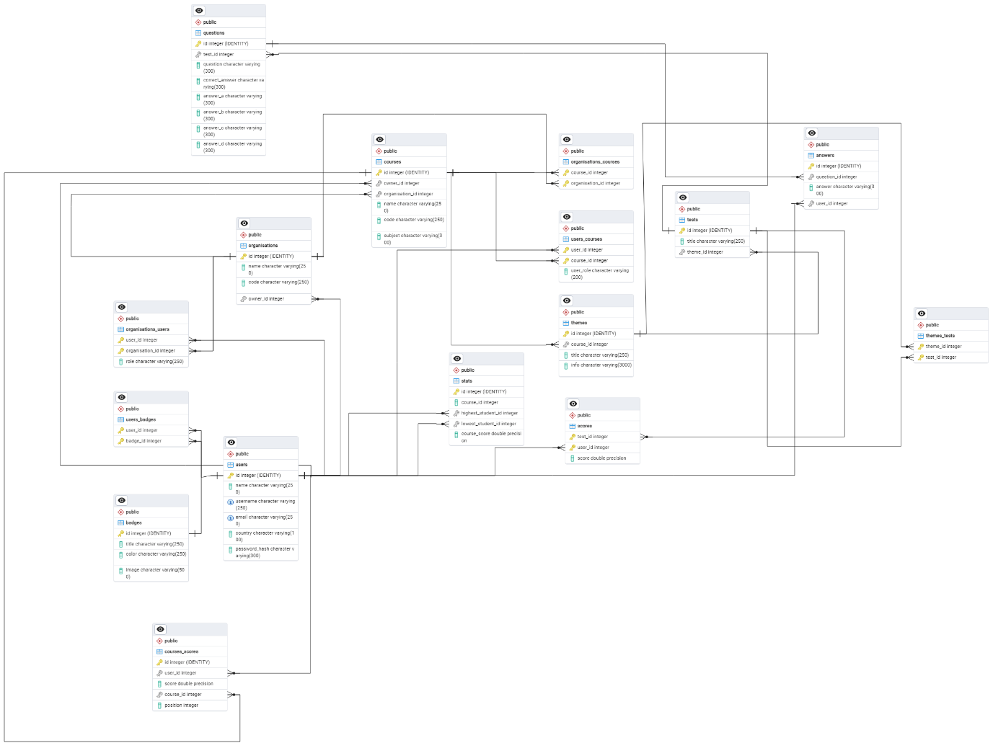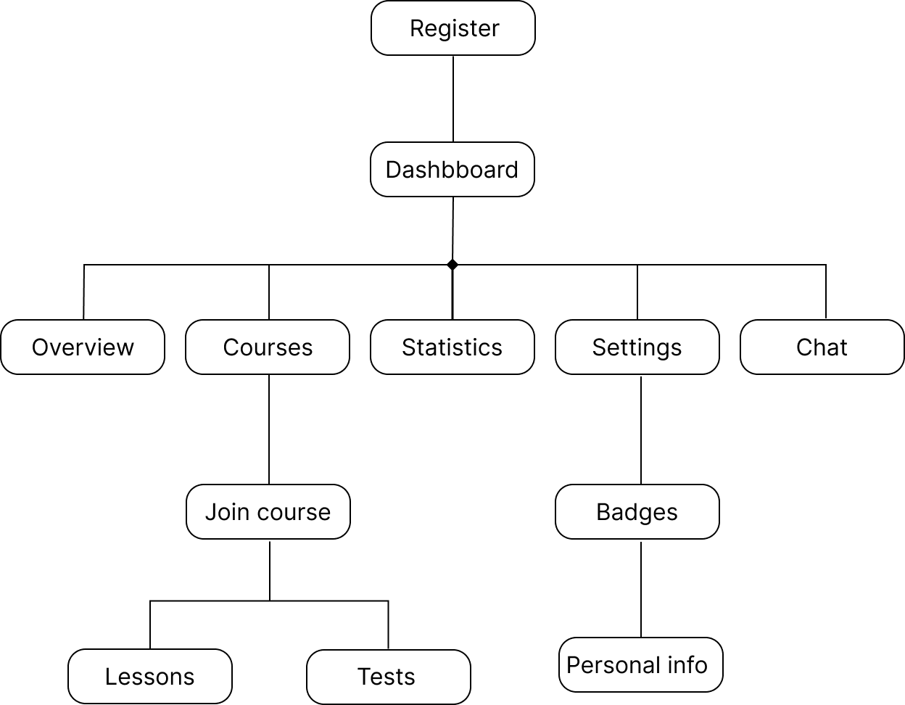

# Conclusion

Lorem-Ipsum serves as an E-Learning hub enabling users to establish organizations and teachers to share lessons online. Our platform facilitates student learning through assignments and graded tests, managed by our software. With minimum passing percentages set by teachers, students can enroll in multiple courses and track their progress conveniently via their dashboard.