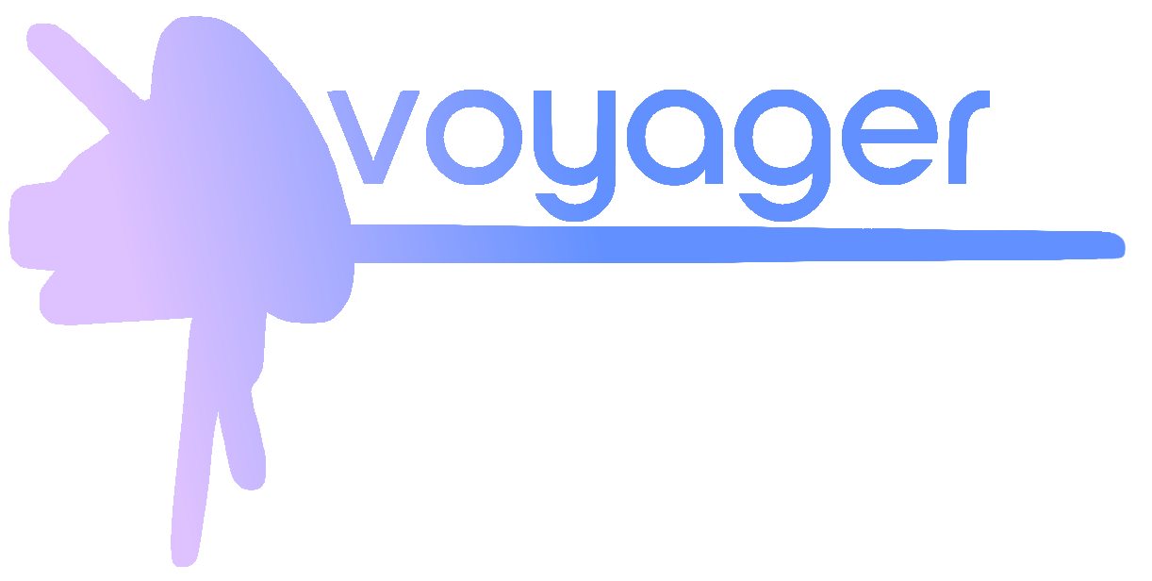

Contents

1. Our team 2

2. Resume 2

Goal: 2

Stages of Realization: 2

Workflow: 2

Used programs and language: 3

3. Conclusion 3

**PROJECT DOCUMENTATION**

# Our team

Tsvetan Zhekov - Scrum trainer

[TPZhekov22@codingburgas.bg](mailto:TPZhekov22@codingburgas.bg)

Nikolai Zhelev - Developer

[NDZhelev22@codingburgas.bg](mailto: NDZhelev22@codingburgas.bg)

Yuan Tomov - Developer

[YVTomov22@codingburgas.bg](mailto: YVTomov22@codingburgas.bg)

Kaloyan Iliev - Developer

[KDIliev22@codingburgas.bg](mailto:KDIliev22@codingburgas.bg)

# Resume

## Goal:

Our team decided to make an educational game about astronomy. For this project we decided to use C++ as a programming language and the raylib programming library.

## Stages of Realization:

At first, we had to distribute the roles and then we started brainstorming ideas, we decided to make an educational game about astronomy using the raylib programming library on C++. We had to come up with a game design. After that we started to work on our project.

## Workflow:

We had to come up with a game design. We decided to use the raylib programming library which we have never used. Because of that we had to learn how to use raylib and its functions. It was hard, but we managed. We began to coding basic game design: main menu, buttons and a starting screen. After that we realized we didn’t have sprites for the game so we split up: two people code and two people draw. After that things ran smoothly.

## Used programs and language:

C++

C++ is a high-level, general-purpose programming language. First released in 1985 as an extension of the C programming language, C++ has object-oriented, generic, and functional features, in addition to facilities for low-level memory manipulation.

Visual Studio 2022

Visual Studio is an integrated development environment developed by Microsoft. It is used to develop computer programs including websites, web apps, web services and mobile apps. Visual Studio uses Microsoft software development platforms such as Windows API, Windows Forms, Windows Presentation Foundation (WPF), Windows Store and Microsoft Silverlight. It can produce both native code and managed code.

Word

Microsoft Word or MS Word is a graphical word processing program that users can type with. It is made by the computer company Microsoft. Its purpose is to allow users to type and save documents. We used Word to create this documentation.

Power Point

PowerPoint is a complete presentation graphics package. It gives you everything you need to produce a professional-looking presentation. This was the place where we did our presentation.

# Conclusion

In the end, after lots of late hours work, we finished the game. The work journey was quite enjoyable, yet under pressure, and we learned a lot about programming, teamwork, time and repository management.