Pedromerter

Elena Keserdzhieva & Stela Ivanova

Content

Introduction 1

UML diagrams 1

Hardware part 2

Software part 3

Functionality 4

# Introduction

Pedometer is a system for tracking a person's daily steps, meters and calories burned. Through the website, the person can track statistics for previous days and also find out how many of how many steps he has walked. Every 1000 steps the person gets an achievement.

# UML diagrams

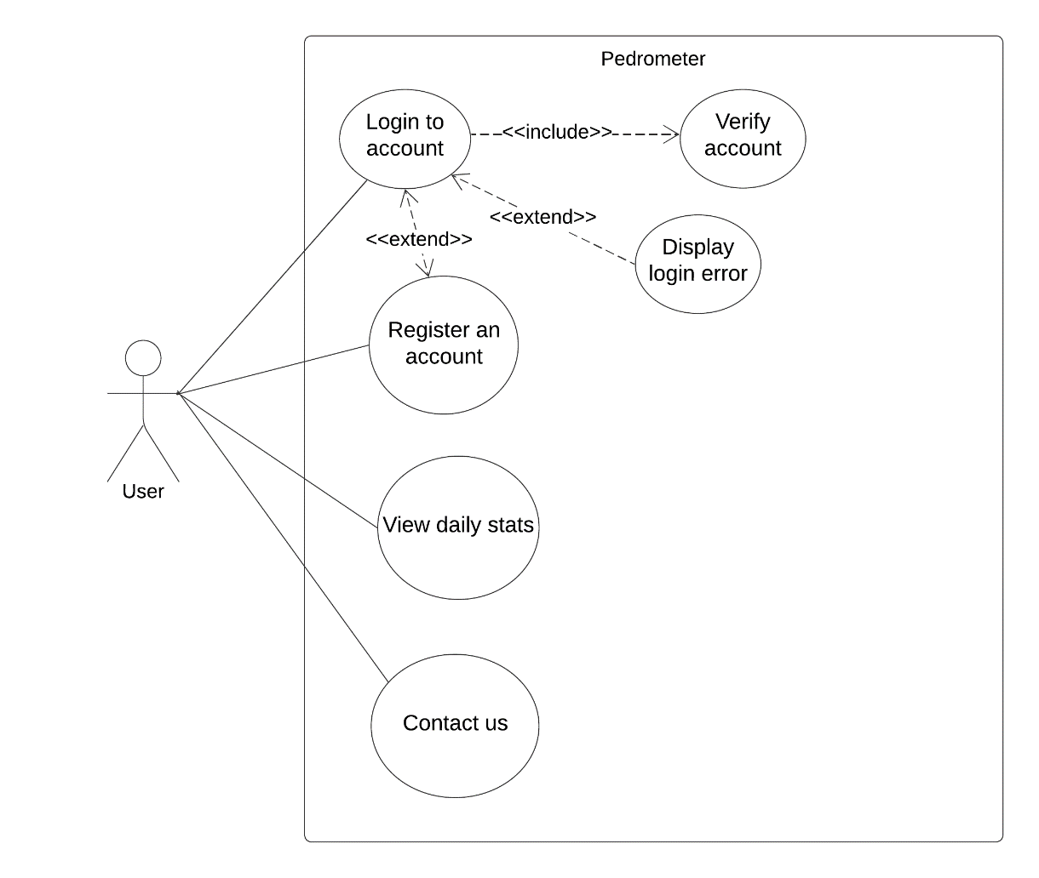Use case diagram

Sequence diagram

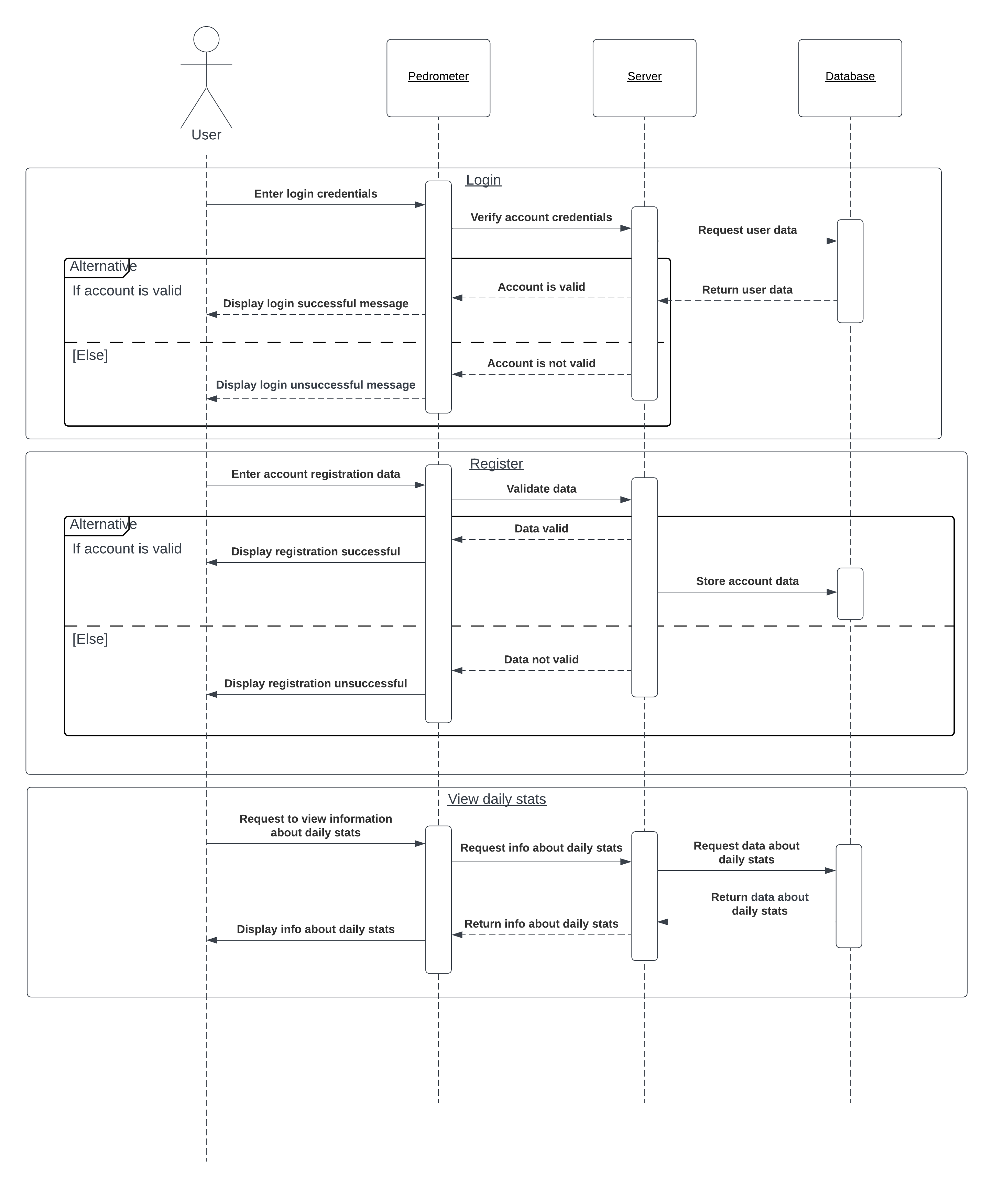

Entity-relationship diagram

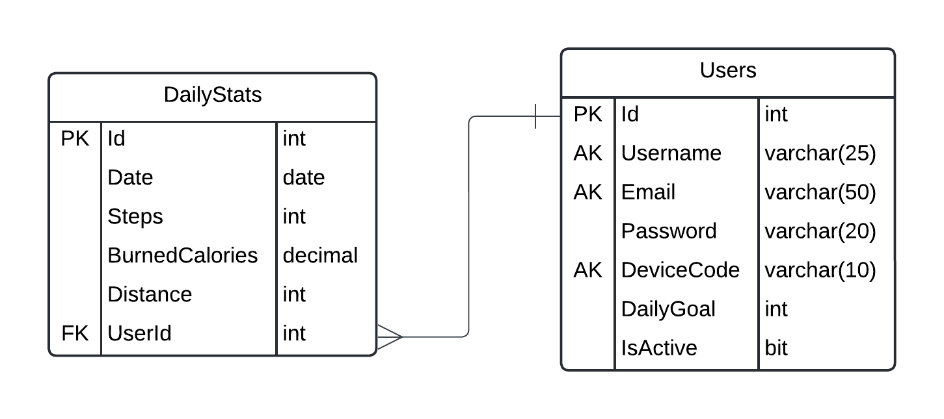

# Hardware part

1. Components

ESP32-WROOM-32D

ESP32-WROOM-32 microcontroller connected to the ADXL 335 sensor and transmitting the data from it to the I2C OLED display and the database.

Characteristics:

* Wi-Fi and Bluetooth supportа
* Low power consumption

ADXL 335 Accelerometer

The ADXL 335 sensor detects changes in position, and counts steps, distance and calories burned from the change.

Characteristics:

* It measures the distance traveled
* Counts steps

I2C OLED дисплей

The I2C OLED display shows basic information collected by the ADXL 335 sensors.

Characteristics:

* High resolution
* Low power consumption

1. Diagram

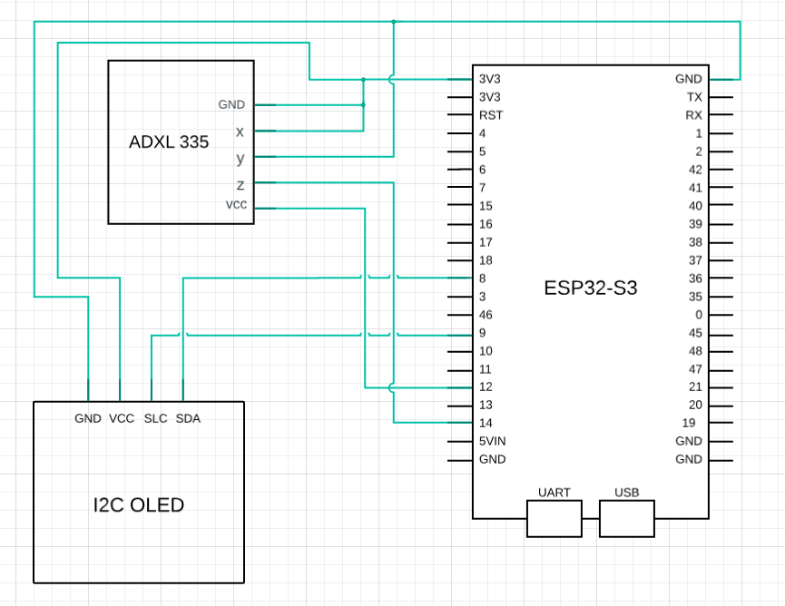

# Software part

Firmware for ESP32-WROOM-32D

The ESP32-WROOM-32D firmware collects data from ADXL 335 sensors and updates the information every second. The data is sent to the OLED display and to the database.

Functionalities:

* Collection of ADXL 335 data
* Renewal of the OLED display
* Transfer data to the database

Java website

The website is developed in Java and uses a three-tier architecture. It contains the following things:

* Login и register
* Home page
* Profil
* Statistics for previous days

# Functionality

Login и register

Users can register and log in to view their statistics from previous days. The day's input is stored in a database and displayed on the page after 00:00.

Home page

The home page provides general information and navigation to the other functionalities of the website.

Statistics

The statistics along with the profile are displayed on the Home page as soon as the person logs into their profile. With arrows, he can see the distance traveled, the steps taken and the calories burned for the previous days.

Additional functionalities

Footer: Users can send us a message if they have questions or criticisms of the site.

Achievements: Every 1000 steps the user receives a different achievement for the day.