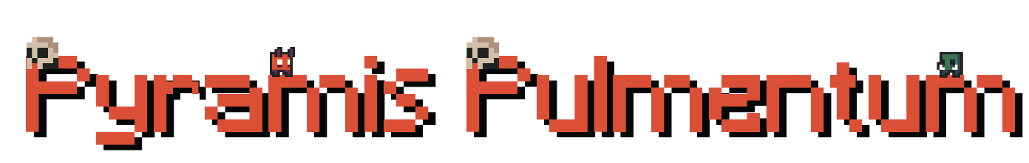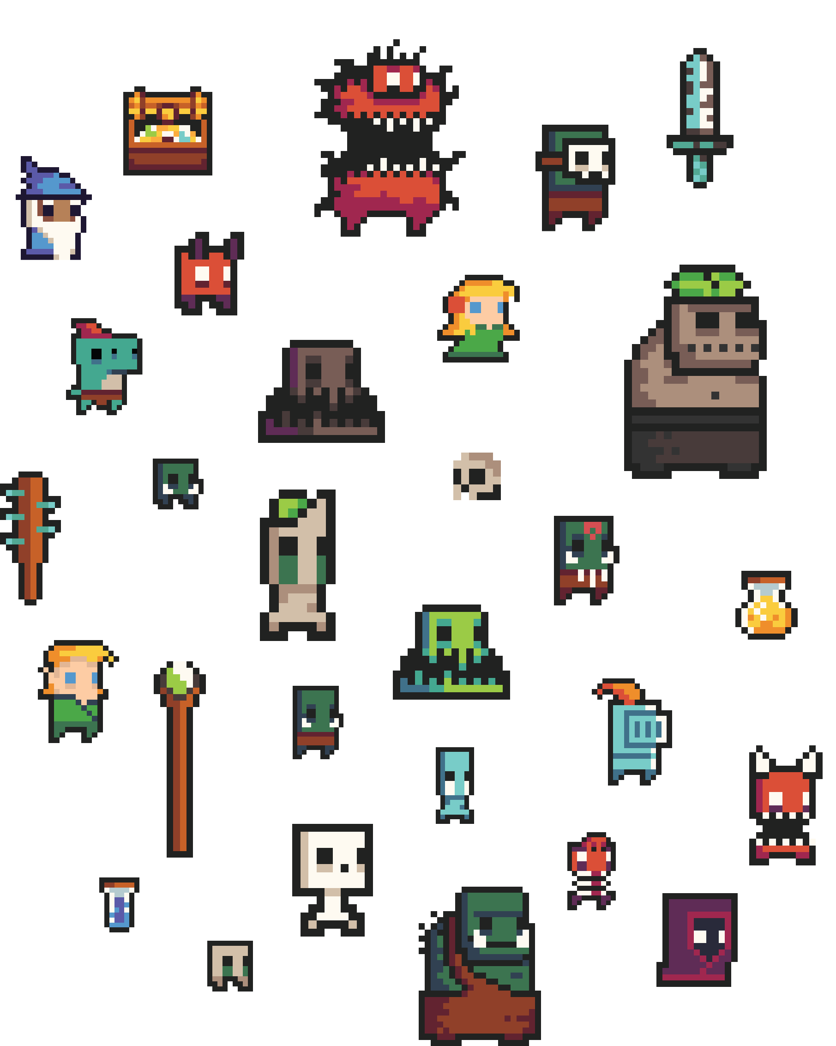

Documentation

Contents

1. INFORMATION ABOUT OUR TEAM 2

2. RESUME 2

3. MAIN GOAL 2

4. TASKS 2

5. USED TECHNOLOGIES 3

6. TEAM LOGO 3



|  |  |  |
| --- | --- | --- |
| **Name** | **Class** | **Roles** |
| **Maria Ilcheva** | 10 **V** | **Scrum Trainer** |
| **Vanina Teneva** | 10 **G** | **Scrum Trainer** |
| **Simeon Redanski** | 9 **A** | **Back-End Developer** |
| **Svetoslav Stoilov** | 9 **B** | Designer |
| **Atanas Atanasov** | 8 **B** | Front-End Developer |
| **Daniel Buzin** | 8 **G** | Front-End Developer |
| **Iva Nedkova** | 8 **B** | Front-End Developer |

# INFORMATION ABOUT OUR TEAM

# RESUME

Lorem Ipsum is simply dummy text of the printing and typesetting industry. Lorem Ipsum has been the industry's standard dummy text ever since the 1500s, when an unknown printer took a galley of type and scrambled it to make a type specimen book. It has survived not only five centuries, but also the.

# MAIN GOAL

Our goal is to create a game that features adventure.

# TASKS

* We collected information about the task.
* 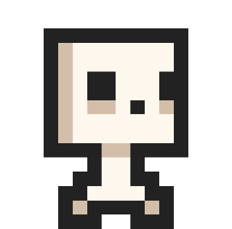We assigned roles.
* We made a logo.
* We made a README file, added “about” on GitHub.
* We wrote the Front-End.
* We wrote the Back-End.
* We made a design for the presentation and documentation.
* We made presentation and documentation.

# USED TECHNOLOGIES

* + **Discord** and **GitHub** - for communication and team synchronization.
  + **Unity** - for making the game.
  + **PowerPoint** - for the making of the presentation.
  + **Word** - for the making of the documentation.
  + **C# -** for the making of our game
  + **HTML –** for the making of our website
  + **CSS –** for the designing of our website
  + **JS –** for the functionality of our website

# TEAM LOGO

