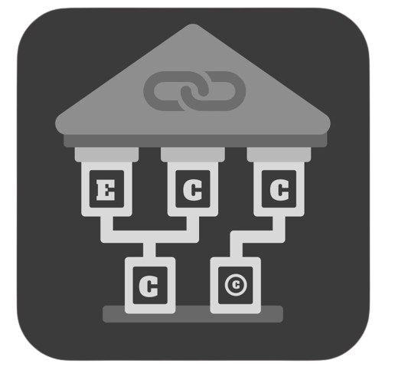

**East Coast Coding Crew**

**Table of Contents**

**Team** 3

**Summary** 3

**1.** **Objectives** 3

**2.** **Stages of development** 3

**3.** **Stages in the scrum process** 4

**4.** **Implementation** 5

**Conclusion** 6

# **Team**

**Front-end/QA** – Boris Milev 10A

**Designer/Scrum Trainer** – Plamen Petkov 10A

**Back-end** – Aleksandar Kolev 10G

**Front-end** – Oleksandr Vinichenko 10G

# **Summary**

## **Objectives**

The goal of our historical event manager is to provide users effective tool for recording, managing, and analyzing historical events using linked lists.

## **Stages of development**

1. **The Topic** - In the first week, our team gathered to exchange ideas for what library we should use and discuss solutions for the design.
2. **Design –** As a designer and Scrum trainer, I created a logo for our application that clearly represents what our team does.
3. **Development** **-** The project continued to improve as we assigned daily tasks to each developer, ensuring that everyone was working equally. If any team member encountered an issue, we gathered as a team to resolve it and offer support. This effective collaboration allowed us to refine our idea to the best of our ability, leading to excellent results.
4. **Introduction** – For our presentation, our team decided to split the slides, giving every member the opportunity to speak and present their part of the project. As the Scrum trainer, I will lead the presentation and introduce the team, which is an important part of my role.

## **Stages in the scrum process**

1. **The assignment and topic** – As the Scrum trainer, my job was to review the assignment and carefully analyze all the requirements. This helped make our work more effective and easier to understand.
2. **ECCC first meeting –** During our first meeting, our team discussed the project requirements and identified the ideal role for each member to ensure more efficient work. We also brainstormed team names and clearly defined our project workspace to create an organized and productive environment.
3. **The task of the assignment** - As the Scrum trainer, I gathered the team and assigned tasks based on each member’s strengths in different areas. It was my responsibility to maintain teamwork and encourage collaboration among our members.
4. **Communication** – As the Scrum trainer, I encouraged open communication among teammates and regularly checked on each member’s progress to ensure everything was on track. This approach helped us move forward smoothly. Whenever someone had questions or faced challenges, we collaborated and provided support, which made our team more effective overall.
5. **Presentation –** As the Scrum trainer, I led the presentation and explained our concept to the audience. I collaborated with every team member and made sure everyone had the opportunity to clearly present their part of the project and answer any questions.

## **Implementation**

For programming our project, we used Visual Studio 2022 as our development environment.

For the creation of our logo the main program is Figma.

Our collaboration and communication tools are: GitHub, Git, Teams and Discord.





Technologies of development we used are: C++, CMake and Lua.



Software used for the documentation of the project are: Microsoft Word and Microsoft PowerPoint



# **Conclusion**

Our Historical Event Manager offers a comprehensive solution for recording and analyzing historical data through a user-friendly C++ console application. By leveraging linked lists, the platform enables efficient event management, allowing users to add, edit, search, and delete entries based on dates and custom criteria. Through structured data handling and intuitive navigation, users can generate detailed reports and maintain an organized timeline of historical moments. This tool enhances both educational and research experiences by providing a clear and accessible way to study historical patterns and events!