**GAP**

**Historical Console Application**

**Table of Contents**

**Team 3**

**Summary 4**

**Objectives 4**

**Main stages in development 4**

**Implementation 6**

**Block Scheme of Gap 7**

**Conclusion 8**

Team

**Scrum Trainer**

Nikol Stefanova Stoyanova 10G

**QA**

Perla Kaloyanova Hristova 10A

**Back-end Developer**

Aleksandar Georgiev Georgiev 10G

Summary

Objectives

The aim of GAP is to make exploring historical events easy and engaging, especially for historical enthusiasts and curious minds. With its interactive features and a clean interface, it lets users search, sort, and explore events in a clear and organized way.

Main stages in development

* Reflection on the topic

During the first days of our project, the team met and discussed ideas based on our topic “List of Time”

* Origin of the name

**The name GAP reflects the project's goal of filling gaps in historical knowledge by making the past more accessible and easier to explore.**

* Development

GAP was developed over several weeks with defined team roles and close collaboration.

Nikol Stoyanova (Scrum Trainer) managed the workflow and kept progress on track.

Perla Hristova (QA) ensured the app’s quality through QA testing, documentation, and presentation work.

Aleksandar Georgiev (Back-end Developer) led the implementation in C++ using Visual Studio 2022, working on JSON file handling, profiles, the search engine, and the timeline.

While Aleksandar focused on the core features, the whole team contributed to the back-end when needed, ensuring a smooth and well-rounded development process.

* • Introduction

**The team agreed that our presentation slides should be split up evenly.**

Implementation

Software used for programming our project is Visual Studio

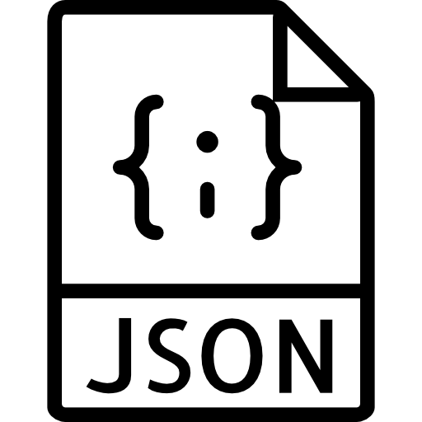The programming language we used is C++ and the library is JSON

Softwares used for the presentation of the project are Microsoft Word and Microsoft PowerPoint

Block Scheme of Gap

Conclusion

GAP provides an interactive and accessible platform for exploring historical events. A key technical feature was the implementation of a linked list data structure, which allowed efficient and dynamic handling of historical entries. This approach made it easier to add, remove, and navigate through events while keeping the system lightweight.

The project was made possible through strong collaboration, well-defined roles, and great communication. With its core features successfully, GAP provides smooth user experience.