

**Table of Contents**

Participants and their roles 1

Main Objective 2

Used apps and technology 3

Block scheme 4

|  |  |  |
| --- | --- | --- |
| Name | Class | Role |
| Ivaylo Gyurov | 10b | Back-end developers |
| Milko Barev | 10g | Scrum trainer |
| Kaloyan Iliev | 10g | Back-end developers |
| Kristiyan Dimitrov | 10b | QA |

# 

# **Participants and their roles**

**Main Objective**

# MBPHistory is a team of passionate developers dedicated to preserving history through technology. We created an easy-to-use application designed to help individuals and organizations manage, document, and share historic events. Whether it's archiving timelines, curating multimedia, or collaborating on historical research, our platform makes it simple, intuitive, and accessible for everyone.

# **Implementation**

# **Communication**

Our communication went through Teams.

# **Application**

# We used Clion as a programming tool. Therefore we used C++ as our main language to create our app.

# **Used apps and technology**

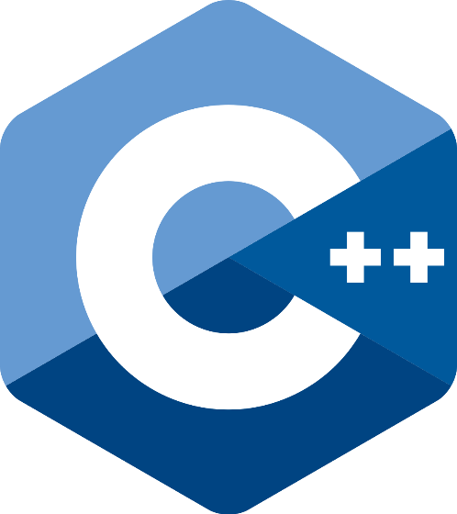**

# **Block scheme**

