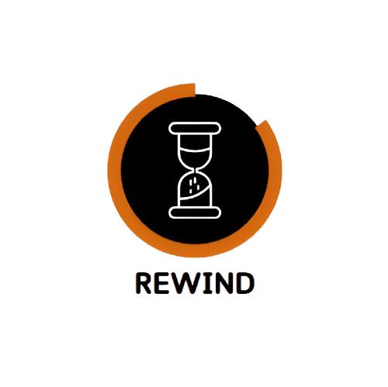

*Documentation*

Table of Contents

1. Team 2

2. Introduction 2

3. Method and manner of implementation 3

4. Summary 3

5. Libraries 3

6. Block scheme 4

# Team

|  |  |
| --- | --- |
| # | Roles in the team |
| 1 | Hristo Rusev – Scrum Trainer |
| 2 | Ivan-Mihail Ivanov – Back-End developer |
| 3 | Martin Dimitrov – Front-End developer |
| 4 | Petur Dimitrov – Q&A Engineer |

# Introduction

|  |  |
| --- | --- |
| # | Introduction |
| 1 | *What is the product?*  This project is a console-based application designed to provide an interactive and informative experience about the key historical events that have shaped the nation of Bulgaria. The application will serve as an educational tool, offering users a detailed chronological overview of significant milestones, historical figures, and transformative moments in Bulgarian history. |
| 2 | *Main stages in the realization?*  First Week – Create the idea and start coding  Second Week – Final touches on the program  Third Week - Realization |
| 3 | *Communication?* Communication is realized through Microsoft Teams. Thanks to all the features and the provided visualization – on-screen communication and feedback are sufficiently completed. |
| 4 | *What technologies are used?* The technologies that are used are Visual Studio 2022 as IDE, C++ as a programming language. Microsoft Word for documentation. Microsoft Teams as a communication channel. Microsoft PowerPoint as a presentation tool. Git and GitHub as a collaborative workplace. |

# Method and manner of implementation

|  |  |
| --- | --- |
| # | Method and manner of implementation |
| 1 | *Productive work.* The tasks are defined in a way that everyone is aware of the tasks performed so far to present and answer quickly, clear, and accurately, and teamwork is more efficient and productive. |
| 2 | *Distribution of tasks* For each task, a person is selected who is more familiar with the field and will be able to perform the task in the most competent way possible. |
| 3 | *Terms* Observance of dates was reminded by the Scrum Trainer. A meeting of the team is held every week to discuss the amount of time needed to complete the assigned task. |

# Summary

|  |
| --- |
| Our console application offers users an engaging platform to explore and learn about the important events that have impacted the nation's history. The application is divided into different time periods, from ancient history to modern-day Bulgaria. |

# Libraries

|  |  |
| --- | --- |
| # | Which Libraries did we use? |
| 1 | *<Windows.h>* It contains declarations for all of the functions in the Windows API. |
| 2 | *<conio.h>*  It includes inbuilt functions like getch() and clrscr(). |
| 3 | *<fstream>*  Provides functionality for reading from and writing to files, enabling file handling operations like input and output. |
| 4 | *<string>*  Provides support for such objects with an interface similar to that of a standard container of bytes, but adding features specifically designed to operate with strings of single-byte characters. |

# Block scheme

