TIME VAULTERS

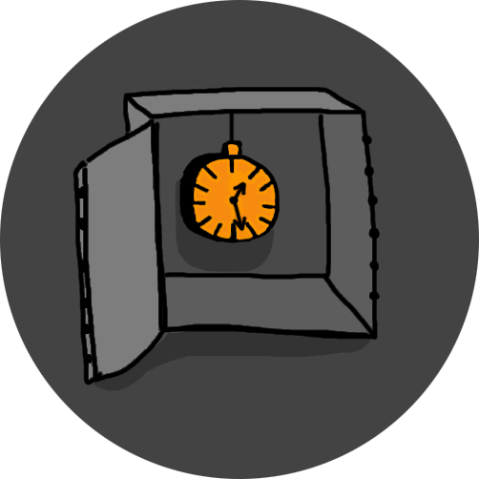

Authors 2

Project Summary 3

Goal 4

Main Stages 4

Implementation 4

Application Description 4

Conclusion 4

# Authors

|  |  |  |
| --- | --- | --- |
| Name | Role | Jobs |
| Калоян Страшимиров Петров | Scrum trainer & QA | Guide the team, call meetings, add issues in github, test functions, help with code |
| Антон Костадинов Бабев | Front end developer | Write the code for the look of the program, write main functions |
| Николай Стоянов Желязков | Back end developer | Write the main code for the program, main functions and files |

# Project Summary

## Goal

* Our aim was to create a program that holds historic events for users to see/ edit/ delete.

## Main Stages

* Idea and concept
* Designing the structure
* Implementing functionality in C++
* Testing and improvements
* Bug fixing
* Finalizing the documentation

## Implementation

* Programming Language: C++
* Developed in: Visual Studio
* Tools used: GitHub for collaboration, Discord for meetings, Powerpoint, Excel and Word for documents.
* Tested with: Native Unit Test Project in Visual Studio
* Technologies: Console application, basic data structures, Static library, Linked Lists

## Application Description

* Main menu for selecting different options.
* View tab – allows viewing of all current events saved.
* Edit tab – path to add events, edit events and delete events.
* Support tab – allows the user to contact our team via email.
* Add new events – allows the user to create new events.
* Edit events – allows the user to edit already existing events.
* Delete events – allows the user to delete events they don’t want.

# Conclusion

* We were able to implement most of our main idea within the two-week timeframe. Our initial plan included adding a sorting system for event names and dates to improve navigation, but due to time constraints, we couldn't fully realize that feature.
* Throughout the project, we collaborated effectively via online meetings and shared development environments.
* Along the way, we gained valuable experience working with text files in C++, implementing doubly linked lists, and using static libraries. This project helped us develop both our technical and teamwork skills.