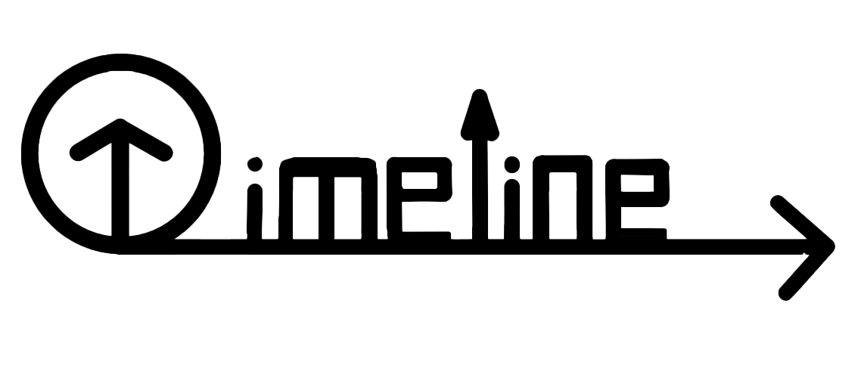**Team Timeline**

**PROJECT DOCUMETATION**

Contents

1. Our team 2

2. Resume 2

Goal: 2

Stages of Realization: 3

Used tools and language: 4

C++ 4

Visual Studio 2022 4

Microsoft Word 4

Microsoft PowerPoint 4

3. Conclusion 4

# Our team

|  |  |  |  |
| --- | --- | --- | --- |
| **№** | **Team Members** | **Class** | **Role** |
| **1** | Tsvetan Zhekov | 10 G | Scrum Master |
| **2** | Velizar Mihailov | 10 A | Front-End Developer |
| **3** | Martin Shavov | 10 G | Back-End Developer |
| **4** | Stiliyan Dyulgerov | 10 A | Quality Assurance |

# Resume

## Goal:

#### Our team aimed to develop a program for registering and managing historical events with a text-based user interface. We chose C++ for its efficiency and versatility and we utilized linked lists to give the user the ability to save, edit and manage historical events.

## Stages of Realization:

|  |  |
| --- | --- |
| **№** | **Stages** |
| **1st week** | *Assembling the team*  We gathered and distributed the roles, so each person can work on the field that is most competent with. We started thinking about an idea for the project |
| **2nd week** | *The process of creating*  We were meeting every day to discuss things about the project. Each member did what they were meant to and if  someone fell behind with the project, we helped each other. |
| **3rd week** | *Finishing the project*  After we finished with the project and the documentation, we fixed some bugs and made the overall user experience a bit more pleasant. |
| **4th week** | *Presenting the product*  After working hard and collaborating as a team, we are  proud to introduce Timeline, a project that combines creativity, technology, and purpose. |

## Used tools and language:

### C++

#### Known for its speed and robustness, C++ was ideal for building the core functionality of Timeline. It allowed us to implement efficient data handling to manage historical events.

### Visual Studio 2022

#### Visual Studio 2022 served as our primary IDE for C++ development. Visual Studio’s features, such as code analysis, project navigation, and efficient refactoring, streamlined our workflow.

### Microsoft Word

#### Word was used for drafting and organizing documentation, making it easier to track our work and refine content for presentations.

### Microsoft PowerPoint

PowerPoint was the platform for creating our final presentation, allowing us to visually communicate the project's key points and future possibilities.

# Conclusion

#### After many late nights and diligent collaboration, we successfully completed the first version of Timeline. The application offers essential tools to manage historical events. Future improvements could include more user-friendly interface features and expanded data management. Through this project, we learned a lot about using linked lists in C++ and developed a product we’re proud of.