

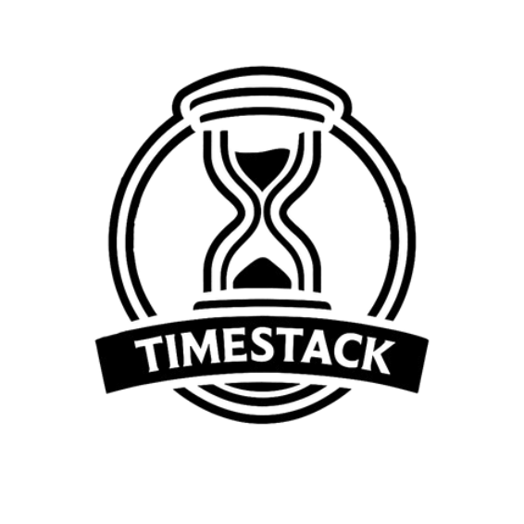

P a g e 1 | 5



Table of Contents

1. About us 3
2. The idea of the project 3
3. Stages of work 4

Assembling the team 4

The process of creating 4

Finishing the project 4

Presenting the product 4

1. Used Technologies 5

P a g e 2 | 5



# About us

|  |  |  |
| --- | --- | --- |
| **Name** | **Role** | **Grade** |
| **Nikolay Zhelev** | Scrum Trainer | 10G |
| **Yuan Tomov** | Developer | 10G |
| **Simeon Kalamerov** | Developer | 10A |
| **Borislav Petkov** | QA | 10A |

# The idea of the project

TimeStack is an interactive educational app built in C++ using Visual Studio. Designed for Windows and cross-platform compatibility, the app allows users to explore significant historical events through an engaging and intuitive interface. TimeStack helps users understand the impact of these events by offering detailed timelines, key facts, and interactive features to deepen their historical knowledge.

P a g e 3 | 5



# Stages of work

|  |  |
| --- | --- |
| **№** | **Stages** |
| **1st week** | *Assembling the team*  We gathered and distributed the roles, so each person can work on the field that is most competent with. We started thinking about an idea for the project |
| **2nd week** | *The process of creating*  We were meeting every day to discuss things about the project. Each member did what they were meant to and if  someone fell behind with the project, we helped each other. |
| **3rd week** | *Finishing the project*  After we finished with the project and the documentation, we fixed some bugs and made the overall user experience a bit more pleasant. |
| **4th week** | *Presenting the product*  After working hard and collaborating as a team, we are  proud to introduce our program, a project that combines creativity, technology, and purpose. |

P a g e 4 | 5



# Used Technologies

* 1. C++ - for creating the app.
  2. Github – for the synchronization.
  3. Visual Studio – for compiling.
  4. MS PowerPoint – for creating presentation.
  5. MS Word – for creating documentation.

# Block diagram

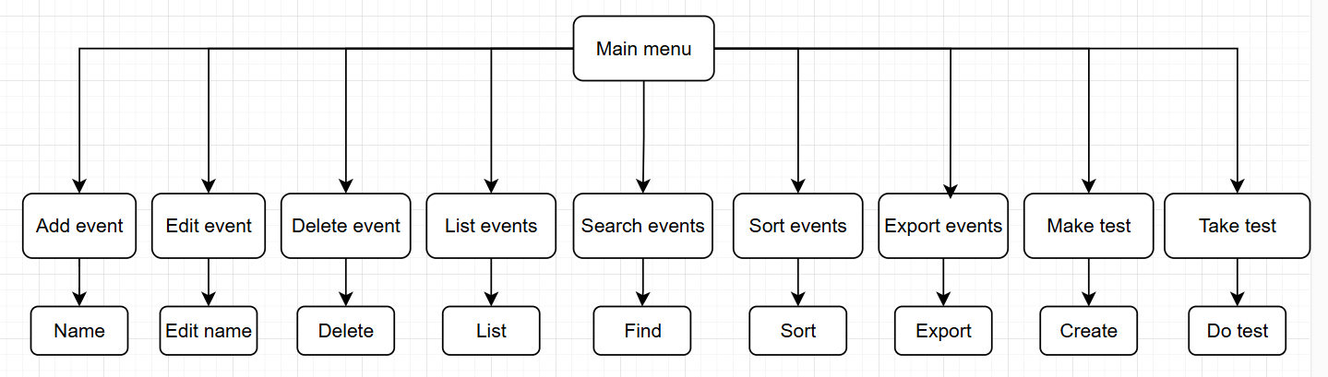

P a g e 5 | 5