

**codeX**

**TEST PLAN**

Table of contents

1. Introduction 3

2. Entry and Exit requirements 3

3. Project goals 4

4. Tasks 4

5. Testing 5

6. Testing process 5



# 1. Introduction

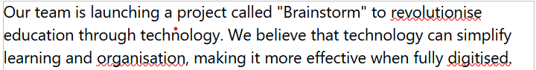

# 2. Entry and Exit requirements

ß

**Exit**

* **Most of the tests are successful.**
* **There are no errors preventing the program from working.**

**Entry**

* **Access to the application is provided.**
* **The first tests begin.**

# 3. Project goals

# 4. Tasks

**The tasks that must be done to ensure our success are:**

* **To test every element.**
* **Create multiple test cases.**
* **To prepare QA documentation.**



# 5. Testing

**Manual testing**

* **Menu options.**
* **Checking that error messages are displayed.**
* **Checking that the correct values are accepted by the code.**
* **Function testing.**

# 6. Testing process

**Test results**

* **Excel table**
* **Test plan**

**Resources**

* **Excel for test management.**
* **Word for Test plan.**
* **GitHub for setting issues.**

