

Table of Contents

1.About Us 3

2.App Description 3

3.Stages of Realisation 3

4.Used Technologies 4

5.Functions 4

6.Block Scheme 5

# ***1.About Us***

|  |  |  |
| --- | --- | --- |
| Name | Role | Grade |
| Miroslav Ganev | Scrum Trainer | 10A |
| Angel Angelov | Backend Developer | 10A |
| Atanas Apostolov | Backend Developer | 10B |
| Polina Dineva | Backend Developer | 9A |
| Hristo Rusev | QA | 9B |
| Petar Kostov | Backend Developer | 9G |

# ***2.App Description***

# ***Our app is designed to improve the education system and support learning in areas such as mathematics, physics and programming. The application is provided with courses both for training, provided with lessons and examples, according to the given lesson. There are also sections for testing and practicing new knowledge, where students will be able to check what percentage, they are doing in the course in which they have decided to test their knowledge.***

# ***3.Stages of Realisation***

**1st Week** – We created our Logo and discussed ideas about the app.

**2nd Week** – We made basic design of the app.

**3rd Week** – We started implementing our app idea through code.

**4th Week** – We have been focusing on finishing the app and the documentation.

***4.Used Technologies***

**1.Microsoft Teams** – For team communication.

**2. Microsoft Word** – For creating the documentation.

**3.Microsoft PowerPoint** – For creating the presentation.

**4.Microsoft Excell** – For creating QA documentation.

**5.Micosoft Visual Studio** – For writing the code.

**6.GitHub** – For the project synchronization.

**7.Git** – For committing our changes.

**8.C++** – For creating the app.

**9.Raylib** – For app visualization.

**10.Figma** – For creating app’s design.

**11.Adobe** – For creating the Logo.

***5.Functions***

|  |  |
| --- | --- |
| *Functions:* | *Description:* |
| *int Courses();* | ***Main function of course buttons*** |
| *void homePage();* | ***Main function for the Home Page*** |
| *void mathLesson1();* | ***Mein function for Math Lesson 1*** |
| *void mathLesson2();* | ***Mein function for Math Lesson 2*** |
| *int mathMenu();* | ***Mein function for all Math Courses*** |
| *void mathTest1();* | ***Mein function for Math Test 1*** |
| *void mathTest2();* | ***Mein function for Math Test 2*** |
| *void physicsLesson1();* | ***Mein function for Physics***  ***Lesson 1*** |
| *void physicsLesson2();* | ***Mein function for Physics***  ***Lesson 2*** |
| *int physicsMenu();* | ***Mein function for all Physics Courses*** |
| *void physicsTest1();* | ***Mein function for Physics Test 1*** |
| *void physicsTest2();* | ***Mein function for Physics Test 2*** |
| *void progLesson1();* | ***Mein function for Programming Lesson 1*** |
| *void progLesson2();* | ***Mein function for Programming Lesson 2*** |
| *int progMenu();* | ***Mein function for Programming Menu*** |
| *void progTest1();* | ***Mein function for Programming Test 1*** |
| *void progTest2();* | ***Mein function for Programming Test 2*** |

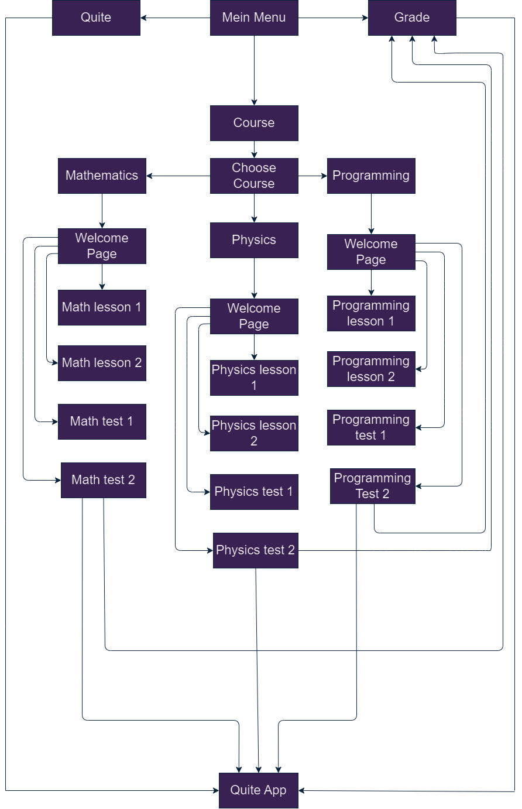***6.Block Scheme***