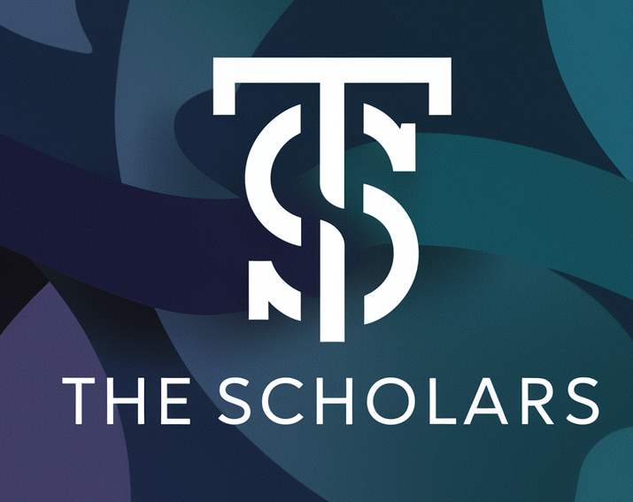

Table of contents

Our Goal 3

Stages of realization 3

# Our Goal

* Our main goal is to help students assess their knowledge on scientific school subjects such as: Geography, Biology, Chemistry, Physics and others.
* Our secondary goal is to help students find the best way for them to learn what they don’t know.

# Stages of realization

* We started by choosing the idea for our project.
* After we chose to make a program for testing students on their science knowledge, we decided to add a student compass to point students in the right direction for their learning method.
* Then we started organizing the work between the members of our team.
* After that every one started working on what was assigned to them.
* Now after all the work is done we are presenting our project.

# Tools of realization

* Microsoft Word
* Microsoft PowerPoint
* Visual studio 2022

# The Program