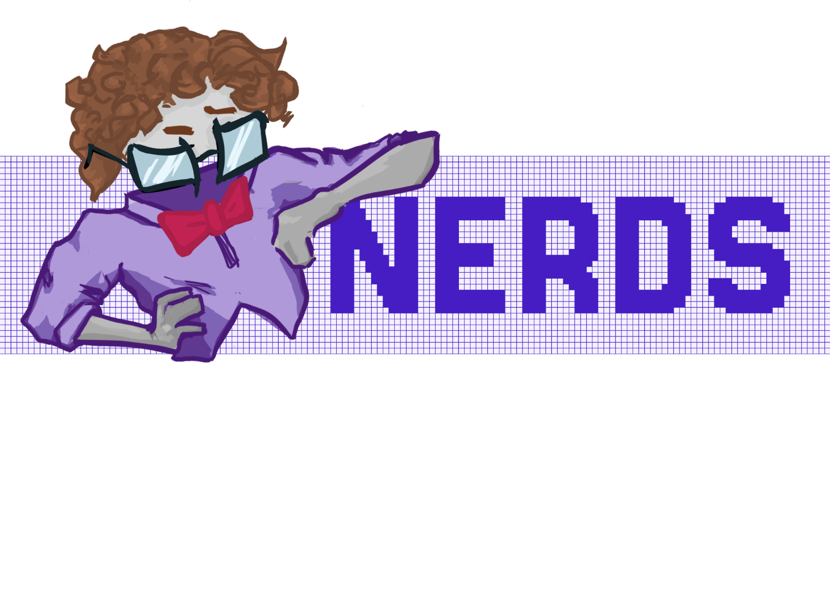

Remote Education

TEODORA lOZEVA 10A

Table of Contents

Team 1

Members 1

Goal 2

Problem 2

Solution 2

How can you access the project? 2

Implementation of the project 3

Stages 3

App 4

Block Diagram 4

# Team

## Members

|  |  |  |
| --- | --- | --- |
|  | Martin Dimitrov | 9G |
|  | Petar Dimitrov |
|  | Vinichenko Oleksandrov |
|  | Gabriel Dimitrov | 10 V |
|  | Martin Stoyanov | 10 B |
|  | Teodora Lozeva | 10 A |

# Goal

## Problem

School subjects can leave many students with many unanswered questions at the end of the school day.

Whether that is from:

* Limited class time;
* Absence from school;
* Social anxiety during class & etc.

That’s why students are given some form for contacting their teacher outside school hours.

But let’s be real. Students won’t sit down to study at appropriate hours and that leaves no time for someone to explain what they couldn’t understand.

## Solution

Create an App that allows students to access materials and ask questions and be provided with explanations whenever they need them, without disturbing teachers late at night.

## How can you access the project?

You can find our project on [GitHub.](https://github.com/codingburgas/school-project-assignment-nerds)

# Implementation of the project

## Stages

TECHNOLOGIES USED

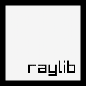 

 

# App

## Block Diagram

