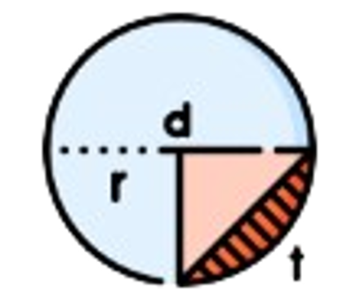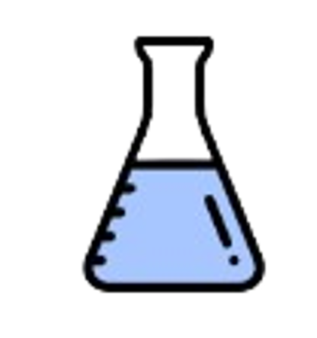

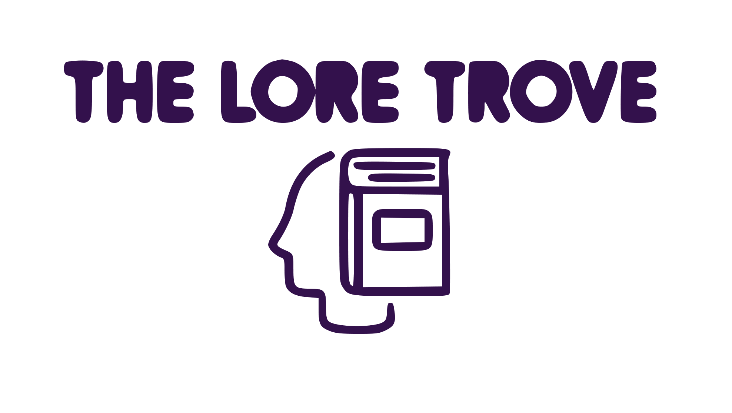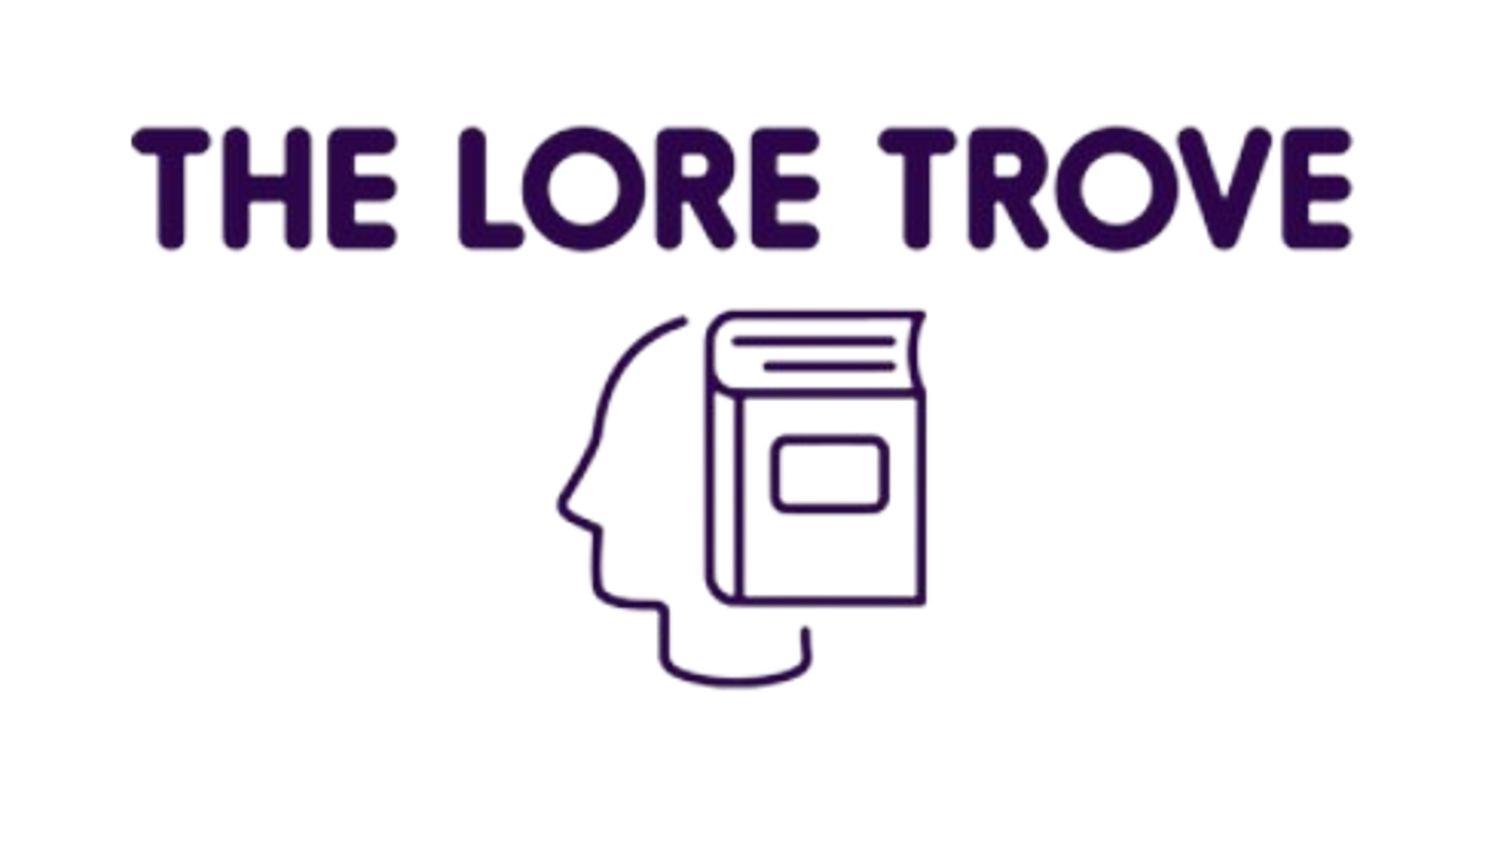

PROJECT DOCUMENTATION

Table of Contents

1. Our Team 3

2. Used programs and languages 4

3.Resume 5

4. Idea 5

5. Workflow 5

6. Conclusion 5

1. Our Team

Nadezhda Ivanova – Scrum trainer – 10th grade

[NTIvanova21@codingburgas.bg](mailto:NTIvanova21@codingburgas.bg)

Valeria Chavdarova - Back-end Developer – 10th grade

[VDChavdarova21@codingburgas.bg](mailto:VDChavdarova21@codingburgas.bg)

Antonia Taneva - Back-end Developer – 10th grade

[ATTaneva21@codingburgas.bg](mailto:ATTaneva21@codingburgas.bg)

Ivan-Michail Ivanov - Back-end Developer – 9th grade

[iiivanov22@codingburgas.bg](mailto:iiivanov22@codingburgas.bg)

Pavlin Peev- Back-end Developer – 9th grade

[pppeev22@codingburgas.bg](mailto:pppeev22@codingburgas.bg)

Nikolay Kulov- Back-end Developer – 9th grade

[ngkulov22@codingburgas.bg](mailto:ngkulov22@codingburgas.bg)

2. Used programs and languages

* C++

C++ was our main programming language.

* Raylib

Raylib is a simple and easy-to-use library to enjoy videogames programming. We used this library to make the graphic textures in our game.

* Visual studio

Visual Studio is an integrated development environment (IDE) from Microsoft. It ‘s used to develop computer programs including websites, web apps, web services and mobile apps.

* Procreate

Procreate is a powerful and intuitive drawing and painting app. It allows users to create artwork digitally using a wide range of tools and features. It is widely used by creative professionals, aspiring artists, and beginners alike. We used it for our sprites.

* Word

Microsoft Word or MS Word (often called Word) is a graphical word processing program that users can type with. Its purpose is to allow users to type and save documents. We used Word to create this documentation.

* Excel

Excel is a spreadsheet program from Microsoft and a component of its Office product group for business applications. This was the place where we did out QA documentation.

* Power point

PowerPoint is a complete presentation graphics package. It gives you everything you need to produce a professional-looking presentation. This was the place where we did our presentation.

3.Resume

Hello! This is our team The Lore Trove and we decided to make a game focused on helping students to understand some small part of the subjects: Maths, Biology and Chemistry. For a programming language we chose to use C++. The main purpose of the game is for the player to learn or start to understand more about a given subject.

4. Idea

When the team gathered for the first time, we started thinking about what we had to do. After lots of ideas and proposals we chose to do a game focused on gaining new knoledge.

5. Workflow

As for the working progress - It went smoothly, without major problems. Even though we had some disagreements during our work regarding the idea for the game, we knew that we had to do it so we made a compromise with each other and then we cleared out what we had to do, to accomplish it.

6. Conclusion

In the end, after lots of late hours work, we finished the game. The work journey was quite enjoyable, yet under pressure, and we learned a lot about teamwork, time, and repository management.