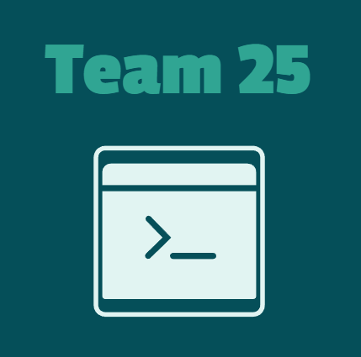
Project Documentation
Contents
1. Our Team 1
2. Resume 2
Goal: 2
Stages Of Realization: 2
Workflow: 2
Used programs and languages: 3
3. Conclusion 4

Our Team
Todor Stamboliev – Scrum Trainer
TPStamboliev23@codingburgas.bg

Cvetomir Luchev – Frontend Developer
TSPLuchev23@codingburgas.bg

Hristiqn Grozdev – Backend Developer
HAGrozdev23@codingburgas.bg

Qvor Velizarov – QA
YAVVelizarov23@codingburgas.bg

Resume

Goal:

Our team decided to make an interesting game with mazes. From this game people can think critically and how to do the maze. For this project we decided to use C++.

Stages Of Realization:

At first, we had to distribute the roles and then we started brainstorming ideas. We decided to make a game about mazes using C++. After that we started to work on our project.

Workflow:

We had to make a game. We decided to use some techniques in C++ we never used. Because of that we had to learn them and see what they can do. After we learnt everything we needed, we started to code a game: main page, difficulties and the maze itself. We split to three teams: one person organizes the team, two people develop the game and one person makes the QA. Everything ran somewhat smoothly.

Used programs and languages:

C++ - We used it for developing the game
Visual Studio – We used it for writing the code for the game
GitHub – We used it for storing, tracking and collaborating on software projects
Discord – We used it for communicating

Conclusion

In the end, after lots of late hours work, we finished the game. The work journey was enjoyable, but under pressure. We learned a lot about C++ and teamwork.

