
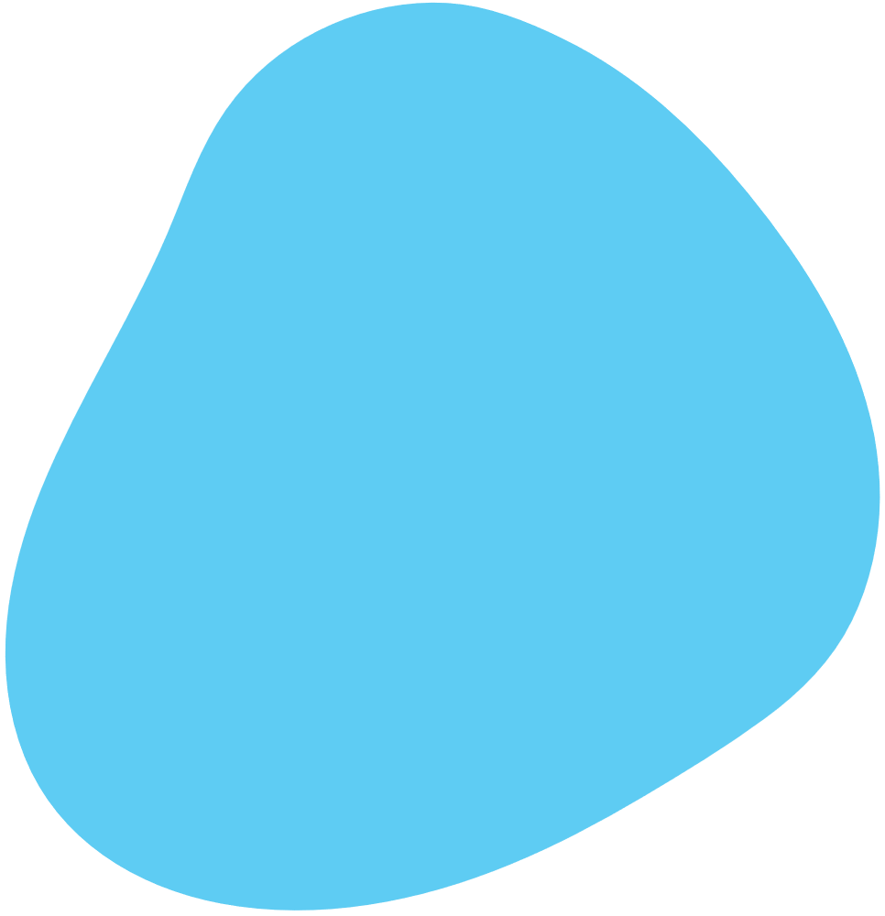

bluelens
  - DOCUMENTATION

Table of Contents
1. Team 2
2. ENCOUNTERED DIFFICULTIES 3
3. Used programs and languages 3
• C++ 3
• Visual Studio Code 3
• Word 3
• PowerPoint 3
4. Resume 4
5. Idea 4
6. Workflow 4
7. CONCLUSION 4
8. Block Scheme 4

Team
Name | Class | Role
Varvara Safonova | 9A | Scrum trainer
Amelia Dorosh | 9G | Front – End developer
Victor Nikolov | 9V | Back – End developer
Beloslava Ileva | 9B | QA

2. ENCOUNTERED DIFFICULTIES

Thankfully we hardly had any encountered difficulties. Most of our teammates were able to communicate properly, although we had a hard time communicating with some of the participants. Our encountered bugs were easily fixed with hard teamwork.
Scaling
1-Very Difficult / 10 – Not Difficult

Communication | 7/10
Teamwork | 8/10
Code | 8/10
Role Distribution | 7/10

Used programs and languages

C++
C++ is a widely used general-purpose universal programing language based on C.

Visual Studio Code
Visual Studio Code is a freeware source-code editor made by Microsoft. Features include support for debugging, syntax highlighting, intelligent code completion, snippets, code refactoring, and embedded Git. Visual Studio Code

Word
Microsoft Word or MS Word (often called Word) is a graphical word processing program that users can type with. It is made by the computer company Microsoft. Its purpose is to allow users to type and save documents.

PowerPoint
PowerPoint is a complete presentation graphics package. It gives you everything you need to produce a professional-looking presentation. PowerPoint offers word processing, outlining, drawing, graphing, and presentation management tools- all designed to be easy to use and learn.

Resume
We are Bluelens. We are building a maze game that teaches players to plan and make smart decisions. The goal is to improve logical thinking in a fun way. Would you like to play it?

Idea
First of all, we aim to get better at coding. We realize the importance of being able to work with various functions, commands and their nuances, and thus we put much effort into learning and getting better! Secondly, we simply have fun, which isn't any less important. And last but not least, we learn to work together, helping each other and trying our best.

Workflow
At times we couldn’t reach our teammates. It made the work harder to complete. Luckily, It didn’t happen that often, but it still occurred from time to time. This was definitely one of the factors for not fully completing everything we wanted to complete.

CONCLUSION
We knew that we could do much more with our project, but we were satisfied with our results. We learned a lot about new technologies and instruments. Our work was found quite enjoyable and we also learned a lot about teamwork and time management.

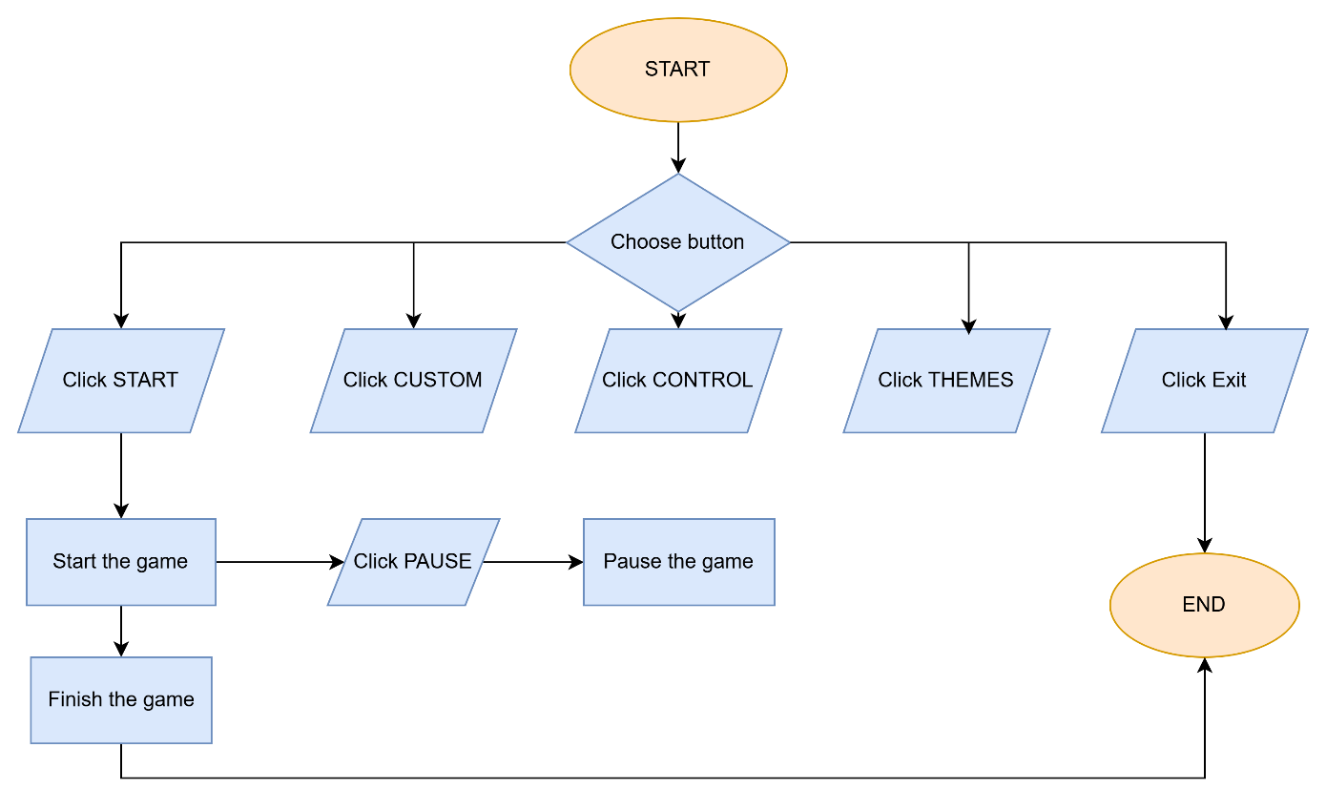
Block Scheme

