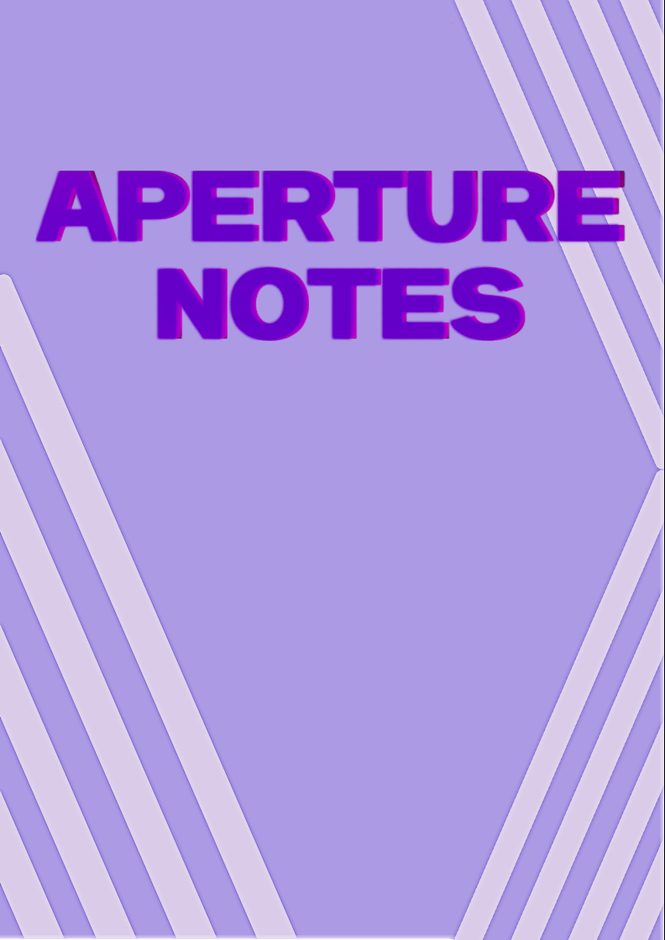

**Educational online test**

**Project 2025**

**Contents**

Assignment2

Team2

Stages of development3

Project description4

Block diagram 5

**Assignment**

The topic is: "Online test". We had to create a total of 50 questions, divided in categories. Then a test would be generated consisting of 20 questions, with an exact number of questions in each category. After solving the test the student will be graded using the six-point system.

**Team**

|  |  |  |
| --- | --- | --- |
| № | Name and class | Role |
| №1 | Petar Dimitrov – 9G | Scrum trainer |
| №2 | Mark Dimitrov– 9G | Back-end developer |
| №3 | Kiril Zhilichev – 9А | Front-end developer |
| №4 | Hristian Stanchev– 9V | Designer |

**Stages of development**

|  |  |
| --- | --- |
| № | Stage |
| 1 | **Assembling the team**  We gathered and distributed the roles, so each person can work on the field that he is most competent with. |
| 2 | **Idea**  We decided to make an app. We started thinking of an idea for the app. We decided to make an interactive notepad designed to transform traditional note-taking into a more engaging and effective learning experience. |
| 3 | **The process of creating the product**  Every week there were meetings to discusses the progress and the tasks that are left. We assigned each task to the person that we believed can do it quickly, clearly, and accurately, so the team would be more productive and efficient. |
| 4 | **Polishing the product**  After we finished with the app and the documentation, we fixed some problems and made the overall user experience a bit more pleasant. |
| 5 | **Presenting the product**  After weeks of hard working and sleepless nights we finished the project and now it is ready to be presented. |

**Project description**

|  |  |
| --- | --- |
| № | Description |
| 1 | **A general idea about the game**  The general idea of our project is to make an app where users can write notes and add images to better understand topics and overcome the monotony of studying. |
| 2 | **How to access our project**  Our repository: <https://github.com/codingburgas/sprint-eschool-aperture.git>,  CMD:  git clone https://github.com/codingburgas/sprint-eschool-aperture.git  Navigate to the new directory:  cd sprint-eschool-aperture  Run premake5.exe to pull the external libraries:  premake5.exe vs2022  If you want to view other platforms, run:  premake5.exe --help |
| 3 | **Team work**  The main communication platform we used is Microsoft Teams. During the project we stayed in touch with each other. |
| 4 | **Used technologies for our project development**  **Back-End**  **C++ – Back-end logic and server operations.**    **SQLite – Database management.**    **Crow.cpp – Web framework for C++.**    **JWT – Secure authentication.**    **Bcrypt – Password hashing.**    **CPR – C++ HTTP request library.**    **Front-End**  **HTML**    **CSS**    **JavaScript – Manages communication between client and server.**    **AI & API Integration**  **Groq – Generates quizzes for active recall.**    **Development Tools**  **Visual Studio Code – Code editor.**    **Visual Studio 2022 – IDE for development.**    **Premake – Build configuration tool.**    **Version Control & Documentation**  **GitHub – Repository hosting.**    **Git – Version control.**    **Git CMD – Command line for Git.**    **Official Docs – Reference and guides.**    **Communication & Design**  **Microsoft Teams – Team collaboration.**    **Pixlr – Image and logo editing.**    **PowerPoint – Presentations.**    **Word – Documentation.** |

**Block diagram**

Main menu

About us

Tests

Lessons