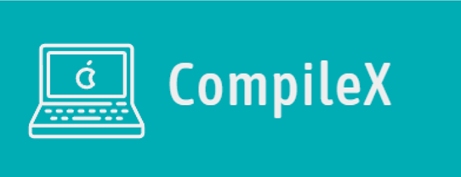Project documentation

Contents

1. Our team 1

2. Resume 2

Goal: 2

Stages of Realization: 2

Workflow: 2

Used programs and languages: 3

3. Conclusion 3

# Our team

Todor Stamboliev – Scrum Trainer

[TPStamboliev23@codingburgas.bg](mailto:TPStamboliev23@codingburgas.bg)

Aleksandur Georgiev – FrontEnd developer

[AVGeorgiev23@codingburgas.bg](mailto:AVGeorgiev23@codingburgas.bg)

Nia Georgieva – BackEnd developer

[NGGeorvieva23@codingburgas.bg](mailto:NGGeorvieva23@codingburgas.bg)

Anastas Apostolov – Designer

[AVApostolov23@codingburgas.bg](mailto:AVApostolov23@codingburgas.bg)

# Resume

## Goal:

Our team decided to make an educational game about learning programming. From our interesting game, people can have fun learning it. For this project we decided to use C++.

## Stages of Realization:

At first, we had to distribute the roles and then we started brainstorming ides. We decided to make an educational game about programming using C++. After that we started to work on our project.

## Workflow:

We had to make a game. We decided to use some techniques in C++ which we have never used. Because of that we had to learn them and see what they do. After we learnt everything we needed, we started to code a game: main page, topic, test. We split to three teams: one person organizes the team, two people develop the game and one person makes the design for the game. Everything ran smoothly.

## Used programs and languages:

C++ - We used it for developing the game

Visual Studio 2022 – We used it for writing the code for the game

GitHub – We used it for storing, tracking, and collaborating on software projects.

# Conclusion

In the end, after lots of late work, we finished the game. The work journey was enjoyable, but under pressure. We learned a lot about C++ and teamwork