
EduSoft


eduSoft
Contents
About us 2
The idea of the project 3
Summary 4
Stages 5
Used Technologies 6





About us
Rosica Parapanova 9V – Scrum Trainer
Raya Kirilova 9A – Designer
Roberta Hristova 9B – Frontend Developer
Leq Susova 9B – Backend Developer

eduSoft



The idea of the project
This is a science knowledge test with three categories: Biology, Chemistry, and Physics. Each test has 20 questions with three answer choices: A, B, or C. The user selects a category and answers the questions one by one. After each question, the program shows if the answer is correct or wrong. At the end, the user gets a final score based on correct answers. This test helps to check and improve knowledge in science.

eduSoft



Summary
The test is a functional and effective tool for testing knowledge in natural sciences. It provides quick feedback, a clear final result and the ability to choose a category. It is written in C++ and is designed to assess the user's knowledge in three main categories of natural sciences: Biology, Chemistry and Physics. Each category contains 20 questions, with answers in the format A, B, C.

eduSoft



Stages
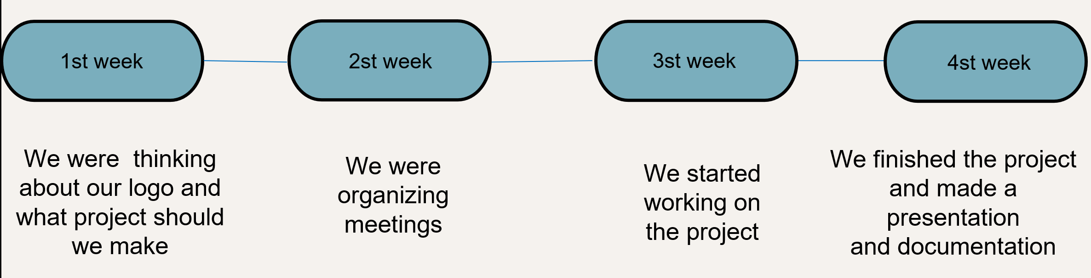
eduSoft



Used Technologies
- C++ - programming language for the creation of the app.

- Git hub - for the synchronization of duties and project storage.
- PowerPoint - for the creation of the presentation.

- Word - for the creation of the documentation.

- Microsoft Teams – for communication.
eduSoft

