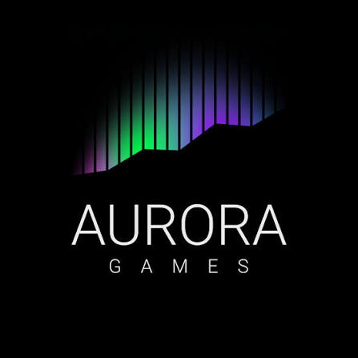
Aurora Games – Wheel of Fortune

Technical Documentation

1. Project Overview
Aurora Games – Wheel of Fortune is a console-based word guessing game developed in C++. The game is inspired by the classic Wheel of Fortune concept: players spin a wheel, guess letters, and attempt to reveal a hidden 7-letter word.

2. Game Rules

1. Players can only guess one letter at a time.
2. Each one of them spins the wheel before guessing to determine points or penalties.
3. If a players gets "+"
4. If a player gets "0", they lose their turn.
5. If a player guesses a letter that has already been revealed, they lose their turn.
6. Players can choose to guess the entire word at any time, but an incorrect guess results game loss.
7. The game ends when the entire word is revealed or a player correctly guesses the full word.

3. Game Features
• Player vs Player mode
• Player vs Bot mode
• Animated spinning wheel in the console
• Scoring system with points, bankrupt, skip, plus, and double
• Word difficulty selection and language configuration hooks

4. Game Flow
1. Main menu is displayed – rules, play settings.
2. The player selects a game mode: Player vs Player or Player vs Bot.
3. A random 7-letter word and its hint are selected based on difficulty and language.
4. Game loop begins:
- Current player spins the wheel.
- Wheel result determines whether the player guesses a letter, loses points, skips, etc.
- Correct letters reveal positions in the word and add points.
- The player can attempt to guess the full word at anytime.
5. If a player guesses the full word correctly, they win immediately.
6. If a player guesses the full word incorrectly, they immediately lose.
7. At the end, the program displays a win, or lose, message and returns to the menu or exits.

5. Player vs Bot Mode
In Player vs Bot mode, the bot behaves like a second player. The bot's turns follow the same wheel rules and scoring system as the human player. Its letter choices are based on internal random logic.

