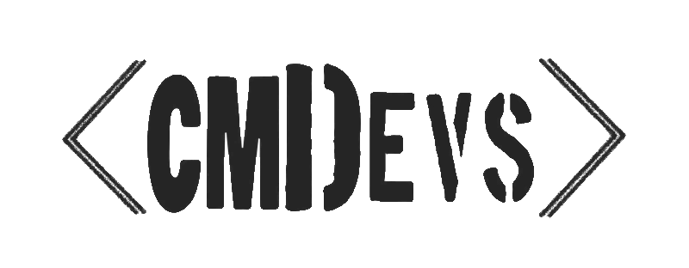

TABLE OF CONTENTS
1. Our team....................................................................
2. Resume......................................................................
3. Parts of the project...................................................
4. What programs and languages we used...................
5. Idea............................................................................
6. Workflow....................................................................
7. Conclusion.................................................................


1. OUR TEAM
Simeon Kostin, 9B – Scrum trainer
Sergei Romanchenko, 9G – Backend developer
Oleksand Bondarenko, 9A – Frontend developer
Sofiya Chapkina, 9V – Designer

2. RESUME
CMDevs is a small team of dedicated schoolmates united by a shared passion for programming,which is why we are here. We came together to complete our first project in 9th grade, for which we decided to create a game of Scrabble written on C++. Our game features a user-friendly interface, a points system and follows the same rules as Scrabble itself.

3. PARTS OF THE PROJECT
Frontend: Menu, Game UI, Menu Art
Backend: Movement, Scoring, Word Checking, Input Handling


4. WHAT PROGRAMS AND LANGUAGES WE USED
C++
Our primary programming language.

Visual Studio 2022


Software that we used for programming.
MS Word and MS PowerPoint


Used to make the documentation and the presentation for our project.
Git and GitHub

Our collaboration tools.
MS Teams
Used for communication between teammates.

5. IDEA
As young developers, our main focus for this project was to learn and realize the importance of being able to work with various functions, commands and their nuances, and thus we put a lot of effort into getting better!

6. WORKFLOW
Week 1
Experimenting with various games related to the topic, lots of communication and rough draft of the final game.
Week 2

Developing the base code of the game while also trying out various newfound possibilities of C++.
Week 3
Adding finishing touches to the game, debugging and documentation.

7. CONCLUSION
While our team did experience difficulties working on this project and enctountered many bugs along the way, we are proud to say that all of them have been overcome.
With that, we are ready to present our game of Scrabble, all complete, to you.



