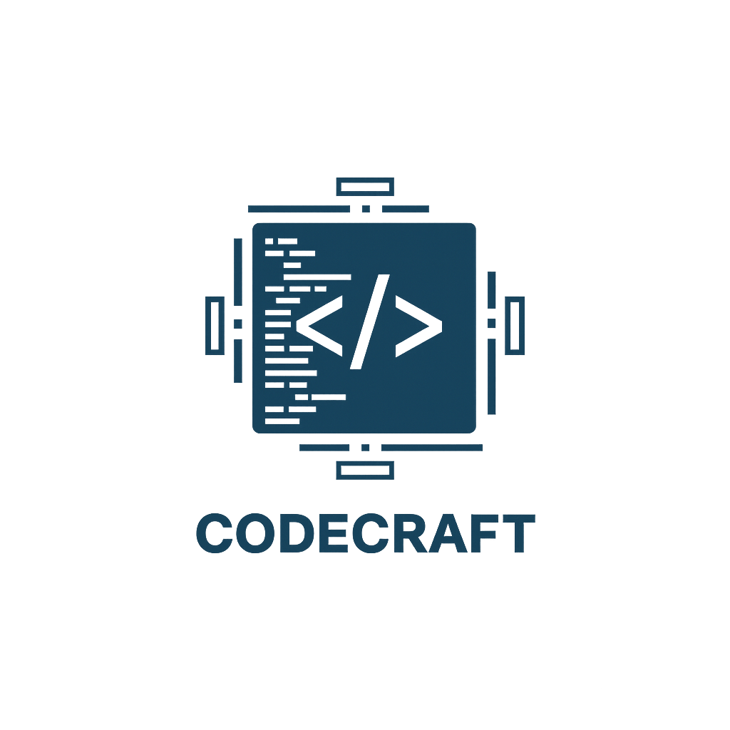
CodeCraft

Contents
1.About us 2
2.Idea of the project 2
3.Stages of working 3
4.Used technologies 3
5. Block diagram 3
6. Functions 5

1.About us
Name | Role | Grade
Ivaylo Georgiev | Scrum trainer | 9B
Toma Ivanov | Back-End Developer | 9A
Dimitar Bornusuzov | Front-End Developer | 9G
Marin Marinov | Designer | 9V

2.Idea of the project
Numeria is an adventure game where the player must restore the shattered Great Equation Stone by traveling through different mathematical realms. Each area-like the Village of Ones, Forest of Division, and Mountains of Geometry-contains story events and obstacles that unlock only when the player solves math puzzles.
The game’s purpose is to develop quick calculation skills and logical thinking through exploration instead of traditional exercises. In Numeria, the story progresses only when the player overcomes each mathematically-sealed challenge.

3.Stages of working
№ | Stages
First Week | We created the idea, logo and the Main Menu.
Second Week | We created the first 4 chapters of the game.
Third Week | In the third week we created the other 2 chapters, presentation and documentation and now the project is ready to be presented.

4.Used technologies
1. C++ - for creating the game.
2. Github – for the synchronization.
3. MS PowerPoint – for creating presentation.
4. MS Word – for creating documentation.
5. Visual Studio 2022 – for writing the code.

5. Block diagram

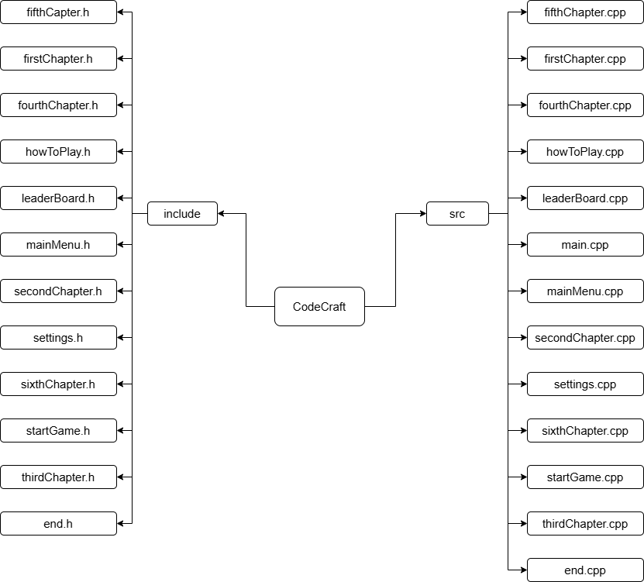

6. Functions

Type | Name
void | endGame()
void | fifthChapter()
void | displayStoneProgress()
void | firstChapter()
void | fourthChapter()
void | showInstructions()
void | clearScreen()
void | setCursorPosition()
void | getConsoleSize()
void | printCenteredAt()
void | displayTitle()
void | mainMenu()
void | displayMenu()
void | showHighScores()
void | showSettings()
void | startGame()
void | secondChapter()
void | sixthChapter()
void | thirdChapter()

