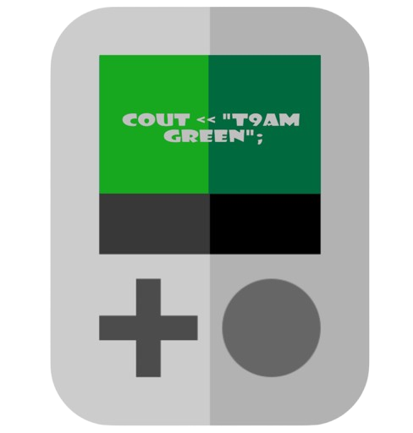

cout << “T9am

Green”;

**DOCUMENTATION**

Contents

1. Project idea 2

2. Preformed Tasks 2

3. Team Members 2

4. Used Technologies 2

5. Block Scheme 3

6. Summary 3

# Project idea

We created a game where the teacher gives you exercises that you need to solve, they have different categories from collection to multiplication. Trying to get the best grade to win!

# Preformed Tasks

Our application currently meets all requirements.

# Team Members

|  |  |  |
| --- | --- | --- |
| Name | Role | Class |
| Daniil Moldovanov | Scrum Trainer | 9V |
| Ivelin Metodiev | Frontend Developer | 9V |
| Grigori Nedialkov | Backend Developer | 9V |
| Djan Muhtar | Designer | 9V |

# Used Technologies

* Visual Studio 2022
* GitHub
* MS Word
* MS Teams
* MS PowerPoint
* Git
* GIMP
* Raylib

# Block Scheme

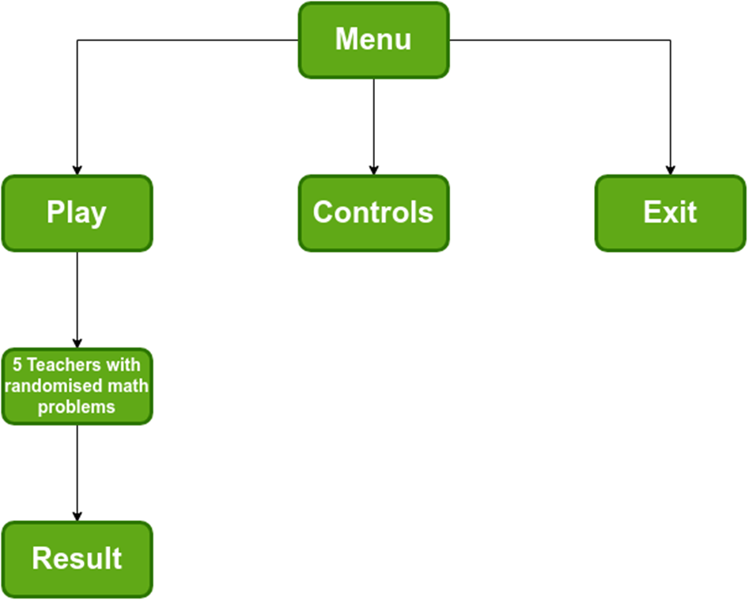

# Summary

|  |  |
| --- | --- |
| Goals | The aim of our project is to create a game related to mathematics. |
| What is our Game | The essence of this project was to create a C++ game in witch you are a student that have to solve math problems to get a high grade. |
| Realisation | We used:  Visual Studio 2022 and C++ - for the application.  Teams – for the communication.  Word and PowerPoint – for documentation.  GIMP – for design. |