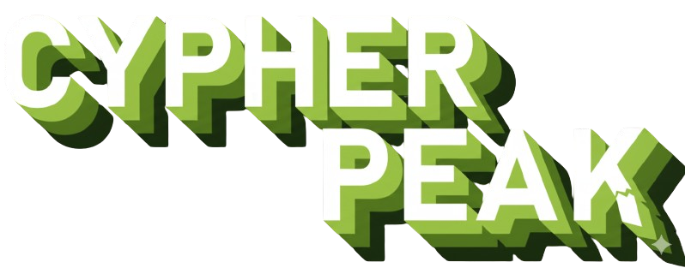
C++ Wordle Project
Table of Contents
- About Us
- The Idea of the Project
- Work Progress
- Tech Stack and Softwares

- About Us
Person | Position | Class
Tatiana Kovacheva | Back-End Developer | 9th “A”
Borislav Andrikov | Front-End Developer | 9th “B”
Atanas Todorov | Scrum Trainer & Developer | 9th “V”
Georgi Dinkov | Back-End Developer | 9th “G”

- The idea of the project

- Our Vision was a modern C++ Wordle-style game developed by the team to showcase clean code design, intuitive gameplay, and a polished user experience. It features a streamlined interface, thoughtful mechanics, and a smooth, engaging way for players to guess words and test their logic.
3. Work Progress
1ˢᵗ Week | Team Formation  During the first week, the Elite Rentals team was formed. Members were assigned roles in development and project coordination. We set the project goals, vision, and outlined our workflow. Tools and communication platforms were chosen to ensure collaboration.
2ⁿᵈ Week | Platform Development  We began building the Elite Rentals platform, focusing on key features like account login, vehicle listings, and the reservation system. The main structure was created, and basic frontend elements were connected, prioritizing functionality during this stage.
3ʳᵈ Week | Project Completion  This week, we completed the platform's main features, created our presentation, and documented our work. We also fixed bugs and made sure the platform worked properly across different devices.
4ᵗʰ Week | Final Presentation  After four weeks of effort and teamwork, the Elite Rentals project was fully prepared and ready to be presented. We finalized our materials and showcased the results of our hard work.
4. Tech Stack and Softwares

- Microsoft Teams – For communication with our teammates.

- Visual Studio Code – For the development of the project.

- Git & GitHub - For storing code, allowing our other teammates to apply changes by using Git.

- Microsoft Word – For creating the documentation of the project.
- Microsoft PowerPoint - For creating the presentation of the project.

