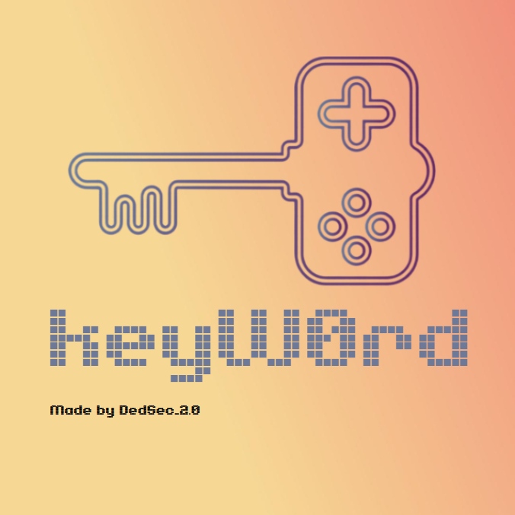

About us

Pavel Plamenov Parvanov 9V- scrum trainer

Rosica Venelinova Parapanova 9V- designer

Milen Ivanov Vasilev 9V- developer

The idea of the project

“keyW0rd” is a word game in which you have 12 attempts to guess a 4 words made up of 5 letters. The game is entertaining and suitable for all ages.

Summary

The keyW0rd game is a fun and educational challenge that stimulates creative thinking, enriches vocabulary and develops the ability to think quickly. Participants make or guess words in an effort to demonstrate their language skills. The game is suitable for all ages and creates opportunities for fun and learning in a fun environment.

Stages

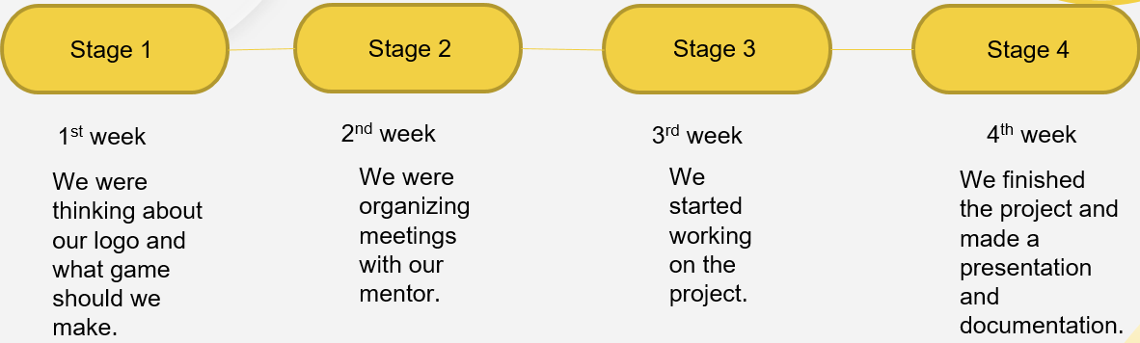

Used Technologies

1. C++ - programming language for the creation of the app.
2. Git hub - for the synchronization of duties and project storage.
3. PowerPoint - for the creation of the presentation.
4. Word - for the creation of the documentation.
5. Microsoft Teams – for communication.

Conclusion

Thanks for joining our word game keyW0rd! We hope you had fun, challenged your mind and learned something new. Word games not only develop creativity and quick thinking.

Block diagram

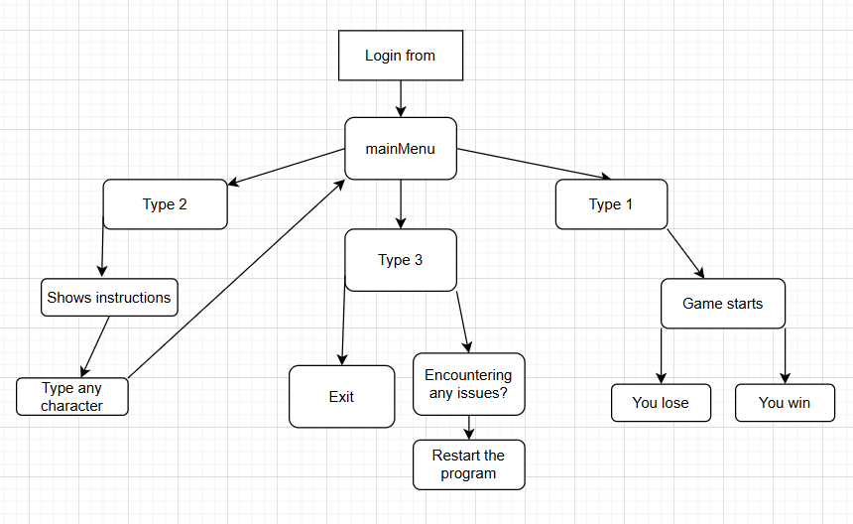

Function

|  |  |
| --- | --- |
| **Type** | **Name** |
| **void** | mainManu |
| **void** | randomWords |
| **void** | gameMechanics |
| **void** | gameInstructions |
| **const bool** | allCorrec |